BridgeU
Software Design Development

Zhiyi Pan 652115558

Bachelor of Science
Software Engineering Program

Department College of Arts,Media,and
Technology
Chiang Mai University
December 2025
Project Advisor
Pattama Longani, Ph.D.

Table Content
Chapter 1 Introduction 3
1.1 Purpose and Scope 3
1.2 Acronyms and Definitions 3
Chapter 2 System Architecture 6
Chapter 3 Detail Design 8
3.1 Feature 1 8
3.1.1 Class Diagram 8
3.1.2 Class Diagram Description 9
3.1.3 Sequence Diagram 24
3.2 Feature 2 31
3.2.1 Class Diagram 31
3.2.2 Class Diagram Description 32
3.2.3 Sequence Diagram 49
3.3 Feature 3 59
3.3.1 Class Diagram 59
3.3.2 Class Diagram Description 60
3.3.3 Sequence Diagram 75
Chapter 4 UI Design 84
Chapter 5 Database Design 94
5.1 Entity Relationship Diagram (ERD) 94
5.2 Data Dictionary 97

Chapter 1 Introduction

Purpose and Scope
The purpose of the software design development is to present a complete software design of the BridgeU project. This document contains the outline of the software architecture, functions used, and activity diagrams with the user interface for this project. BridgeU aims to eliminate language barriers through AI technology and establish a bilingual mutual assistance ecosystem connecting Chinese students, global students, and local Thai merchants.

Acronyms and Definitions
Acronyms
SRS | Software Requirement Specification
UI | User Interface
SDD | Software Design Document
FD | Function Description

Name | Definition
IEEE | Institute for Electrical and Electronics Engineers. Biggest global interest  group for engineers of different branches and computer scientists.
Plan | A document series of tasks requires meeting an objective, typically  including the associated schedule, budget, resources, organizational  description and work breakdown structure.
Feature | Feature Transformation of input parameters to output parameters based  on a specified algorithm. It describes the functionality of the product in  the language of the product. Used for requirements analysis, design,  coding, testing or maintenance.
Project  Management | The application of knowledge, skills, tools, and techniques to project  activities in order to meet or exceed stakeholder needs and expectations  from a project.
Project Plan | A formal, approved document used to guide both project execution and  project control. The primary uses of the project plan are to document  planning assumptions and the decision, to facilitate communication  among stakeholders, and to document approved scope, cost, and  schedule baseline.
Risk | An uncertain event or condition that, if it occurs, has a positive or  negative effect on a project’s objectives. It is a function of the  probability of occurrence of a given threat’s occurrence.
Risk Management | The systematic application of management policies, procedures and  practices to the tasks of identifying, analyzing, evaluating, treating and  monitoring risk.
System Testing | Testing conducted on a complete and integrated system for evaluate the  system’s compliance with its specified requirements.
Unit Test | A test of individual programs or modules in order to remove a design or  programming errors.
Traceability | The ability to trace the history, application or location of an item or  activity, or work products or activities, by means of recorded  identification. The establishment and maintenance of relationships  between such items. Horizontal traceability describes the relationship  between work products of the same type (e.g. Customer requirements).  Vertical traceability describes the relationship between work products,  which build or derived from each other (e.g., from customer  requirements to qualification test cases). Bidirectional traceability  allows to directly following relationships in both directions.
Use Case | A use case is a description of a specific interaction between a system  and its users to accomplish a particular goal or task. It outlines the  sequence of steps or actions that a user performs in the system and  describes the system's responses to those actions. Use cases help to  identify and define the functional requirements of a system from the  perspective of its users.
Crawler | A program that systematically browses the World Wide Web in order to create an index of data.
Qwen AI | he Large Language Model provided by Alibaba Cloud used for translation and summarization.

Chapter 2 System Architecture
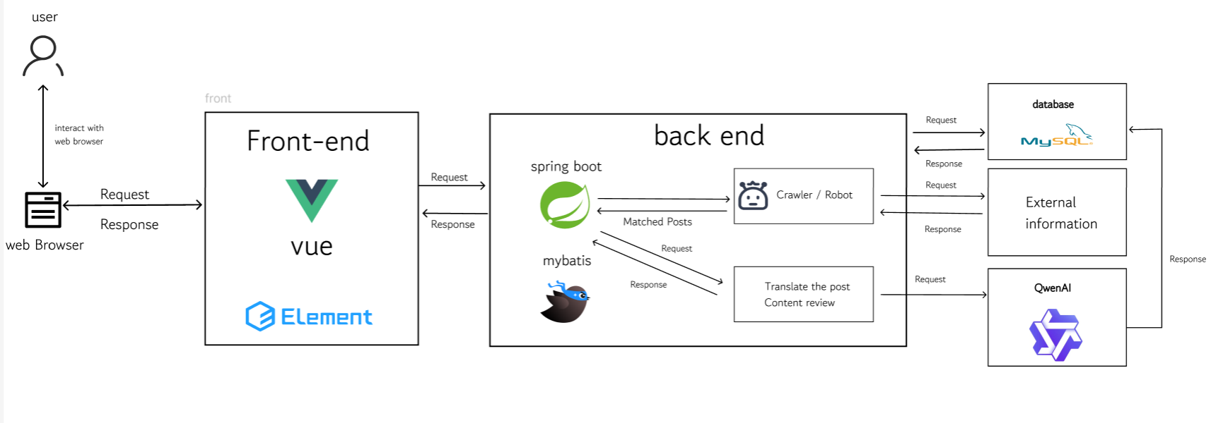

Description:
The system architecture consists of a front-end built using Vue.js 3 and ElementPlus 2.6, which provides a responsive user interface. The back-end is built with Spring Boot3.2, a robust Java framework, handling business logic and RESTful API requests. MySQL 8 is used as the primary database for storing structured user and post data. Elasticsearch is integrated to provide high-performance semantic search capabilities. Additionally, the system connects to the Aliyun Qwen3 max API to perform natural language processing tasks such as summarization and translation. Axios is used for communication between the front-end and back-end.

Chapter 3 Detail Design

3.1 Feature 1

3.1.1 Class Diagram
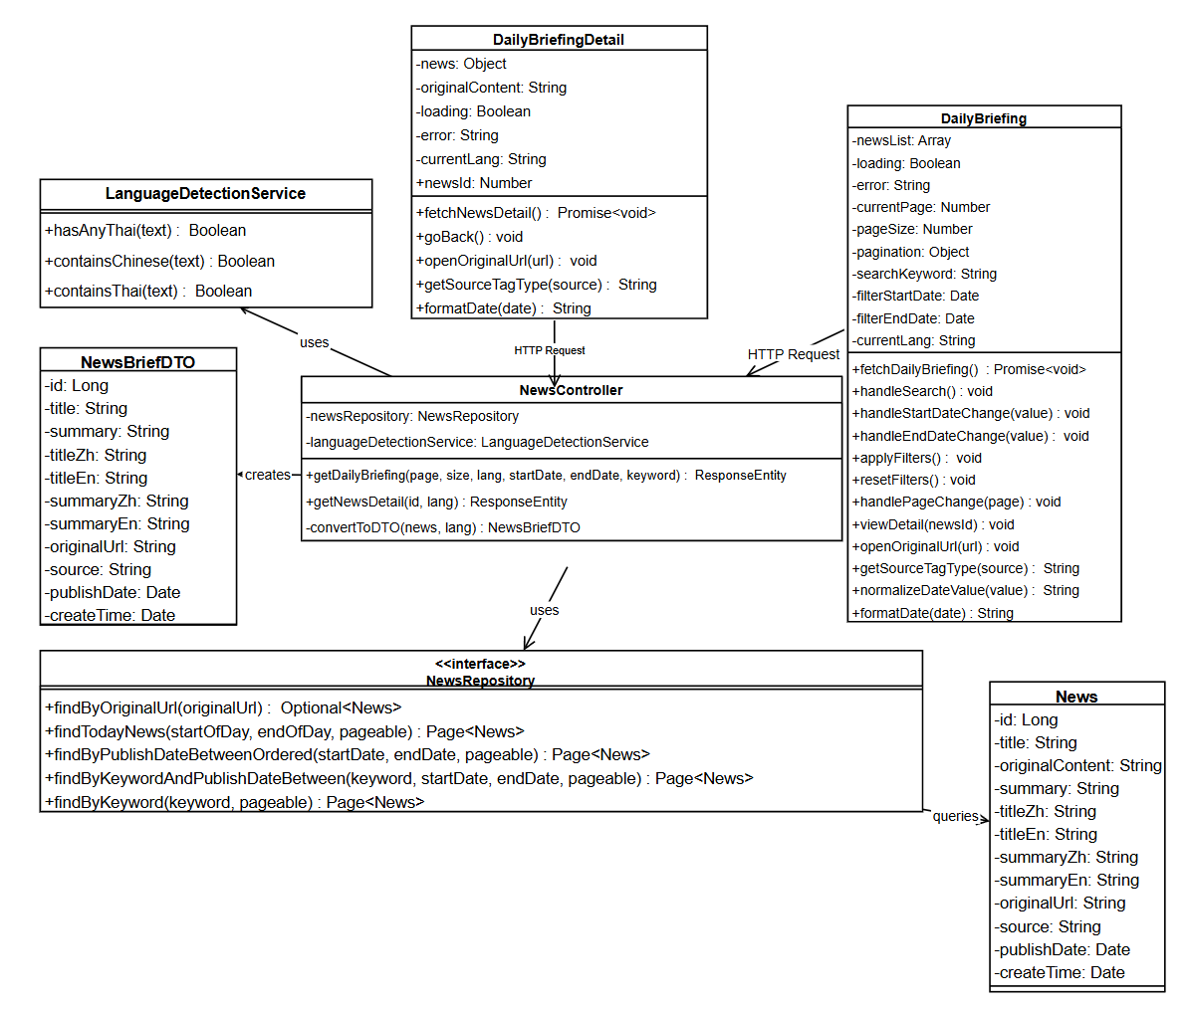

3.1.2 Class Diagram Description

3.1.2.1 View

3.1.2.1.1 DailyBriefing
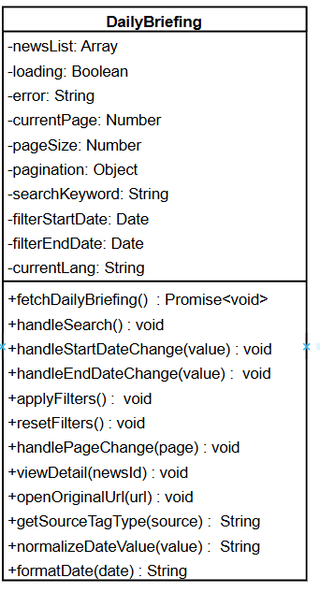

Attributes:
ID | Name | Description | Type
1 | newsList | Array containing the list of Daily Briefing news items to be displayed | Array
2 | loading | Boolean flag indicating if the news data is currently being fetched | Boolean
3 | error | String containing error message if data fetching fails | String
4 | currentPage | Current page number for pagination (1-based) | Number
6 | pageSize | Number of news items to display per page | Number
7 | searchKeyword | String containing the keyword entered by the user for searching news | String
8 | filterStartDate | Date object representing the start date for filtering news by publication date | Date
9 | filterEndDate | Date object representing the end date for filtering news by publication date | Date
10 | currentLang | String representing the current interface language ("zh" for Chinese, "en" for English) | String

Methods:
ID | Name | Description | Parameter | Return Type
1 | fetchDailyBriefing | Fetches Daily Briefing news items from the backend API with pagination, search, and filter parameters. Sets loading=true, calculates 0-based page number, builds params object with page, size, lang, keyword (if provided), startDate and endDate.Sends GET request to /api/news/daily-briefing. On success, updates newsList and pagination object. Handles errors and sets loading=false in finally block. | None | Promise<void>
2 | handleSearch | Handles search action by resetting currentPage to 1 and calling fetchDailyBriefing(). This ensures search results start from the first page. | None | Void
3 | handleStartDateChange | Updates the filterStartDate when user selects a start date | value: Date \null | void
4 | handleEndDateChange | Updates the filterEndDate when user selects an end date | value: Date \null | void
5 | applyFilters | Validates date range (checks if startDate > endDate, shows warning if invalid). If valid, resets currentPage to 1 and calls fetchDailyBriefing() to fetch filtered results. Note: fetchDailyBriefing() internally calls normalizeDateValue() to normalize date values before sending to API. | None | void
6 | resetFilters | Clears all filter conditions: sets searchKeyword='', filterStartDate=null, filterEndDate=null, resets currentPage to 1, and calls fetchDailyBriefing() to reload all news without filters. | None | void
7 | handlePageChange | Handles pagination by updating currentPage to the new page number and calling fetchDailyBriefing() to fetch the corresponding page. Scrolls to top after page change. | page: Number | void
8 | viewDetail | Emits an event to navigate to the news detail page for a specific news item | newsId: Number | void
9 | openOriginalUrl | Opens the original news article URL in a new browser tab | url: String | void
10 | getSourceTagType | Returns the Element UI tag type (primary/success/info) based on the news source | source: String | String
11 | normalizeDateValue | Normalizes date value to DD-MM-YYYY format string. Handles Date objects (extracts year, month, day), string values (validates DD-MM-YYYY format, ignores incomplete inputs with letters), and null values. Returns null for invalid inputs. | value: Date \String | String \null
12 | formatDate | Formats a date object to "DD-MM-YYYY HH:mm" format string | date: Date \String | String

3.1.2.1.2 DailyBriefingDetail
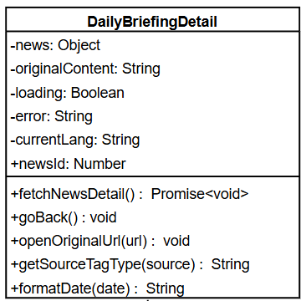
Attributes:
ID | Name | Description | Type
1 | news | Object containing the detailed information of a single Daily Briefing news item | Object
2 | originalContent | String containing the original content of the news article | String
3 | loading | Boolean flag indicating if the news detail data is currently being fetched | Boolean
4 | error | String containing error message if data fetching fails | String
5 | currentLang | String representing the current interface language ("zh" for Chinese, "en" for English) | String
6 | newsId | Number representing the ID of the news item to display (passed as prop) | Number

Methods:
ID | Name | Description | Parameter | Return Type
1 | fetchNewsDetail | Fetches detailed information of a single news item from the backend API using newsId. Sets loading=true, error=null, builds params with lang (currentLang or 'en'), sends GET request to /api/news/daily-briefing/{id}. First checks response.status === 200, then checks response.data.success. On success, updates news = response.data.data and originalContent = response.data.originalContent. Handles errors: 404 (shows localized notFound message), 401 (shows login expired message, handled by interceptor), 500 (shows error message from response), network errors (shows localized networkError message). Sets loading=false in finally block. | None | Promise<void>
2 | goBack | Emits an event to navigate back to the Daily Briefing list page | None | Void
3 | openOriginalUrl | Opens the original news article URL in a new browser tab | url: String | Void
4 | getSourceTagType | Returns the Element UI tag type (primary/success/info) based on the news source | source: String | String
5 | formatDate | Formats a date object to "DD-MM-YYYY HH:mm" format string | date: Date \String | String

3.1.2.2 Controller

3.1.2.2.1 Controller: NewsController
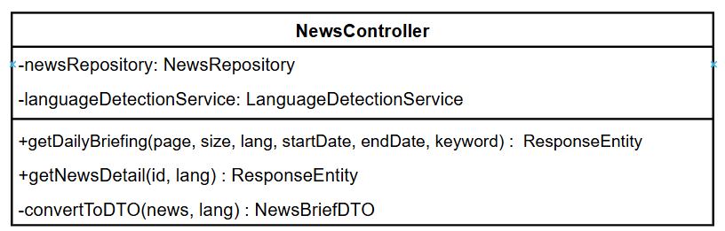
Attributes:
ID | Name | Description | Type
1 | newsRepository | Instance of NewsRepository for database operations | NewsRepository
2 | languageDetectionService | Instance of LanguageDetectionService for detecting Thai and Chinese content | LanguageDetectionService

Methods:
ID | Name | Description | Parameter | Return Type
1 | getDailyBriefing | Handles GET request to retrieve paginated Daily Briefing news list with optional filters (keyword, date range, source). Returns ResponseEntity with paginated news data. | page: int, size: int, lang: String, source: String, startDate: String, endDate: String, keyword: String | ResponseEntity<Map<String, Object>>
2 | convertToDTO | Converts News entity to NewsBriefDTO based on language preference. Ensures no Thai content is displayed on the website. | news: News, lang: String | NewsBriefDTO
3 | getNewsDetail | Handles GET request to retrieve detailed information of a single news item by ID. Returns DTO data and optional original content. | `id: Long`, `lang: String` | `ResponseEntity<Map<String,Object>>`

3.1.2.3 Repository

3.1.2.3.1 Repository: NewsRepository
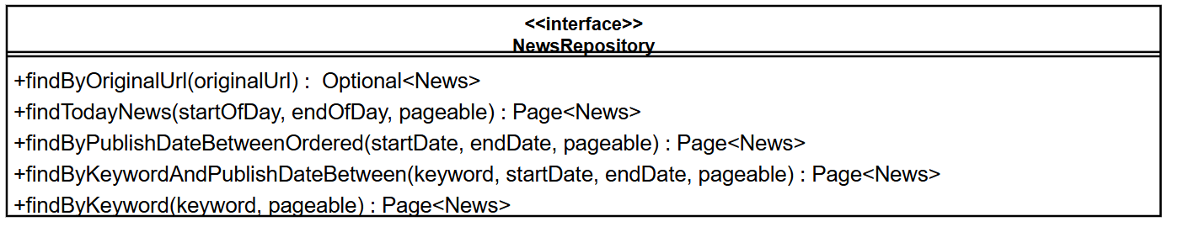
Methods:
ID | Name | Description | Parameter | Return Type
1 | findByOriginalUrl | Finds a news item by its original URL (for deduplication) | originalUrl: String | Optional<News>
2 | findTodayNews | Finds today's news items based on publishDate (with pagination) | startOfDay: Date, endOfDay: Date, pageable: Pageable | Page<News>
3 | findByPublishDateBetweenOrdered | Finds news items within publish date range, ordered by publishDate DESC (with pagination) | startDate: Date, endDate: Date, pageable: Pageable | Page<News>
4 | findByKeywordAndPublishDateBetween | Searches news items by keyword (in title, content, summary, translations) and publish date range (with pagination) | keyword: String, startDate: Date, endDate: Date, pageable: Pageable | Page<News>
5 | findByKeyword | Searches news items by keyword across all historical news (with pagination) | keyword: String, pageable: Pageable | Page<News>

3.1.2.4 Model

3.1.2.4.1 Model: News
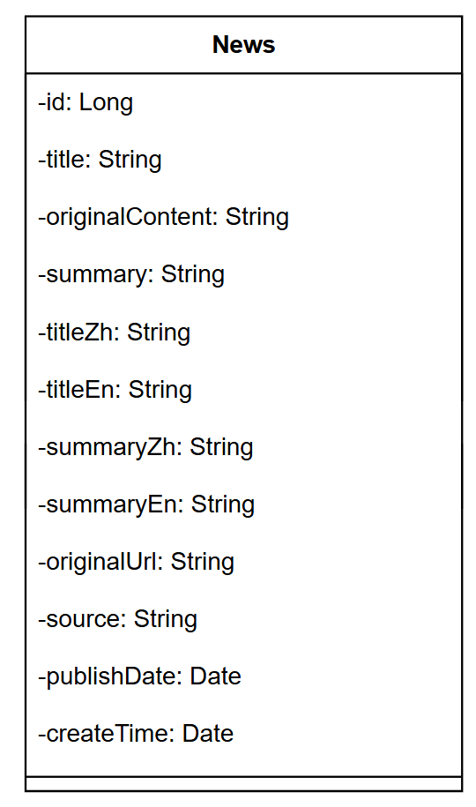

Attributes:
ID | Name | Description | Type
1 | Id | Primary key ID of the news item | Long
2 | title | Original news title | String
3 | originalContent | Original content of the news article (stored as TEXT) | String
4 | summary | AI-generated summary of the news article | String
5 | titleZh | Chinese translation of the title | String
6 | titleEn | English translation of the title | String
7 | summaryZh | Chinese translation of the summary | String
8 | summaryEn | English translation of the summary | String
9 | originalUrl | Original article URL from the source website | String
10 | source | Source website name | String
11 | publishDate | Publication date from the source website | Date
12 | createTime | timestamp when the news was crawled and stored | Date

3.1.2.4.2 Model: NewsBriefDTO
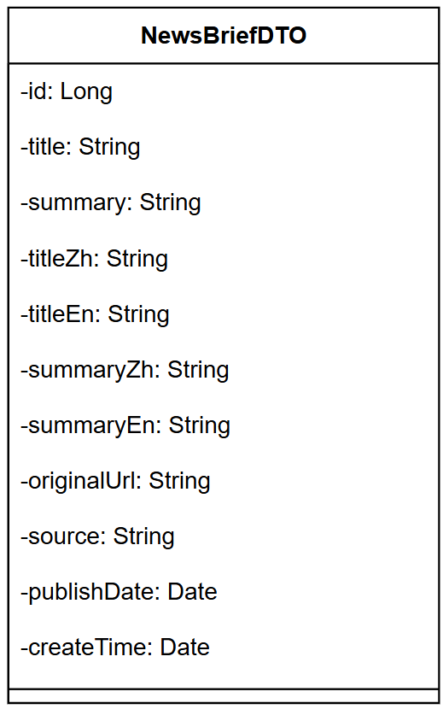
Attributes:
ID | Name | Description | Type
1 | Id | Primary key ID of the news item | Long
2 | Title | news title (language-specific based on user preference) | String
3 | Summary | news summary (language-specific based on user preference) | String
4 | titleZh | Chinese translation of the title | String
5 | titleEn | English translation of the title | String
6 | summaryZh | Chinese translation of the summary | String
7 | summaryEn | English translation of the summary | String
8 | originalUrl | Original article URL from the source website | String
9 | source | Source website name | String
10 | publishDate | Publication date from the source website | Date
11 | createTime | Timestamp when the news was crawled and stored | Date

3.1.3 Sequence Diagram
SD-01：View Daily Briefings
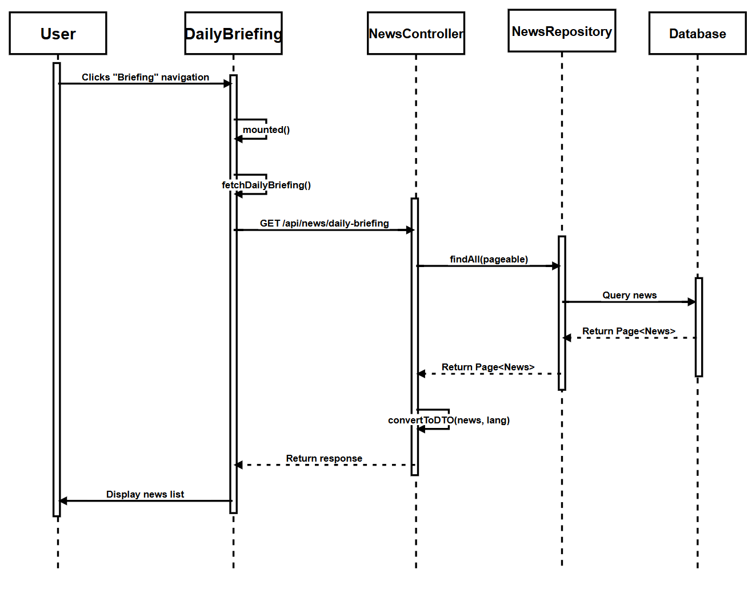

SD-02: View Daily Briefing News Details
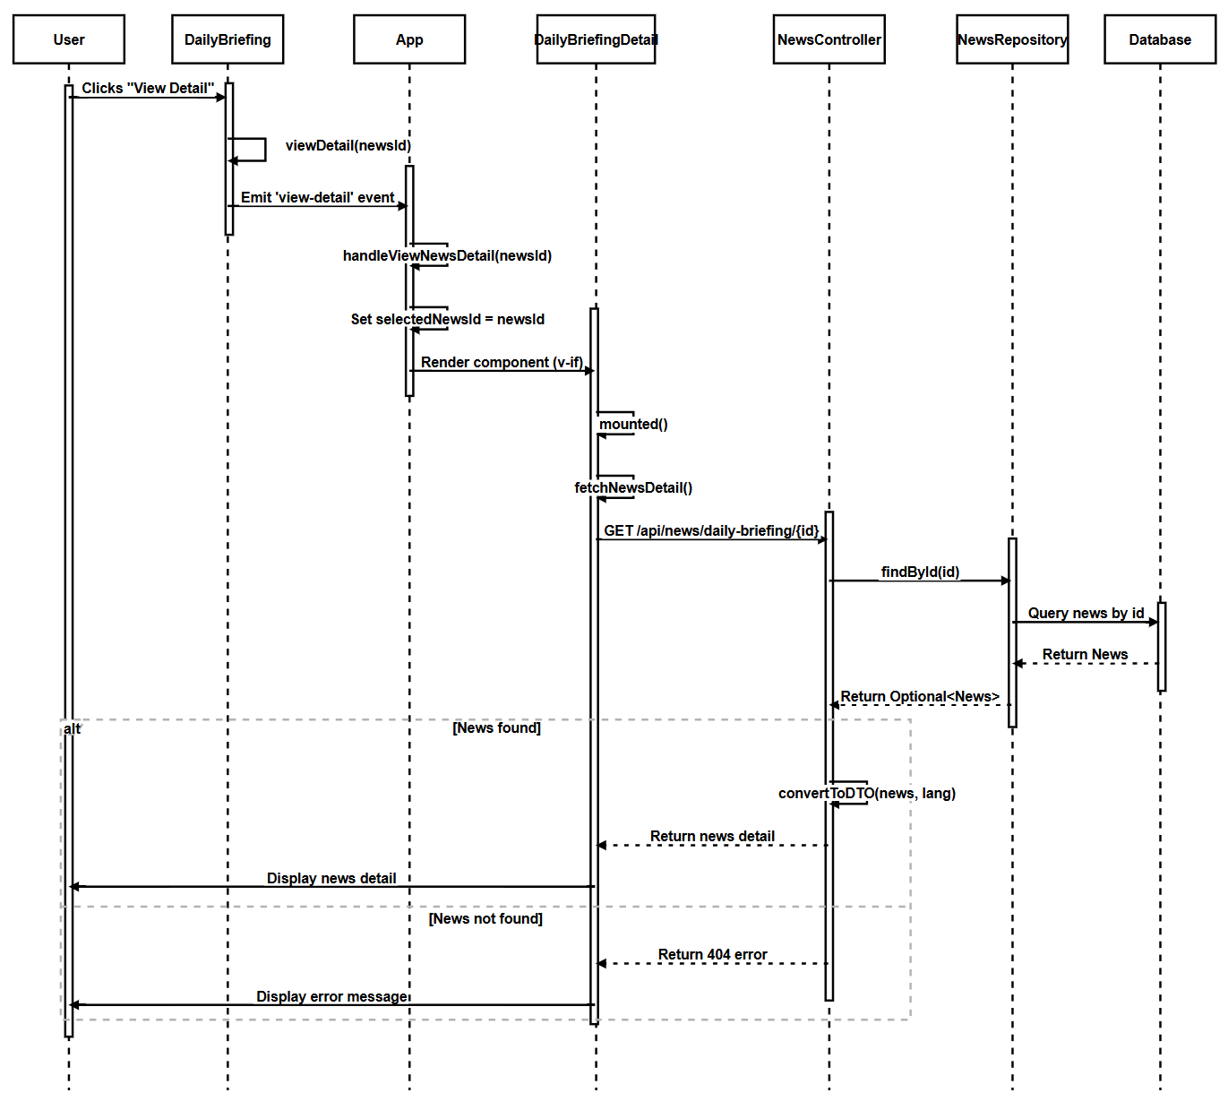

SD-03: Switch Interface Language
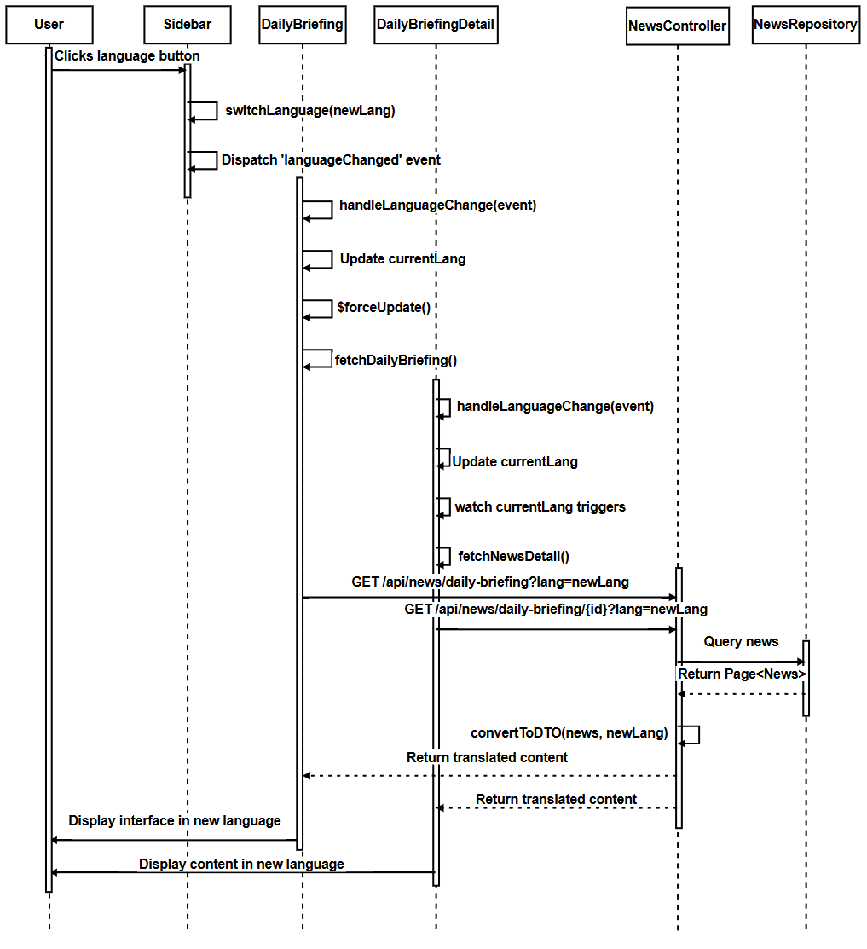

SD-04: Jump to Original Link
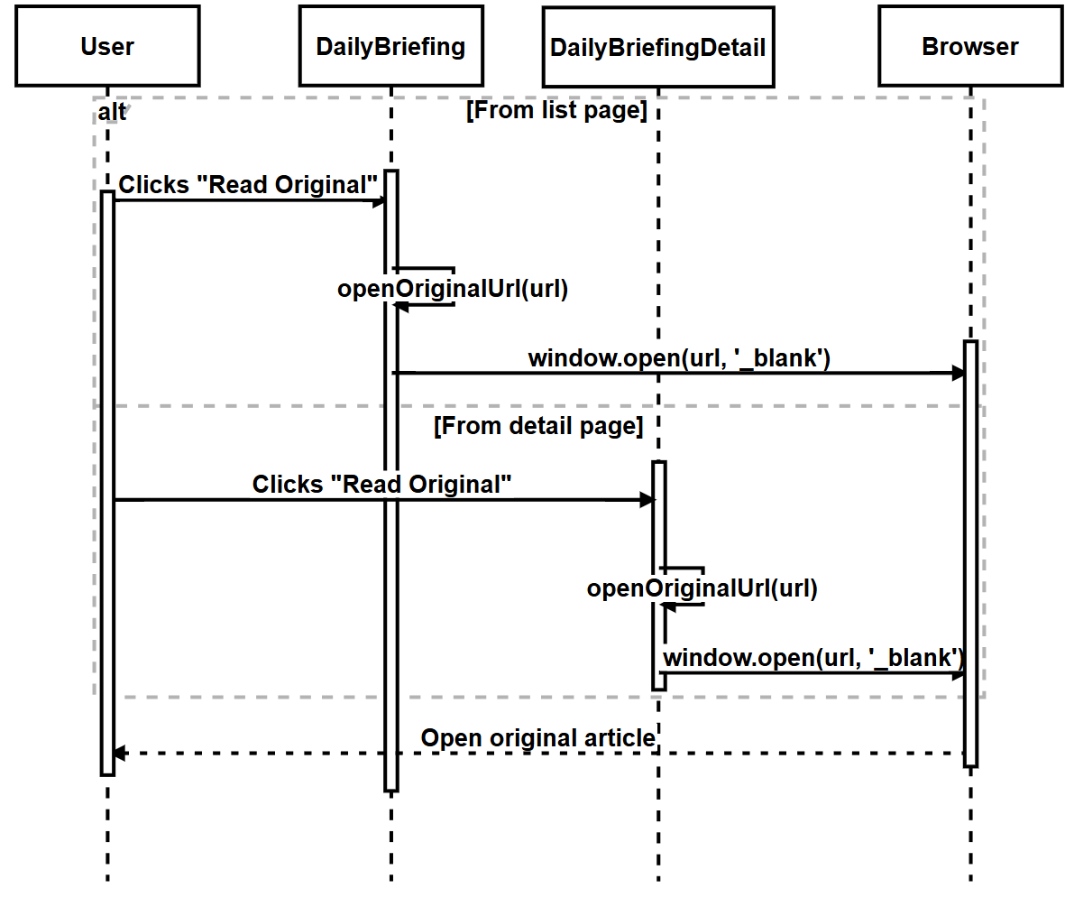

SD-05: Filter Daily Briefing News by Date
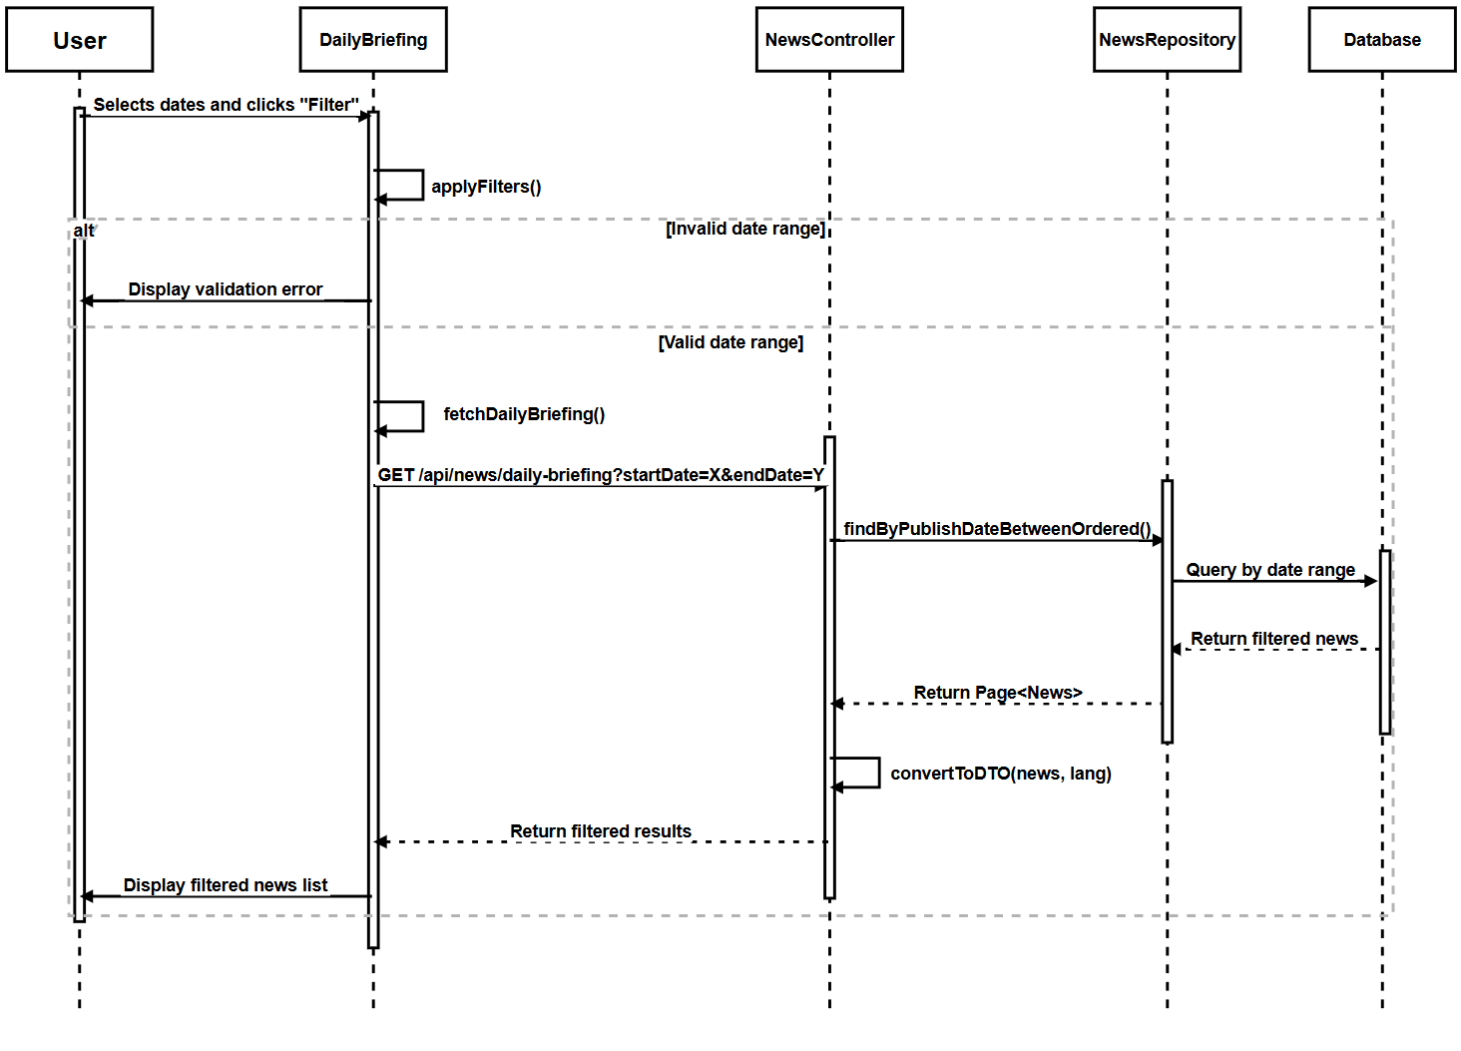

SD-06: Search Daily Briefing News
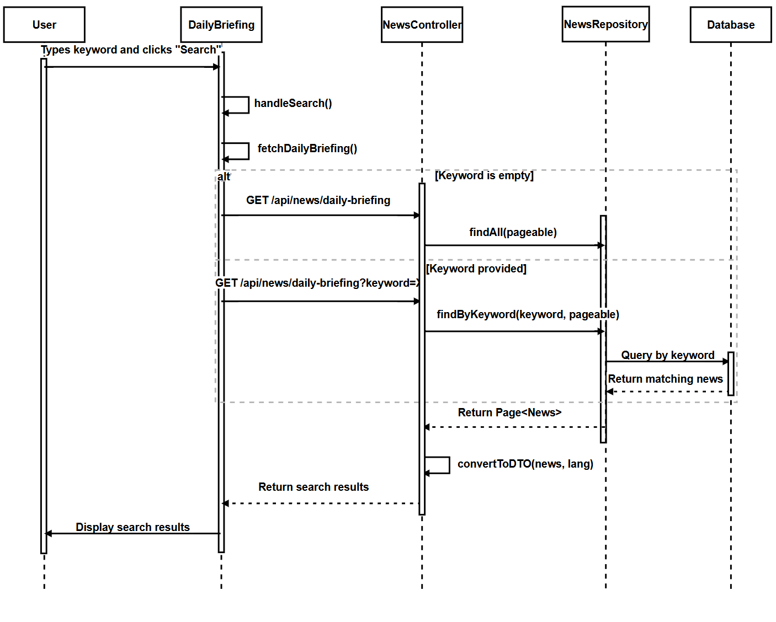

3.2 Feature 2

3.2.1 Class Diagram
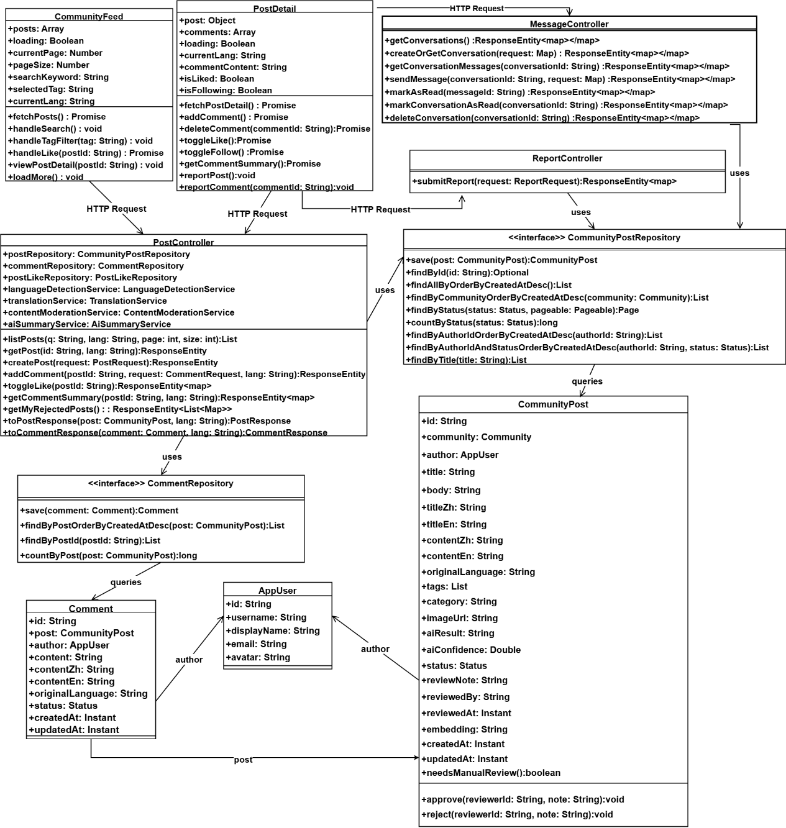

3.2.2 Class Diagram Description

3.2.2.1 View

3.2.2.1.1 CommunityFeed
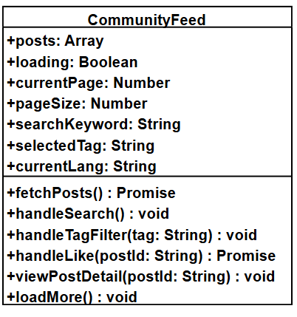
Attributes:
ID | Name | Description | Type
1 | posts | Community posts currently displayed in the feed | Array
2 | loading | Whether posts are currently being fetched | Boolean
3 | currentPage | Current page number for pagination | Number
4 | pageSize | Number of posts to display per page | Number
5 | searchKeyword | Keyword used to search posts | String
6 | selectedTag | Currently selected tag filter (Study, Housing, Travel, Part-time Job, Life Services) | String
7 | currentLang | Current interface language ("zh" for Chinese, "en" for English) | String

Methods:
ID | Name | Description | Parameter | Return Type
1 | fetchPosts | Fetches community posts from the backend API with current filters and language | None | Promise\<void>
2 | handleSearch | Updates `searchKeyword` and reloads posts | None | void
3 | handleTagFilter | Updates `selectedTag` and reloads posts | `tag: String` | void
4 | handleLike | Sends like/unlike request for a post | `postId: String` | Promise\<void>
5 | viewPostDetail | Navigates to the post detail page for a specific post | `postId: String` | void
6 | loadMore | Loads the next page of posts and appends them to `posts` | None | void

3.2.2.1.2 PostDetail
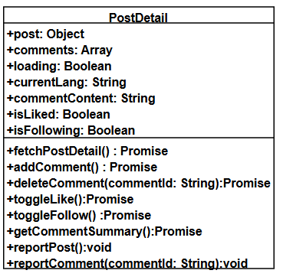
Attributes:
ID | Name | Description | Type
1 | post | Detailed information of the selected post | Object
2 | comments | Comments for the post | Array
3 | loading | Whether post detail data is currently being fetched | Boolean
4 | currentLang | Current interface language ("zh" for Chinese, "en" for English) | String
5 | commentContent | Content of a new comment being composed | String
6 | isLiked | Whether the current user has liked this post | Boolean
7 | isFollowing | Whether the current user is following the post author | Boolean

Methods:
ID | Name | Description | Parameter | Return Type
1 | fetchPostDetail | Fetches detailed information of the post and its comments | None | Promise\<void>
2 | addComment | Sends a request to add a new comment and refreshes the comments list | None | Promise\<void>
3 | deleteComment | Sends a request to delete a comment | `commentId: String` | Promise\<void>
4 | toggleLike | Sends a like/unlike request for the post | None | Promise\<void>
5 | toggleFollow | Sends a follow/unfollow request for the post author | None | Promise\<void>
6 | getCommentSummary | Requests an AI-generated summary of all comments for the post | None | Promise\<void>
7 | reportPost | Sends a report request for the post | None | void
8 | reportComment | Sends a report request for a specific comment | `commentId: String` | void

3.2.2.2 Controller

3.2.2.2.1 Controller: `PostController`
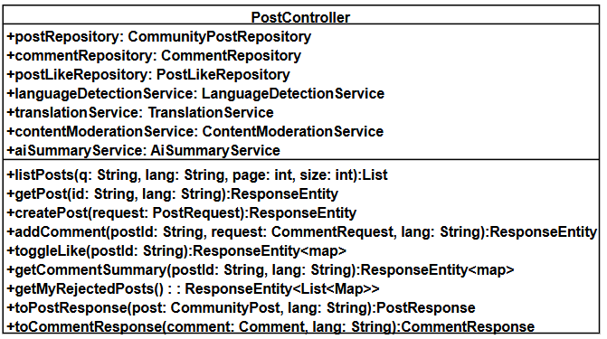
Attributes:
ID | Name | Description | Type
1 | postRepository | Instance of `CommunityPostRepository` for database operations | CommunityPostRepository
2 | commentRepository | Instance of `CommentRepository` for comment operations | CommentRepository
3 | postLikeRepository | Instance of `PostLikeRepository` for like operations | postLikeRepository
4 | languageDetectionService | Instance of `LanguageDetectionService` for language detection | LanguageDetectionService
5 | translationService | Instance of `TranslationService` for content translation | TranslationService
6 | contentModerationService | Instance of `ContentModerationService` for AI content moderation | ContentModerationService
7 | aiSummaryService | Instance of `AiSummaryService` for AI-generated summaries | AiSummaryService

Methods:
ID | Name | Description | Parameter | Return Type
1 | listPosts | Returns a paginated list of community posts with optional filters (keyword, tag, language) | `q: String`, `lang: String`, `page: int`, `size: int` | `List<PostListResponse>`
2 | getPost | Returns detailed information of a single post including comments | `id: String`, `lang: String` | `ResponseEntity<PostDetailResponse>`
3 | createPost | Creates a new community post with AI moderation and translation | `request: PostRequest` | `ResponseEntity<PostResponse>`
4 | addComment | Adds a new comment to the specified post with translation | `postId: String`, `request: CommentRequest`, `lang: String` | `ResponseEntity<CommentResponse>`
5 | toggleLike | Toggles like status for a post | `postId: String` | `ResponseEntity<Map>`
6 | getCommentSummary | Returns an AI-generated summary of all comments for a post | `postId: String`, `lang: String` | `ResponseEntity<Map>`
7 | getMyRejectedPosts | Returns list of rejected posts for the current user | None | `ResponseEntity<List<Map>>`
8 | toPostResponse | Converts `CommunityPost` entity to `PostResponse` DTO based on language preference | `post: CommunityPost`, `lang: String` | `PostResponse`
9 | toCommentResponse | Converts `Comment` entity to `CommentResponse` DTO based on language preference | `comment: Comment`, `lang: String` | `CommentResponse`

3.2.2.2.2 Controller: `ReportController`
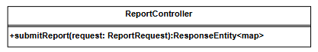
Methods:
ID | Name | Description | Parameter | Return Type
1 | submitReport | Submits a new report for a post or comment | `request: ReportRequest` | `ResponseEntity<Map>`

3.2.2.2.3 Controller: `MessageController`
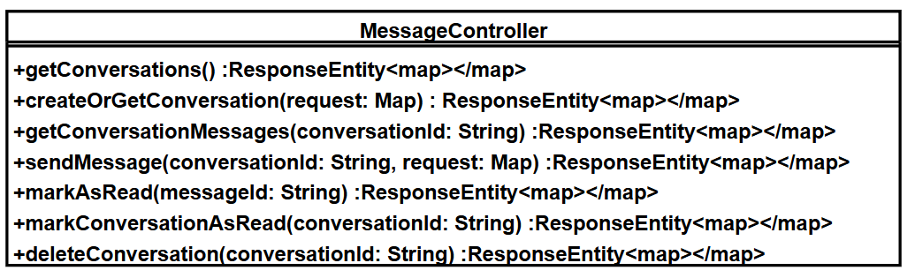
Methods:
ID | Name | Description | Parameter | Return Type
1 | getConversations | Returns the list of conversations for the current user, wrapped in a map (e.g. list, pagination info, unread counts). | None | ResponseEntity<Map>
2 | createOrGetConversation | Creates a new conversation with the specified user or restores an existing soft-deleted conversation. Requires the current user to follow the target user. | request: Map<String, String> (contains userId) | ResponseEntity<Map>
3 | getConversationMessages | Returns messages for the specified conversation, wrapped in a map (e.g. list, pagination info, unread status). | conversationId: String | ResponseEntity<Map>
4 | sendMessage | Sends a message in the specified conversation. If the users are not mutually following, the current user is limited to a single message in that conversation until followed. | conversationId: String, request: Map<String,String> | ResponseEntity<Map>
5 | markAsRead | Marks a single message as read. | messageId: String | ResponseEntity<Map>
6 | markConversationAsRead | Marks all messages in the specified conversation as read for the current user. | conversationId: String | ResponseEntity<Map>
7 | deleteConversation | Soft-deletes a conversation from the current user's view without removing the underlying messages or the other user's conversation. | conversationId: String | ResponseEntity<Map>

3.2.2.3 Repository

3.2.2.3.1 Repository: `CommunityPostRepository`
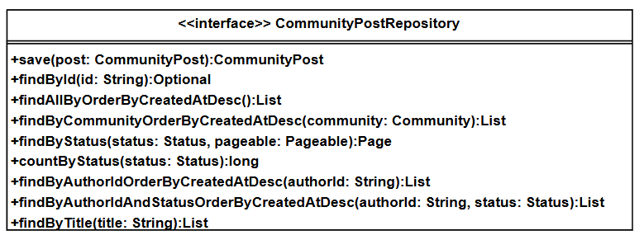
Methods:
ID | Name | Description | Parameter | Return Type
1 | save | Saves a post entity (create or update). | post: CommunityPost | CommunityPost
2 | findById | Finds a post by its ID. | id: String | Optional<CommunityPost>
3 | findAllByOrderByCreatedAtDesc | Finds all posts ordered by creation date descending. | None | List<CommunityPost>
4 | findByCommunityOrderByCreatedAtDesc | Finds posts by community ordered by creation date descending. | community: Community | List<CommunityPost>
5 | findByStatus | Finds posts by status with pagination. | status: Status, pageable: Pageable | Page<CommunityPost>
6 | countByStatus | Counts posts by status. | status: Status | long
7 | findByAuthorIdOrderByCreatedAtDesc | Finds posts by author ID ordered by creation date descending. | authorId: String | List<CommunityPost>
8 | findByAuthorIdAndStatusOrderByCreatedAtDesc | Finds posts by author ID and status ordered by creation date descending. | authorId: String, status: Status | List<CommunityPost>
9 | findByTitle | Finds posts by title (for duplicate checking). | title: String | List<CommunityPost>

3.2.2.3.2 Repository: `CommentRepository`
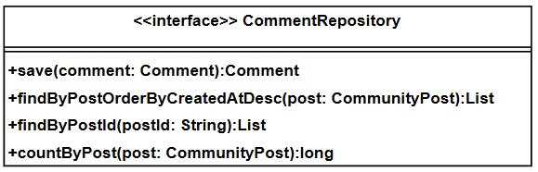
Methods:
ID | Name | Description | Parameter | Return Type
1 | save | Saves a comment entity (create or update). | `comment: Comment` | Comment
2 | findByPostOrderByCreatedAtDesc | Finds comments for a post ordered by creation date descending | `post: CommunityPost` | List\<Comment>
3 | findByPostId | Finds comments by post ID | `postId: String` | List\<Comment>
4 | countByPost | Counts comments for a post | `post: CommunityPost` | long

3.2.2.4 Model

3.2.2.4.1 Model: `CommunityPost`
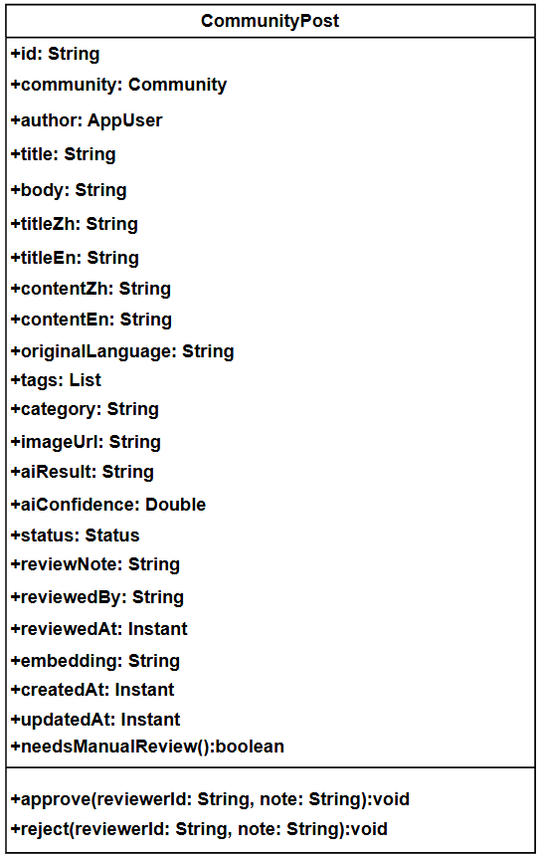
Attributes:
ID | Name | Type | Description
1 | id | String | Primary key ID (UUID)
2 | community | Community | Community this post belongs to (nullable)
3 | author | AppUser | Author of the post
4 | title | String | Post title
5 | body | String | Post content (TEXT)
6 | titleZh | String | Chinese translation of title
7 | titleEn | String | English translation of title
8 | contentZh | String | Chinese translation of content
9 | contentEn | String | English translation of content
10 | originalLanguage | String | Detected original language (zh/en/th)
11 | tags | List<String> | Post tags (e.g., Study, Housing, Travel)
12 | category | String | Post category
13 | imageUrl | String | Image URL if post contains images
14 | aiResult | String | AI moderation result (TEXT)
15 | aiConfidence | Double | AI confidence score (0.0 - 1.0)
16 | status | Status | Post moderation status (PENDING_REVIEW, APPROVED, REJECTED, REPORTED_REMOVED)
17 | reviewNote | String | Review note (filled by AI system with reviewerId "AI_AUTOMOD")
18 | reviewedBy | String | Reviewer ID ("AI_AUTOMOD" for AI-approved/rejected posts）
19 | reviewedAt | Instant | Review timestamp
20 | embedding | String | Semantic embedding for search (TEXT)
21 | createdAt | Instant | Time when the post was created
22 | updatedAt | Instant | Time when the post was last updated

Methods:
ID | Name | Description | Parameter | Return Type
1 | needsManualReview | Indicates whether the post requires additional AI-based safety checks (no manual review). | None | boolean
2 | approve | Approves the post with reviewer information | `reviewerId: String`, `note: String` | void
3 | reject | Rejects the post with reviewer information | `reviewerId: String`, `note: String` | void

3.2.2.4.2 Model: `Comment`
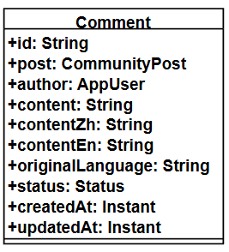
Attributes:
ID | Name | Type | Description
1 | id | String | Primary key ID (UUID)
2 | post | CommunityPost | Post this comment belongs to
3 | author | AppUser | Author of the comment
4 | content | String | Comment content (TEXT)
5 | contentZh | String | Chinese translation of content
6 | contentEn | String | English translation of content
7 | originalLanguage | String | Detected original language (zh/en/th)
8 | status | Status | Comment status (ACTIVE, REPORTED_REMOVED)
9 | createdAt | Instant | Time when the comment was created
10 | updatedAt | Instant | Time when the comment was last updated

3.2.2.4.3 Model: `AppUser`
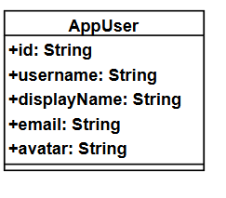
Attributes:
ID | Name | Description | Type
1 | Id | Primary key ID | String
2 | Username | Username for login | String
3 | Display | Display name shown to other users | String
4 | Email | User email address | String
5 | Avatar | User avatar URL | String

3.2.3 Sequence Diagram
SD-07: Browse Community Feed
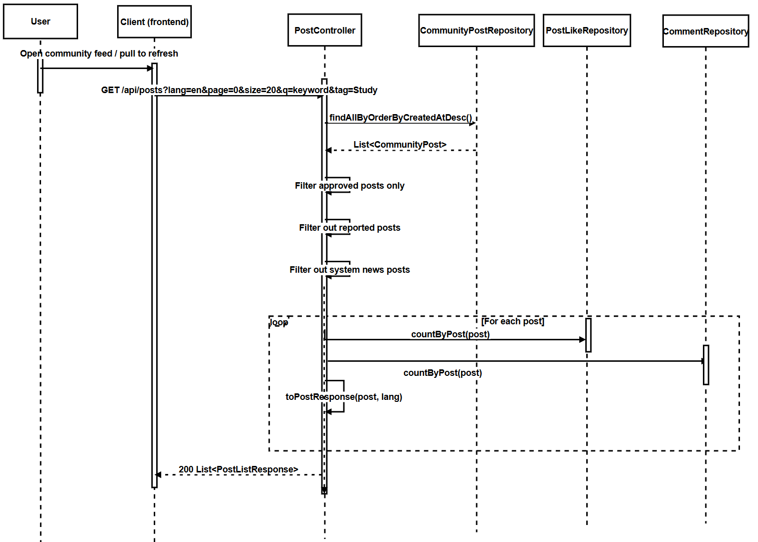
SD-08: Create Publish Post
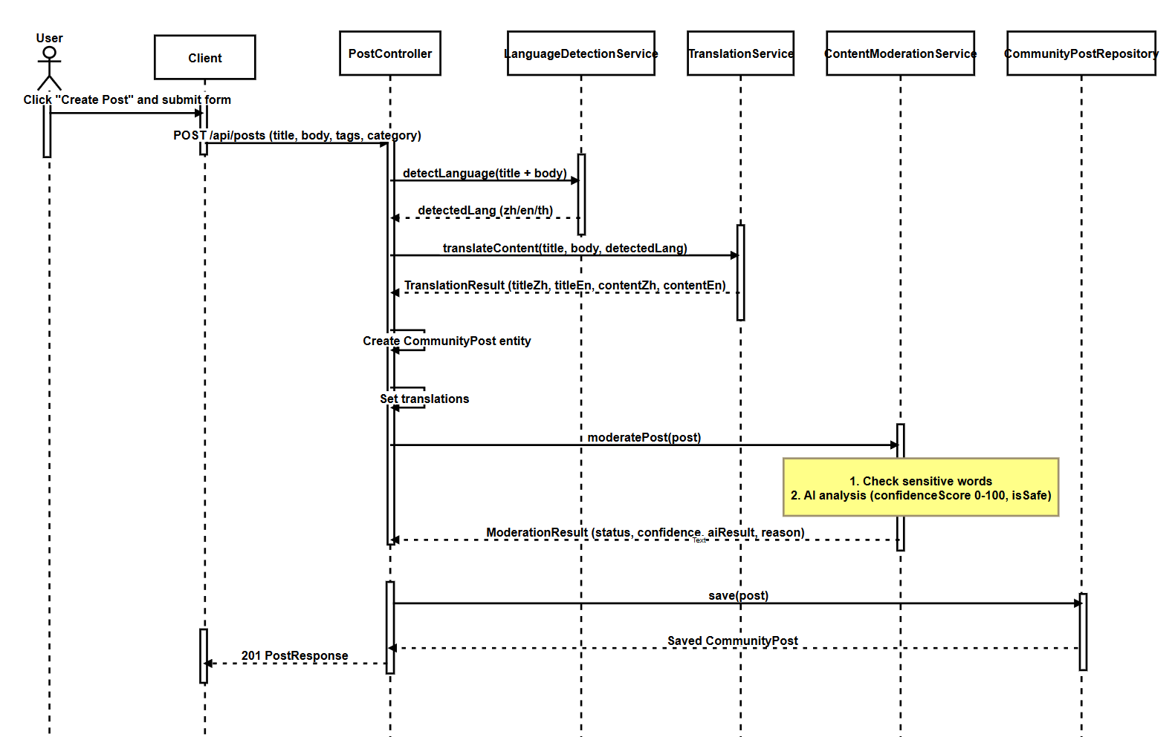

SD-09:Like Post
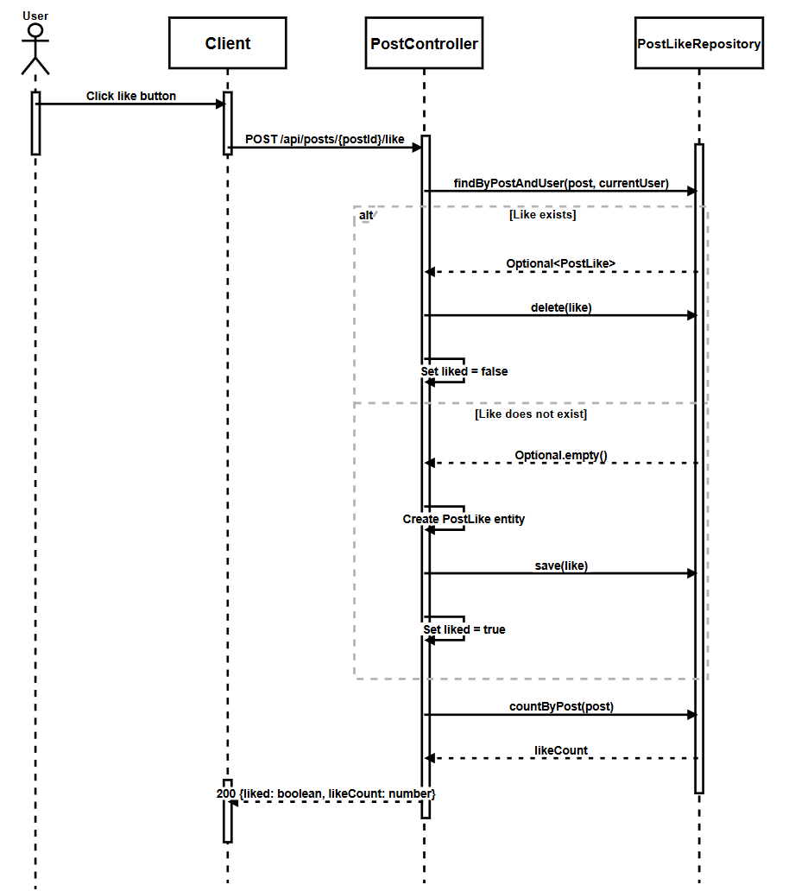

SD-10:Filter Post by tag
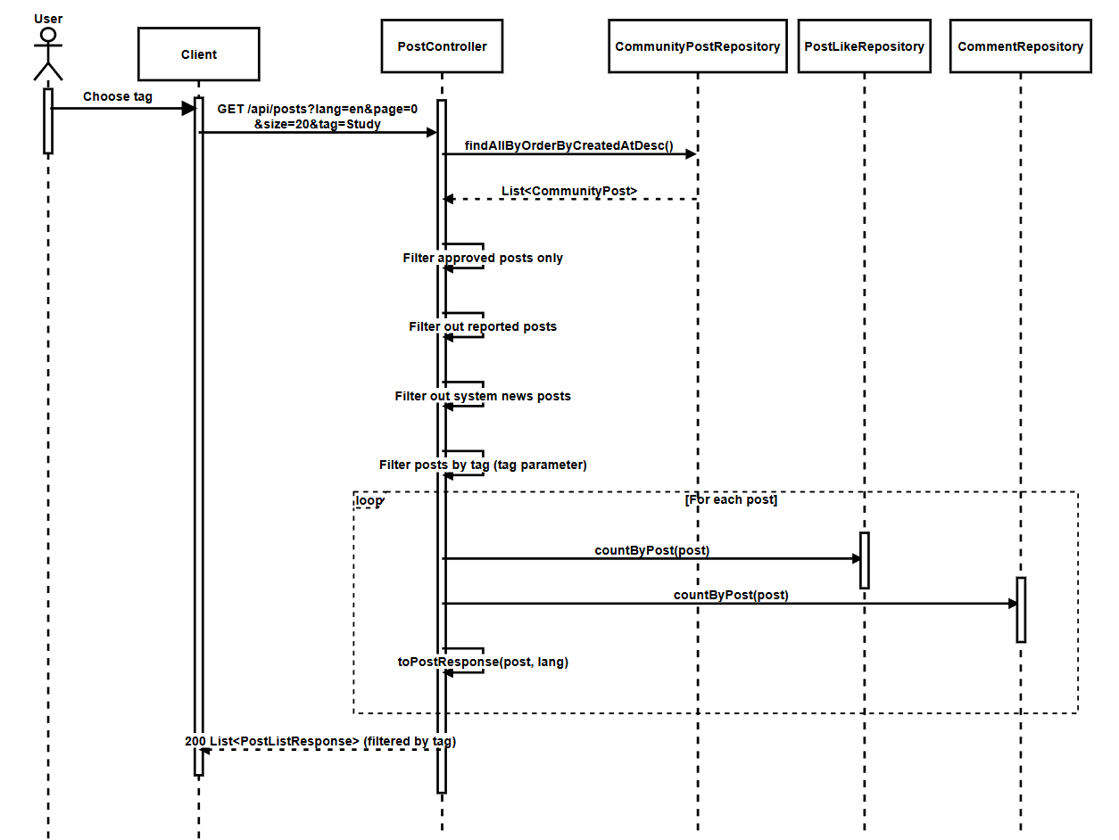
SD-11: View Post Details
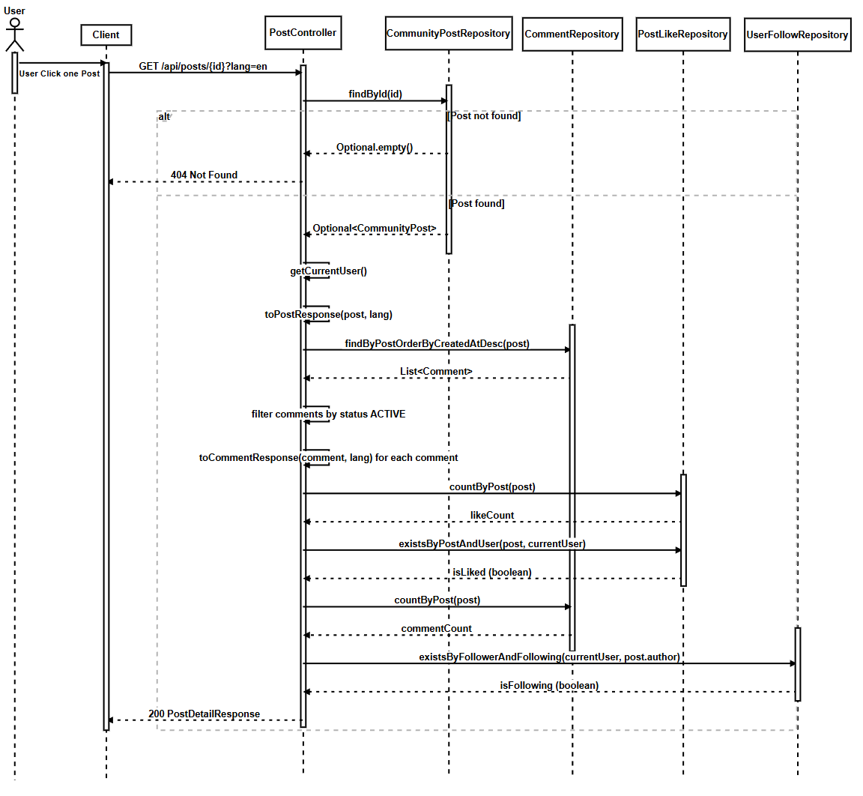
SD-12: Report Post/Comment

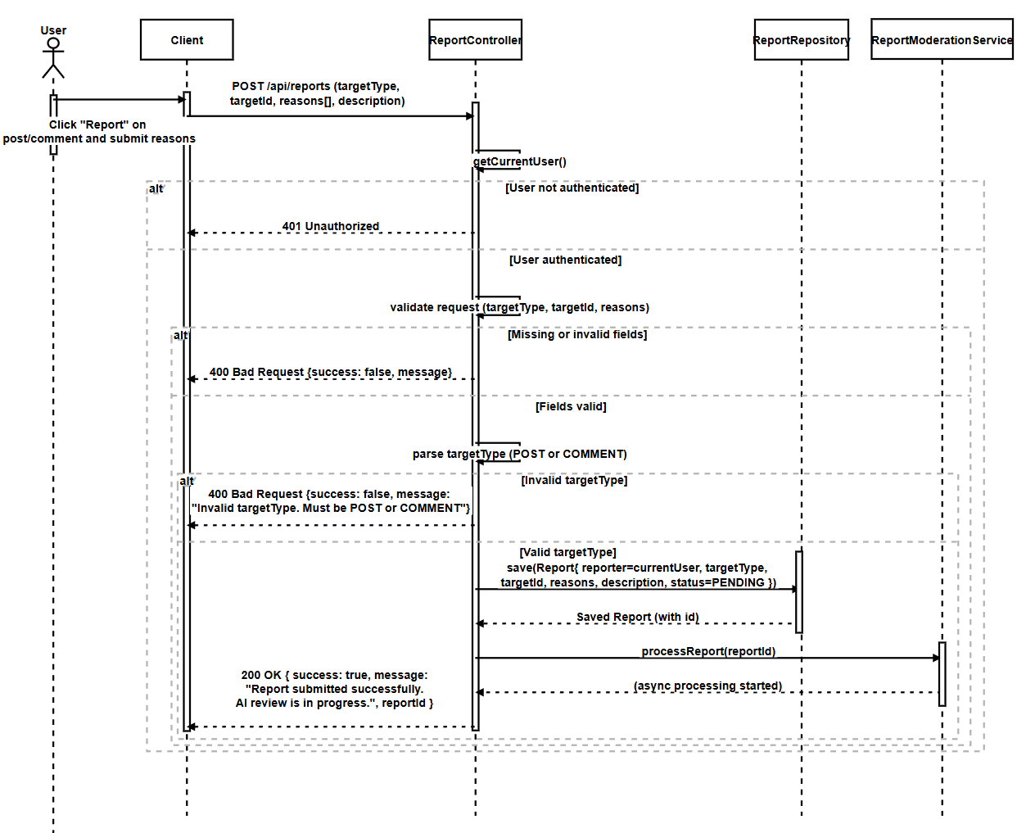
SD-13: Post Comment
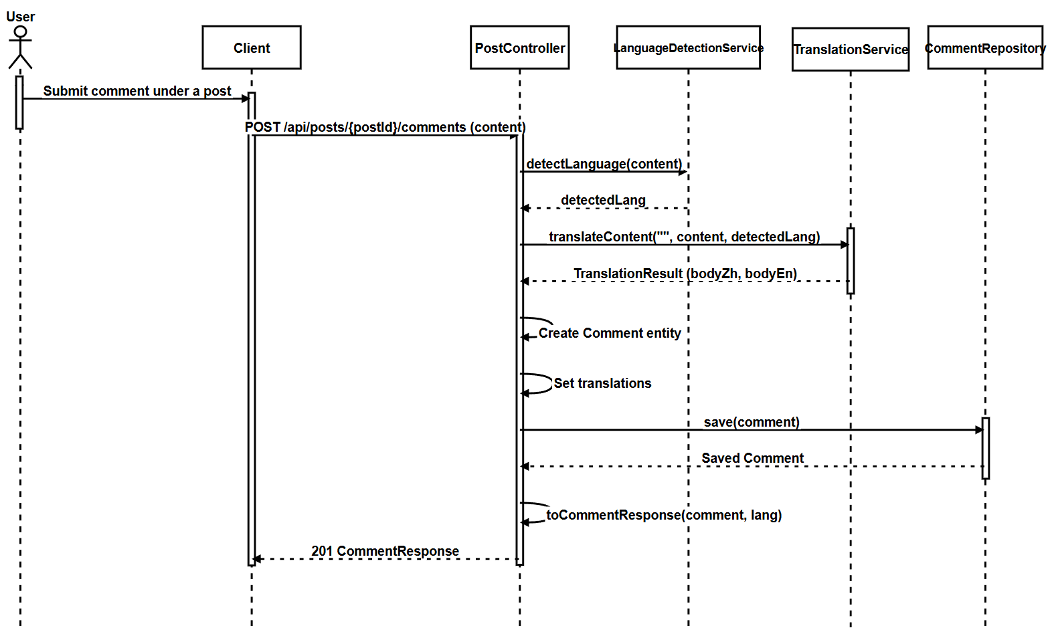
SD-14: Search Posts
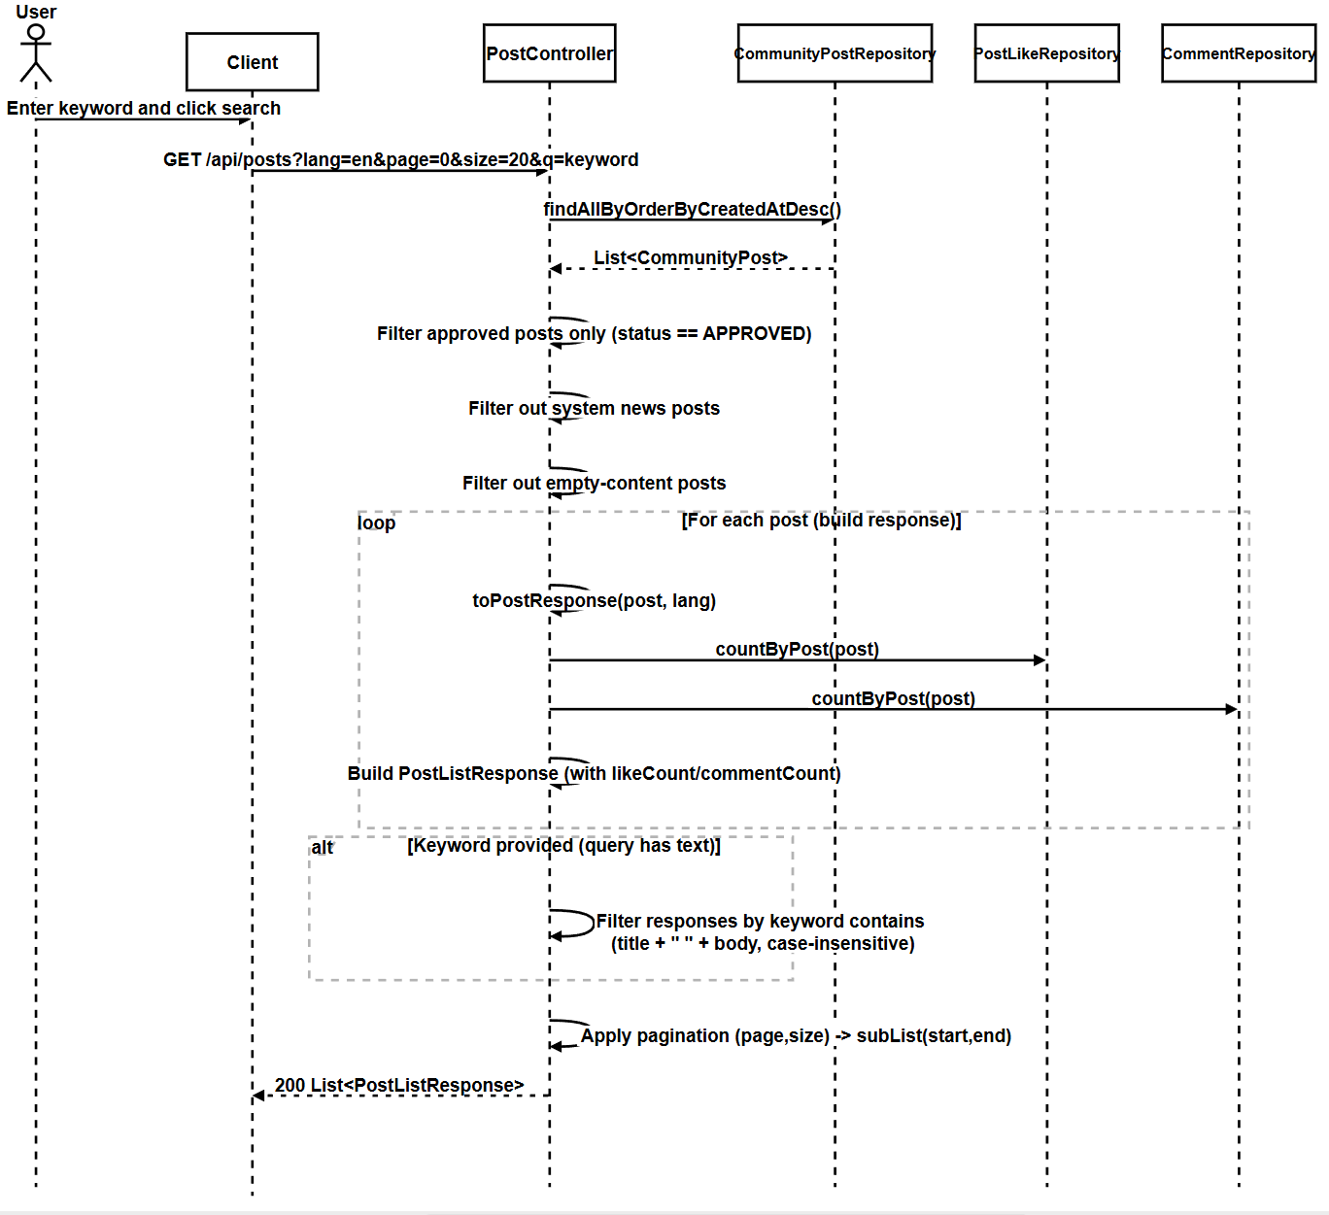

SD-15: AI Summary Comment
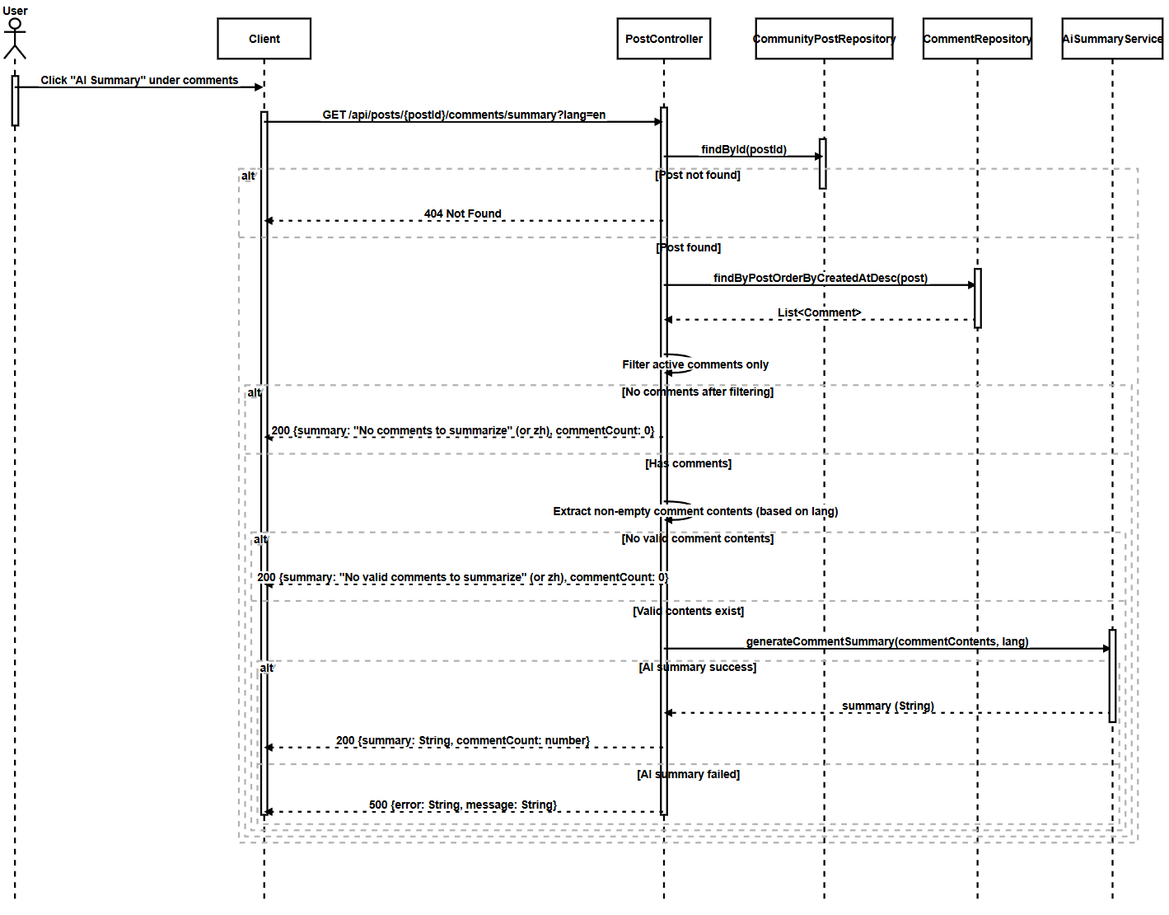
SD-16:Manage private messages with other users

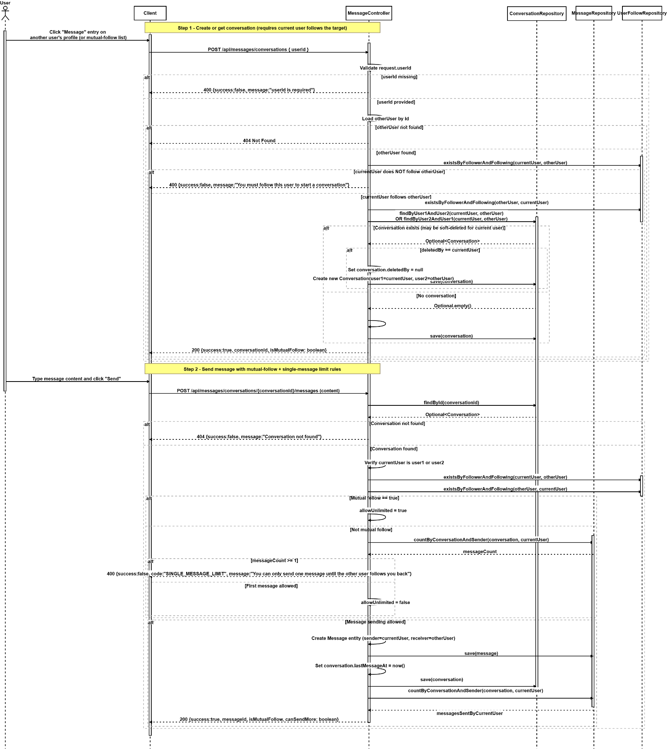
SD-17: Manage Message Status
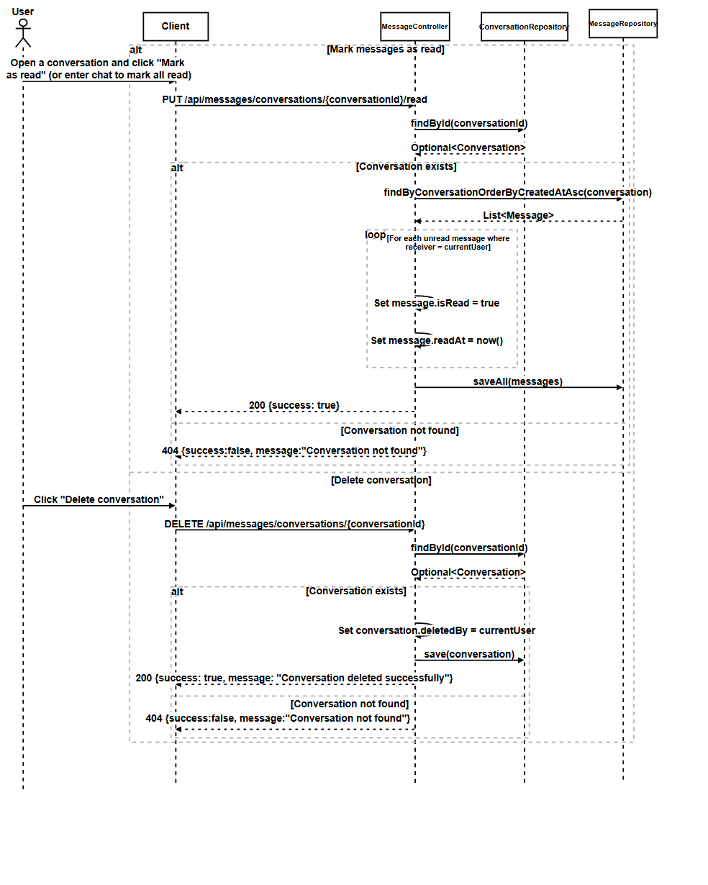

3.3 Feature 3

3.3.1 Class Diagram
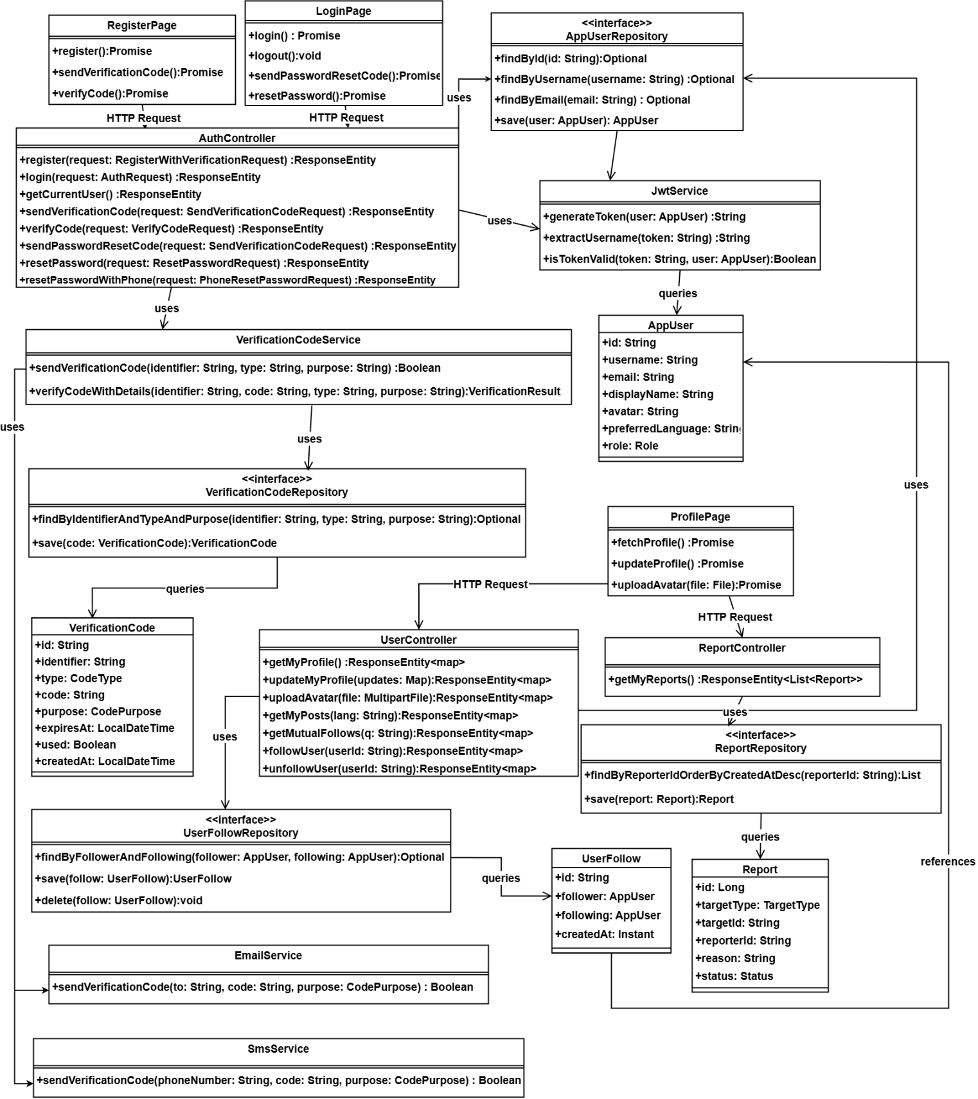

3.3.2 Class Diagram Description

3.3.2.1 View

3.3.2.1.1 RegisterPage
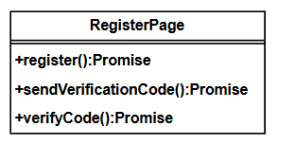

Methods:
ID | Name | Description | Parameter | Return Type
1 | register | Registers a new user account | None | Promise\<void>
2 | sendVerificationCode | Sends a verification code for registration | None | Promise\<void>
3 | verifyCode | Verifies the registration verification code | None | Promise\<void>

3.3.2.1.2 LoginPage
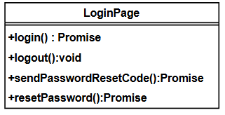
Methods:
ID | Name | Description | Parameters | Return Type
1 | login | Authenticates user and logs in | None | Promise<void>
2 | logout | Logs out the current user | None | void
3 | sendPasswordResetCode | Sends password reset verification code (email or phone) | None | Promise<void>
4 | resetPassword | Resets password using verification code | None | Promise<void>

3.3.2.1.3 ProfilePage
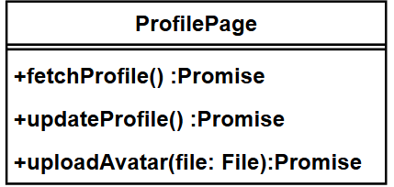

Methods:
ID | Name | Description | Parameters | Return Type
1 | fetchProfile | Fetches current user's profile information | None | Promise<void>
2 | updateProfile | Updates user's profile information | None | Promise<void>
3 | uploadAvatar | Uploads a new avatar image for the user | file: File | Promise<void>

3.3.2.2 Controller
3.3.2.2.1 Controller: `AuthController`
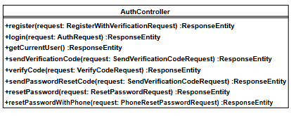
Methods:
ID | Name | Description | Parameters | Return Type
1 | register | Registers a new user account | request: RegisterWithVerificationRequest | ResponseEntity<AuthResponse>
2 | login | Authenticates user and returns JWT token | request: AuthRequest | ResponseEntity<AuthResponse>
3 | getCurrentUser | Retrieves current authenticated user information | None | ResponseEntity<UserDTO>
4 | sendVerificationCode | Sends verification code to email or phone | request: SendVerificationCodeRequest | ResponseEntity
5 | verifyCode | Verifies verification code | request: VerifyCodeRequest | ResponseEntity
6 | sendPasswordResetCode | Sends password reset verification code to email or phone | request: SendVerificationCodeRequest | ResponseEntity
7 | resetPassword | Resets password using email verification code | request: ResetPasswordRequest | ResponseEntity
8 | resetPasswordWithPhone | Resets password using phone (Firebase verified) | request: PhoneResetPasswordRequest | ResponseEntity

3.3.2.2.2 Controller: `UserController`
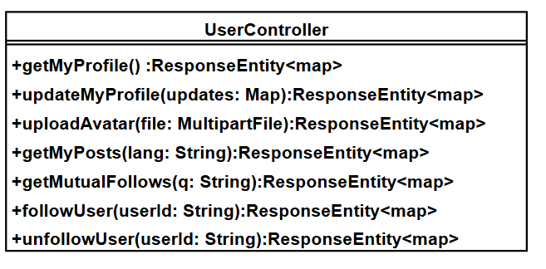

Methods:
ID | Name | Description | Parameters | Return Type
1 | getMyProfile | Retrieves current user's profile information | None | ResponseEntity<Map>
2 | updateMyProfile | Updates current user's profile | updates: Map | ResponseEntity<Map>
3 | uploadAvatar | Uploads avatar image for current user | file: MultipartFile | ResponseEntity<Map>
4 | getMyPosts | Retrieves current user's posts | lang: String | ResponseEntity<Map>
5 | getMutualFollows | Retrieves mutual follows list for current user | q: String | ResponseEntity<Map>
6 | followUser | Follows a user | userId: String | ResponseEntity<Map>
7 | unfollowUser | Unfollows a user | userId: String | ResponseEntity<Map>

3.3.2.2.3 Controller: `ReportController`
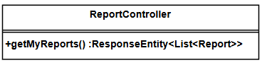
Methods:
ID | Name | Description | Parameter | Return Type
1 | getMyReports | Retrieves all reports submitted by the current user | None | `ResponseEntity<List<Report>>`

3.3.2.3 Repository

3.3.2.3.1 Repository: `AppUserRepository`
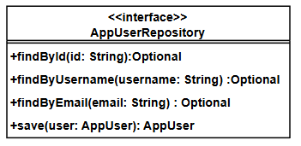
Methods:
ID | Name | Description | Parameters | Return Type
1 | findById | Finds a user by ID | id: String | Optional<AppUser>
2 | findByUsername | Finds a user by username | username: String | Optional<AppUser>
3 | findByEmail | Finds a user by email | email: String | Optional<AppUser>
4 | save | Saves a user entity | user: AppUser | AppUser

3.3.2.3.2 Repository: `UserFollowRepository`
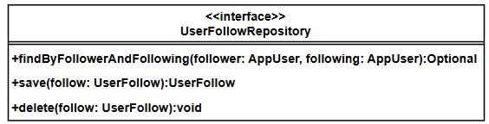

Methods:
ID | Name | Description | Parameters | Return Type
1 | findByFollowerAndFollowing | Finds a follow relationship by follower and following users | follower: AppUser, following: AppUser | Optional<UserFollow>
2 | save | Saves a follow relationship entity | follow: UserFollow | UserFollow
3 | delete | Deletes a follow relationship | follow: UserFollow | void

3.3.2.3.3 Repository: `ReportRepository`
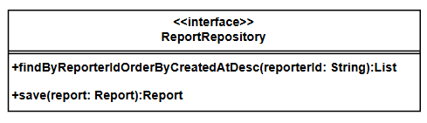
Methods:
ID | Name | Description | Parameter | Return Type
1 | findByReporterIdOrderByCreatedAtDesc | Finds all reports submitted by a specific reporter, ordered by creation time descending | `reporterId: String` | List\<Report>
2 | save | Saves a report entity | `report: Report` | Report

3.3.2.3.4 Repository: `VerificationCodeRepository`
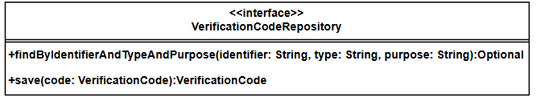
Methods:
ID | Name | Description | Parameter | Return Type
1 | findByIdentifierAndTypeAndPurpose | Finds a verification code by identifier, type, and purpose | `identifier: String`, `type: String`, `purpose: String` | Optional\<VerificationCode>
2 | save | Saves a verification code entity | `code: VerificationCode` | VerificationCode

3.3.2.4 Model

3.3.2.4.1 Model: `AppUser`
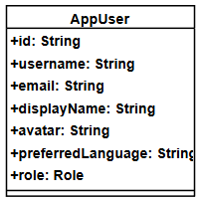

Attributes:
ID | Name | Type | Description
1 | id | String | Primary key ID
2 | username | String | Username
3 | email | String | Email address
4 | displayName | String | Display name
5 | avatar | String | Avatar image URL
6 | preferredLanguage | String | Preferred interface language
7 | role | Role | User role

3.3.2.4.2 Model: `UserFollow`
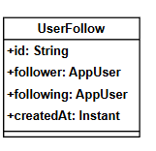
Attributes:
ID | Name | Type | Description
1 | id | String | Primary key ID
2 | follower | AppUser | User who is following
3 | following | AppUser | User being followed
4 | createdAt | Instant | When the follow relationship was created

3.3.2.4.3 Model: `Report`
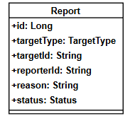
Attributes:
ID | Name | Type | Description
1 | id | Long | Primary key ID
2 | targetType | TargetType | Type of target being reported
3 | targetId | String | ID of the target being reported
4 | reporterId | String | ID of the user who submitted the report
5 | reason | String | Reason for the report
6 | status | Status | Status of the report

3.3.2.4.4 Model: `VerificationCode`
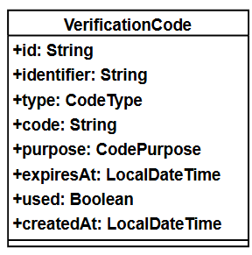

Attributes:
ID | Name | Type | Description
1 | id | String | Primary key ID
2 | identifier | String | Email address or phone number
3 | type | CodeType | Verification code type (EMAIL or SMS)
4 | code | String | Verification code (6 digits)
5 | purpose | CodePurpose | Code purpose (REGISTER or RESET_PASSWORD)
6 | expiresAt | LocalDateTime | Expiration time
7 | used | Boolean | Whether the code has been used
8 | createdAt | LocalDateTime | Creation time

3.3.2.5 Service

3.3.2.5.1 Service: `JwtService`
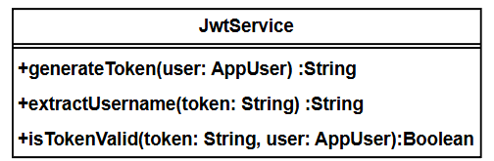
Methods:
ID | Name | Description | Parameters | Return Type
1 | generateToken | Generates a JWT token for the given user | user: AppUser | String
2 | extractUsername | Extracts username from JWT token | token: String | String
3 | isTokenValid | Validates if the JWT token is valid for the given user | token: String, user: AppUser | Boolean

3.3.2.5.2 Service: `VerificationCodeService`
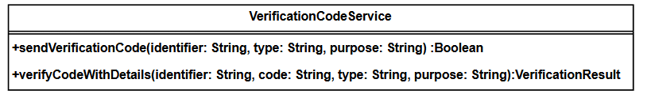

Methods:
ID | Name | Description | Parameter | Return Type
1 | sendVerificationCode | Sends a verification code to the specified identifier | `identifier: String`, `type: String`, `purpose: String` | Boolean
2 | verifyCodeWithDetails | Verifies a verification code with detailed result | `identifier: String`, `code: String`, `type: String`, `purpose: String` | VerificationResult

3.3.2.5.3 Service: `EmailService`
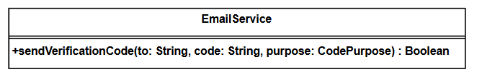
Methods:
ID | Name | Description | Parameter | Return Type
1 | sendVerificationCode | Sends a verification code email to the specified email address | `to: String`, `code: String`, `purpose: CodePurpose` | Boolean

3.3.2.5.4 Service: SMSService
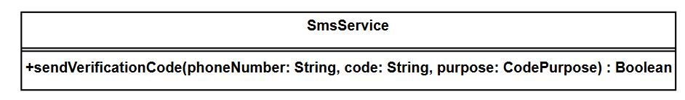
Methods:
ID | Name | Description | Parameter | Return Type
1 | sendVerificationCode | Sends a verification code SMS to the specified phone number | `phoneNumber: String`, `code: String`, `purpose: CodePurpose` | Boolean

3.3.3 Sequence Diagram
SD-18:View the Friends/Followers list
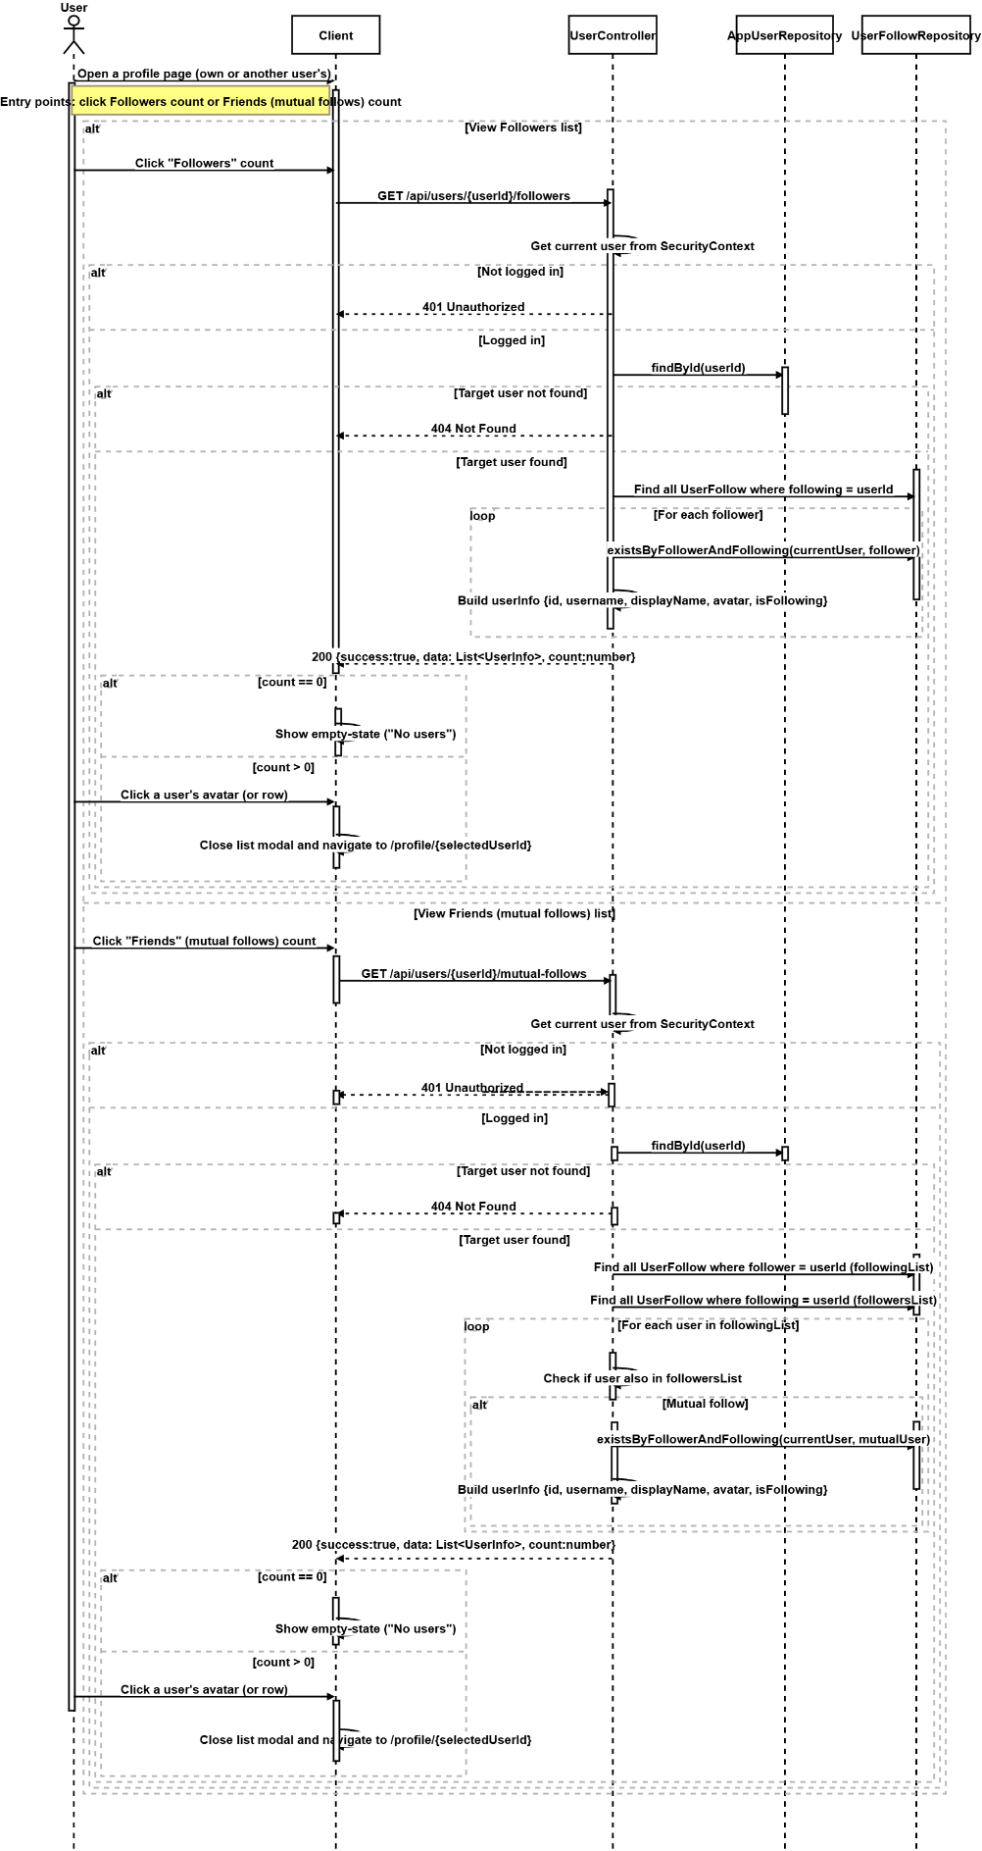
SD-19: Register Account (Phone)
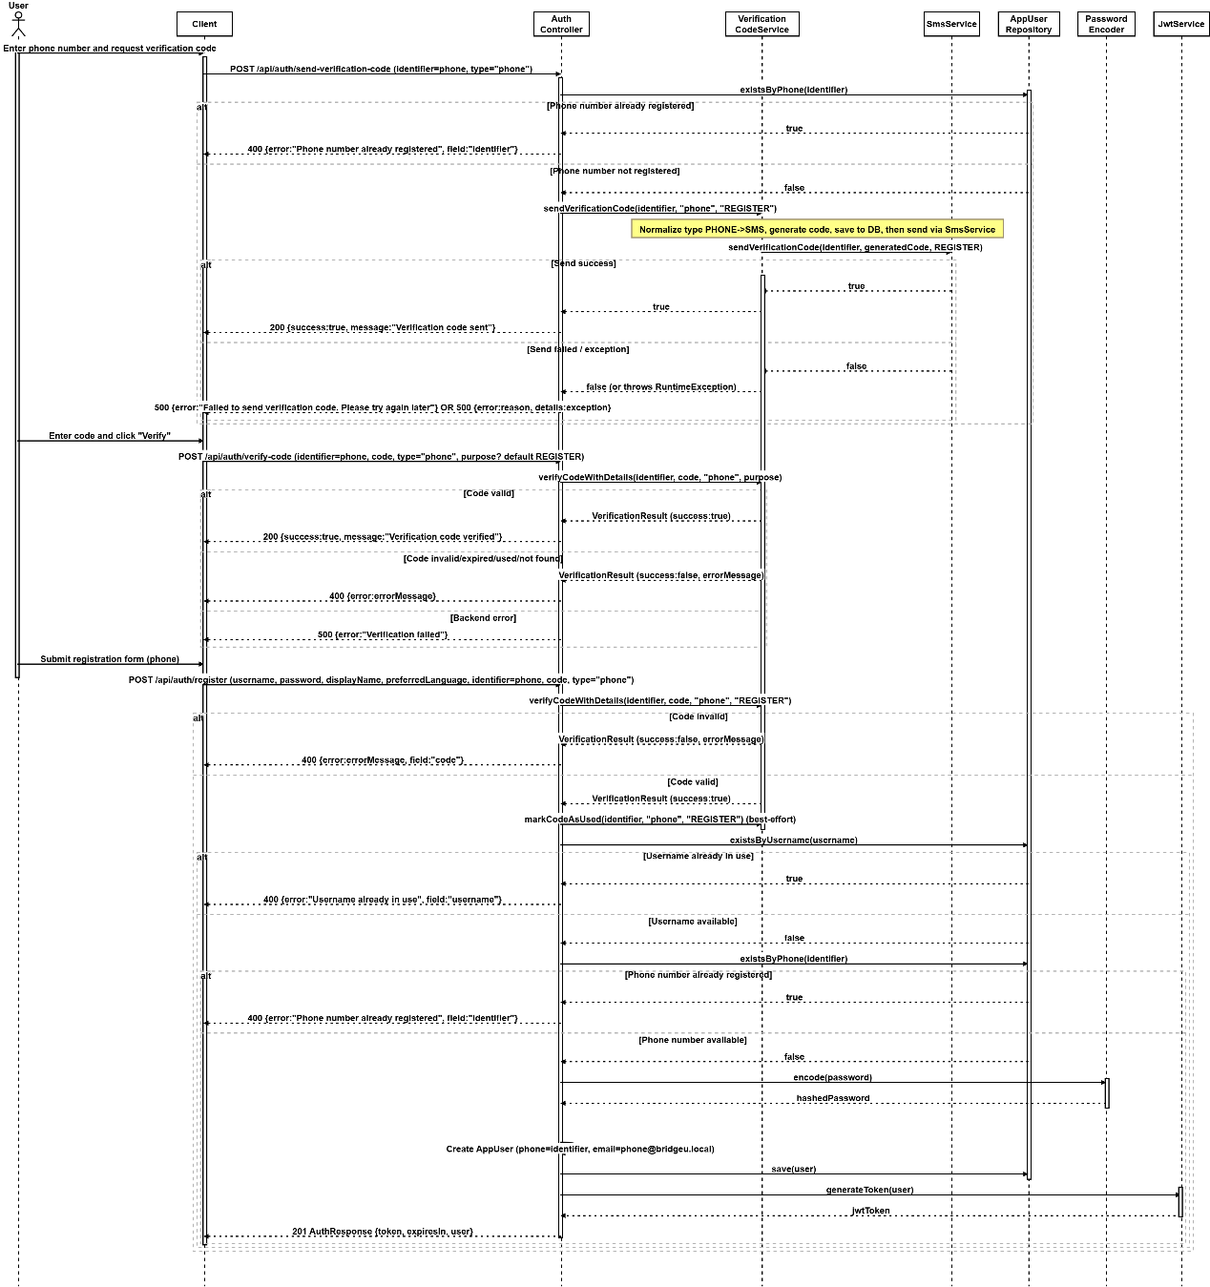

SD-20: Register Account (Email)
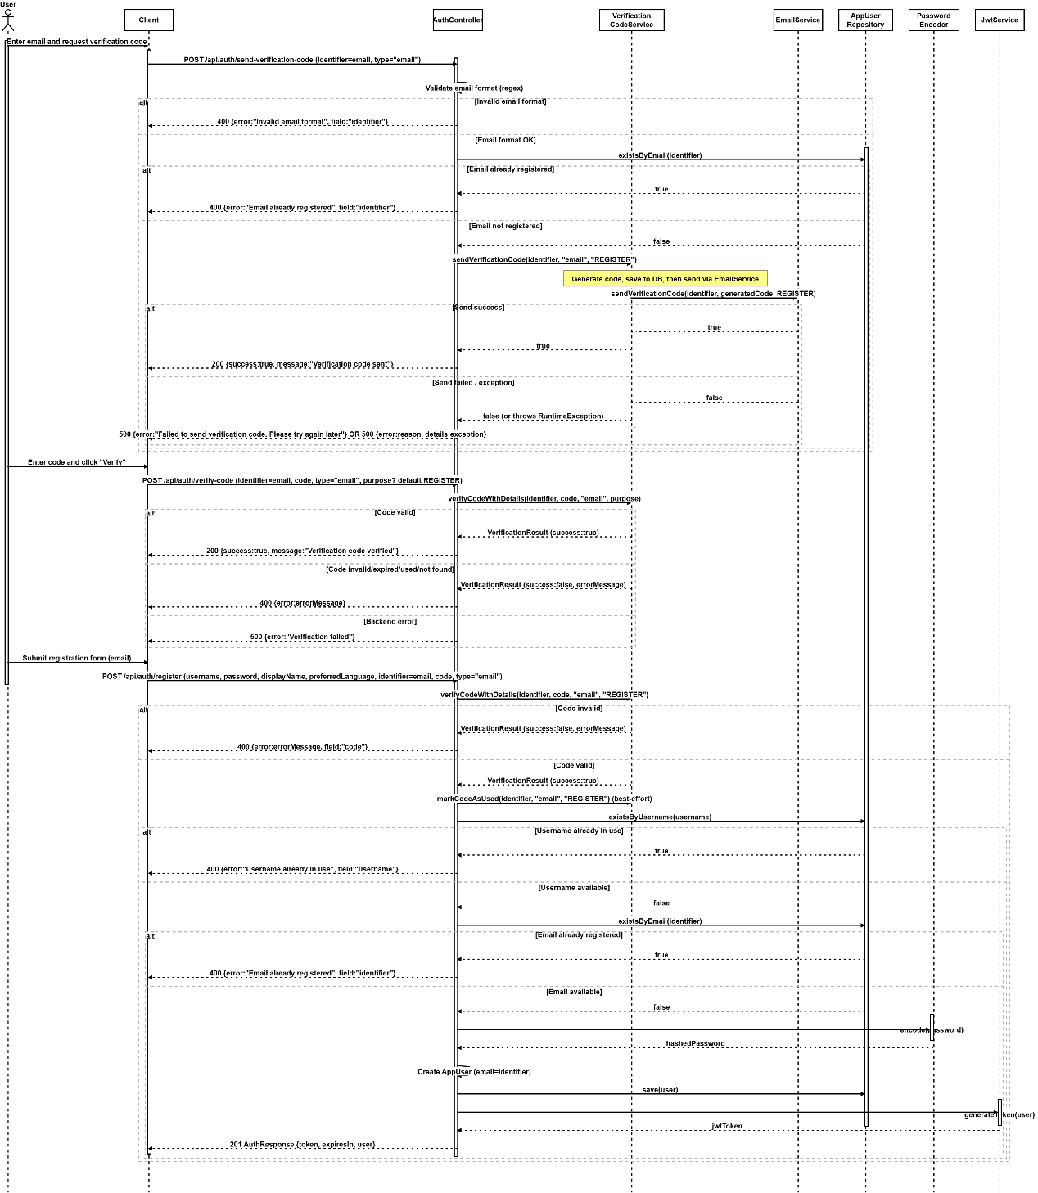

SD-21: Log In
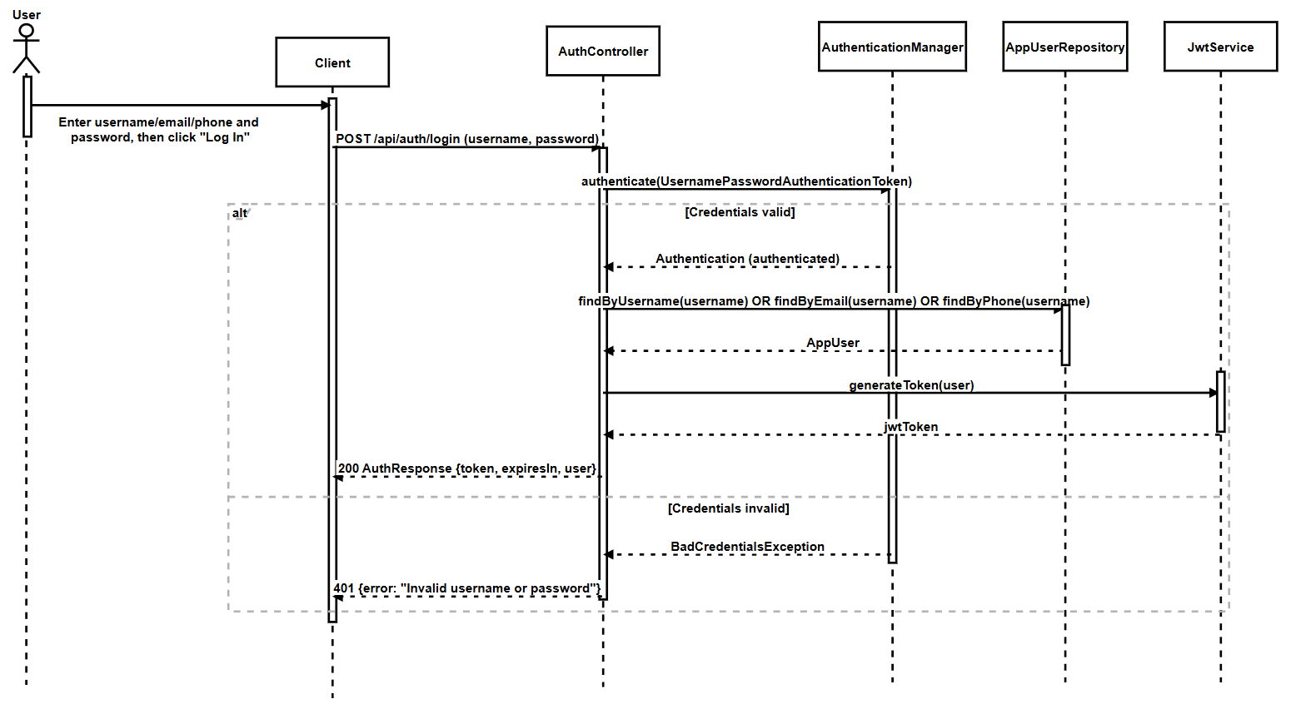
SD-22:Log Out
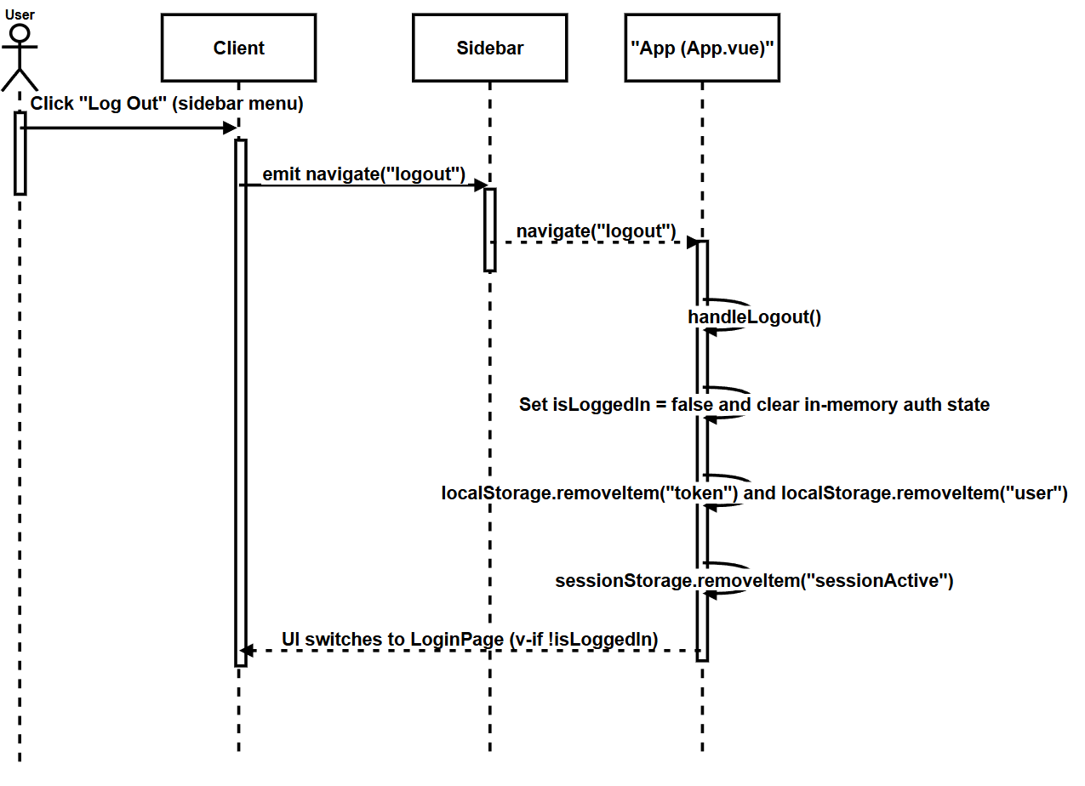

SD-23: Edit Profile
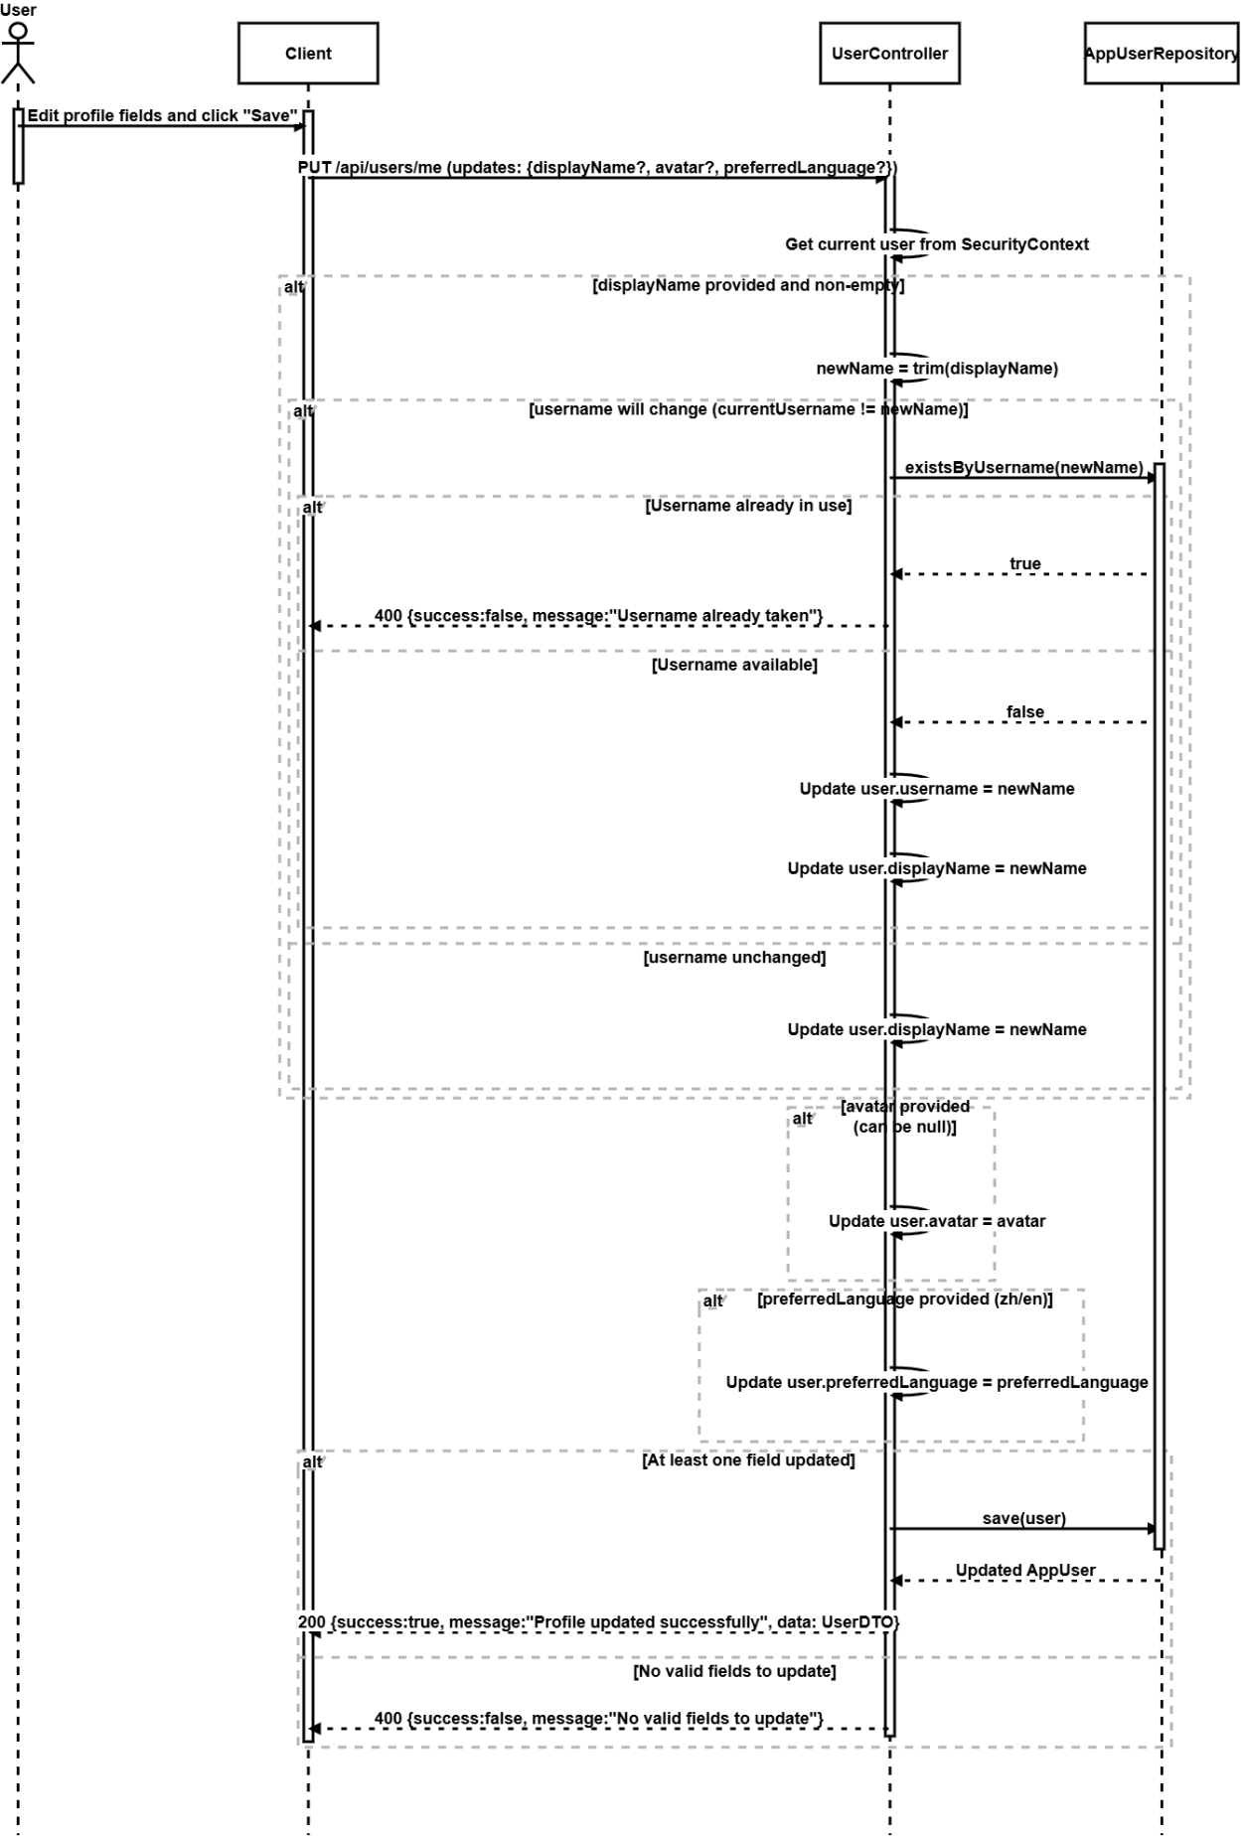
SD-24: View My Community Posts
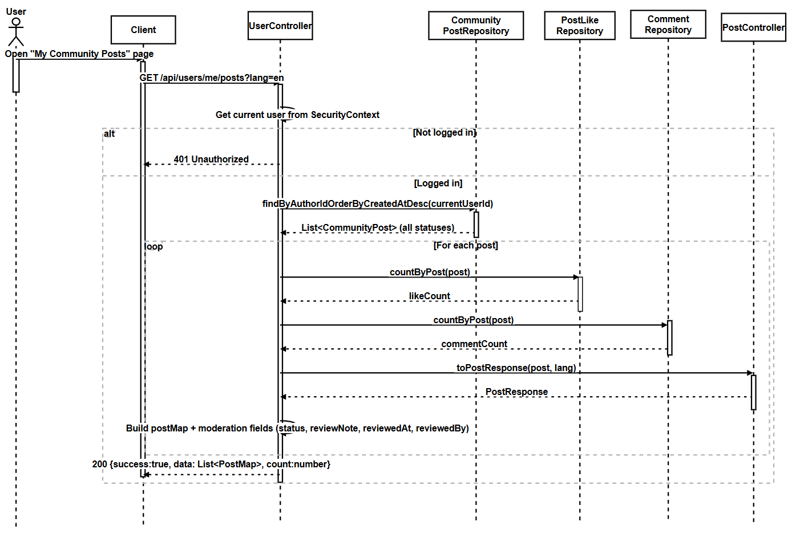
SD-25: View My Reports
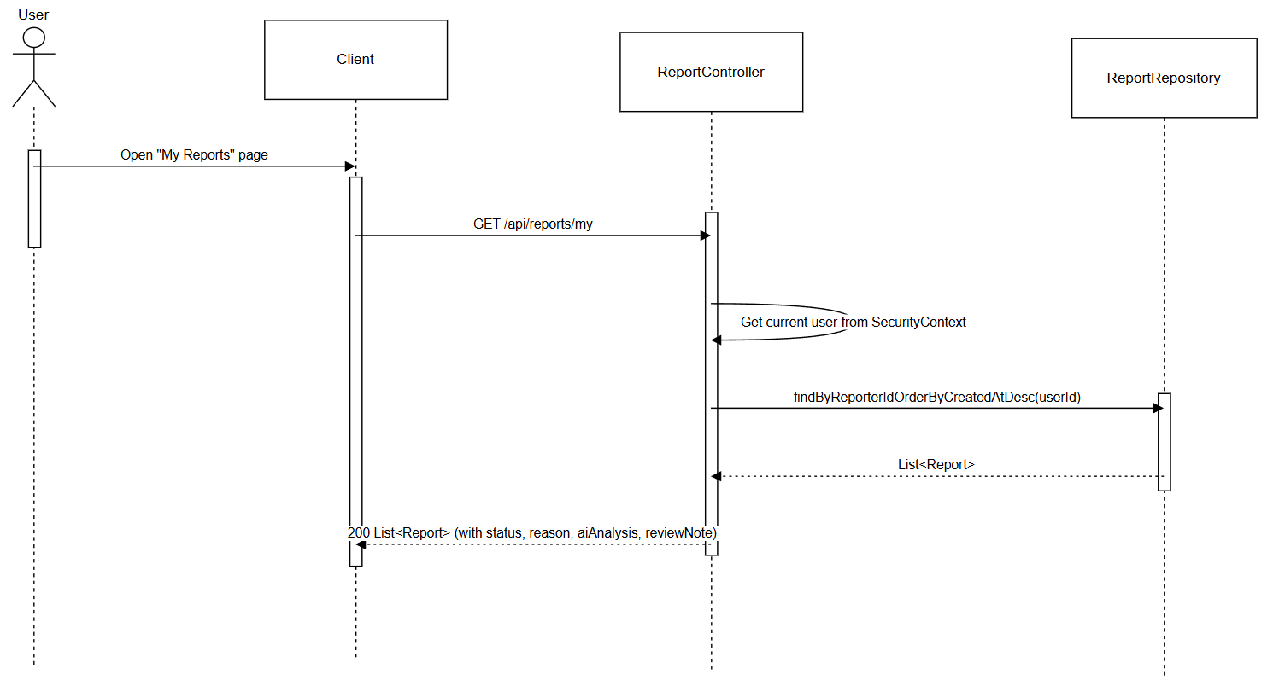
SD-26: SMS-based Password Reset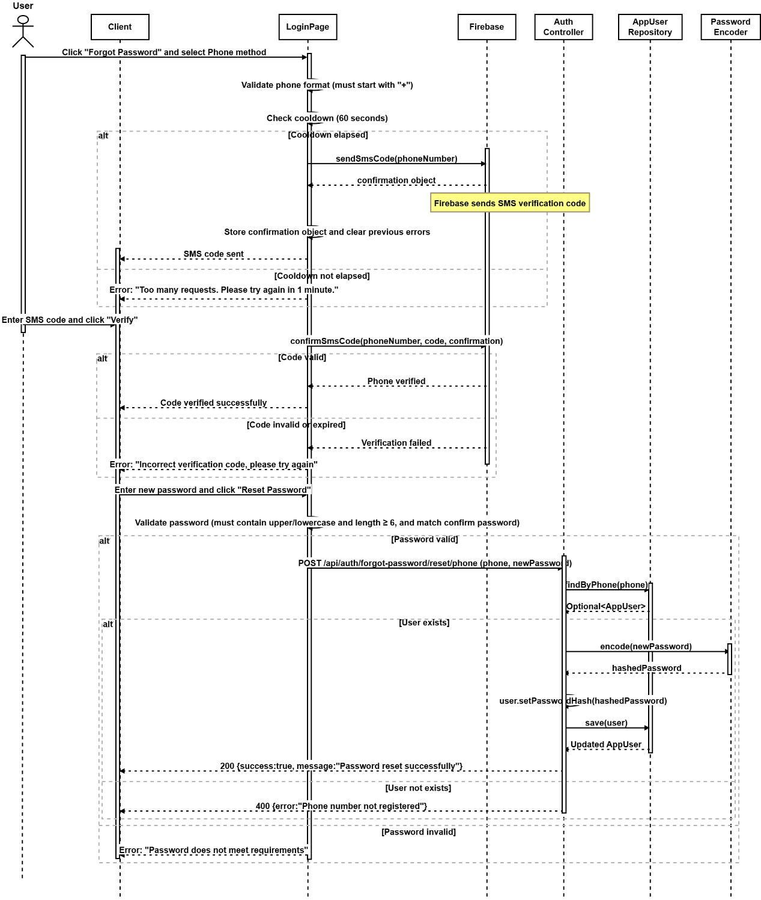

SD-27: Email-based Password Reset
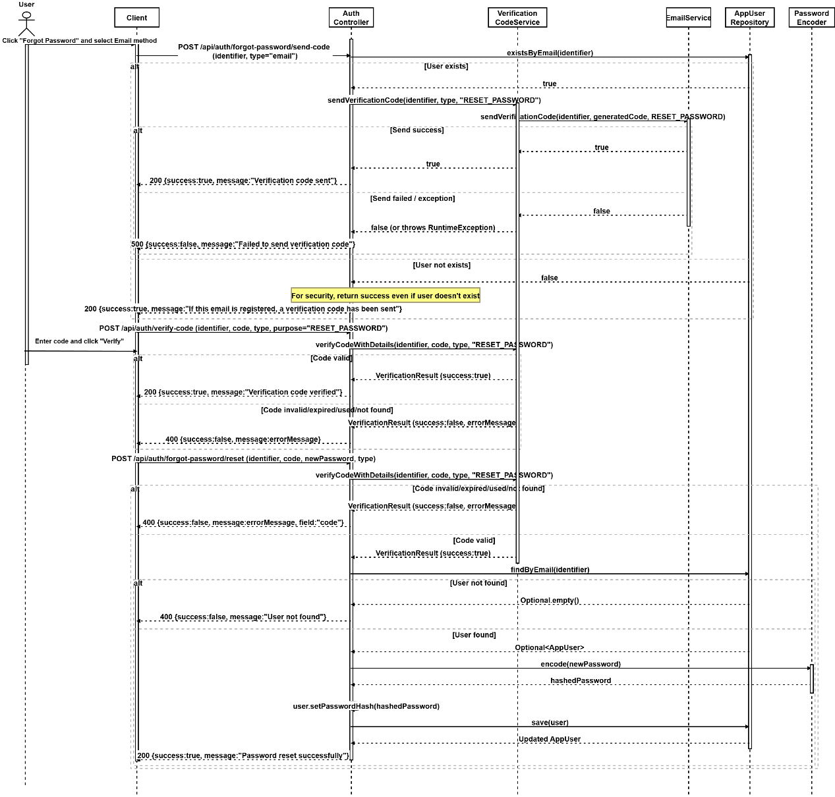

Chapter 4 UI Design
UI-01 Daily Briefing Page
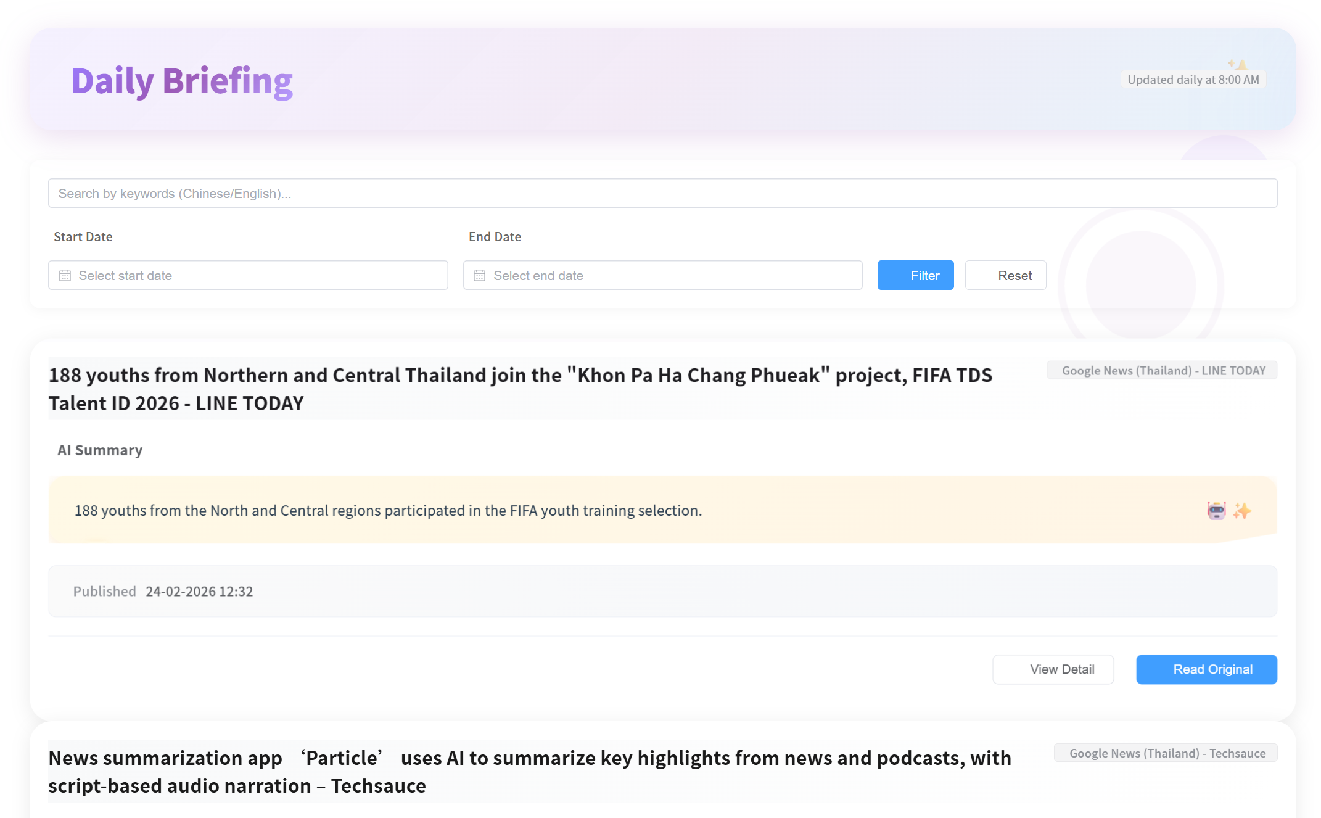
UI-01-01 Invalid date filtering
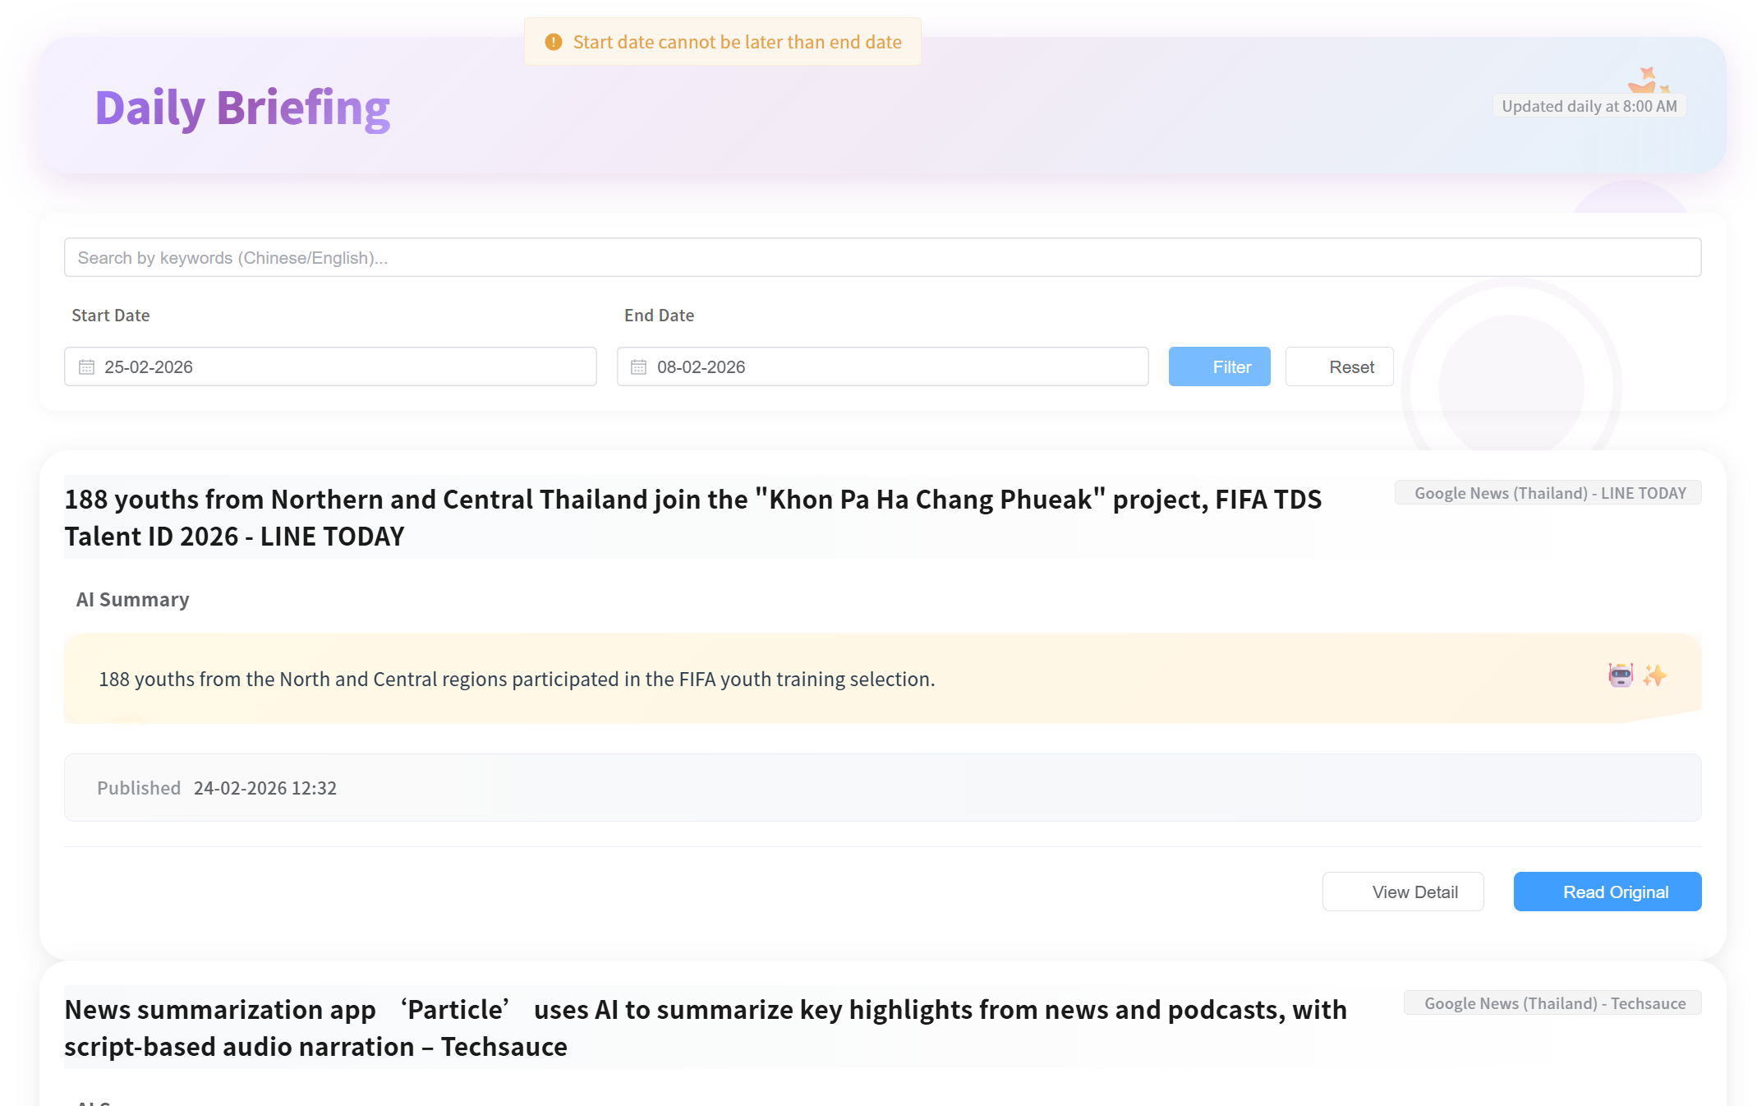
UI-01-02 Select the page number
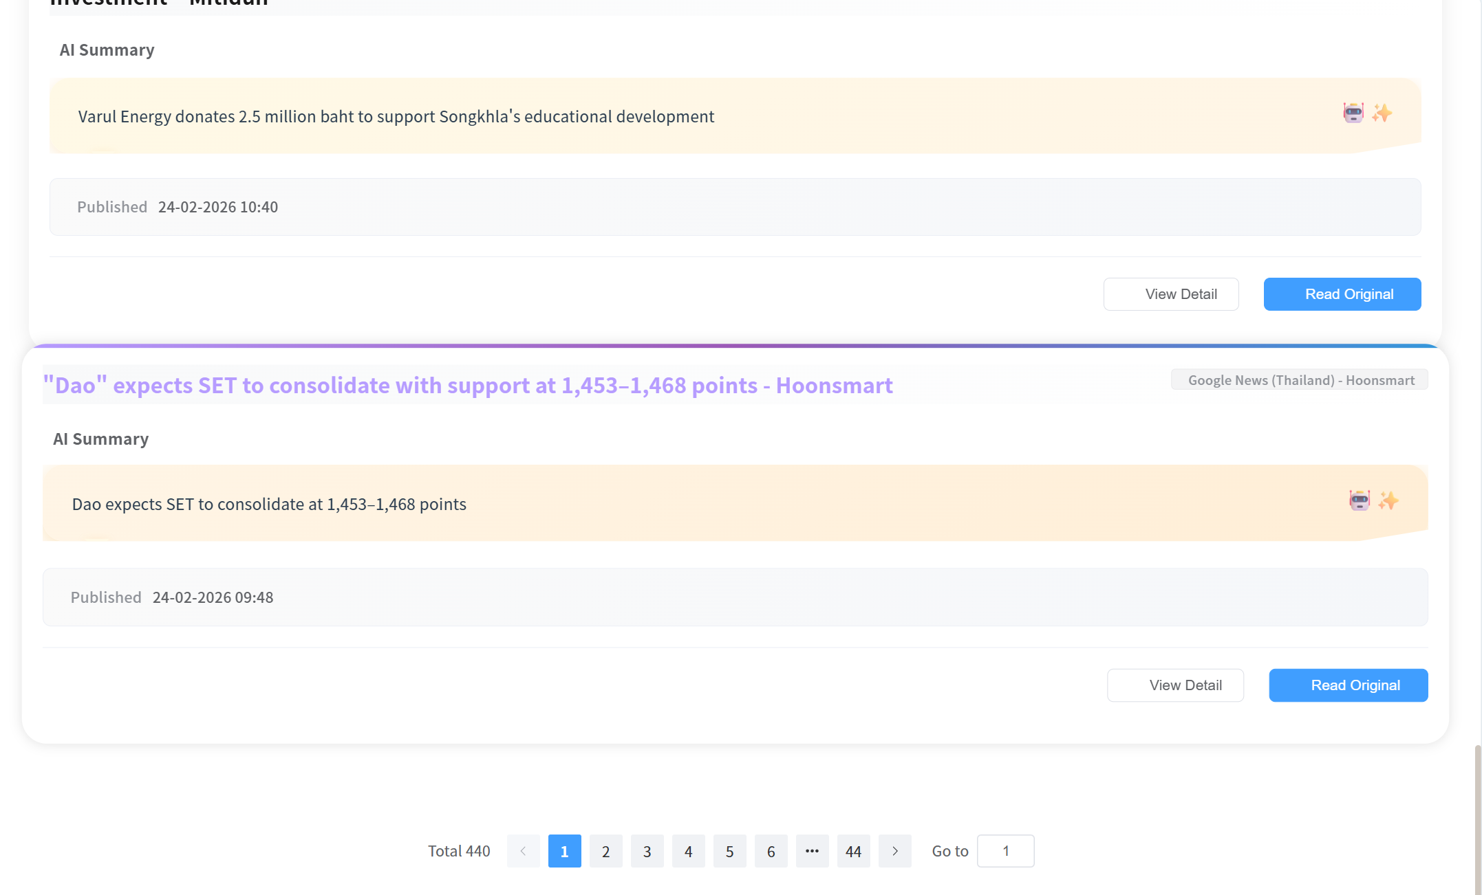
UI-02: Daily Briefing Page
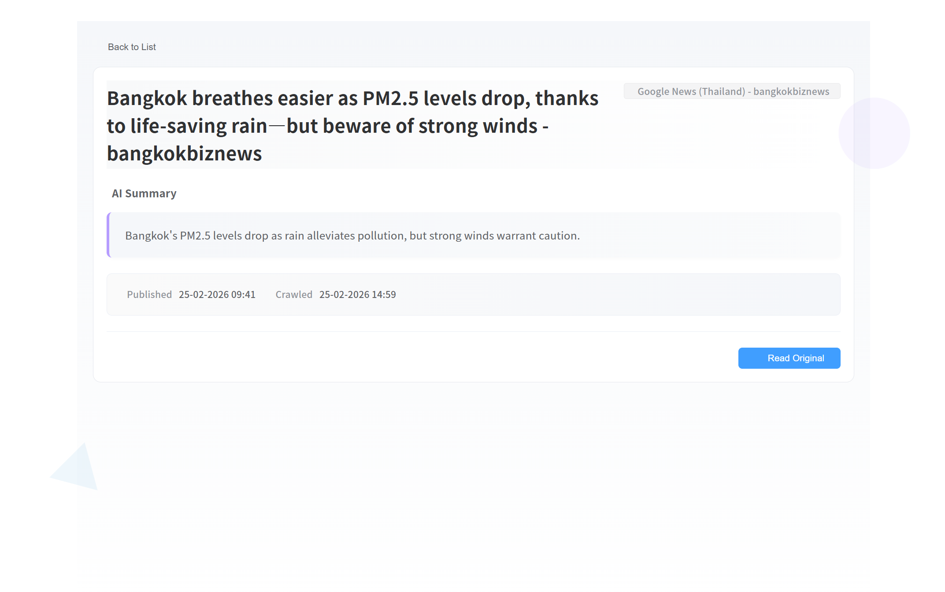
UI-03:Community Page
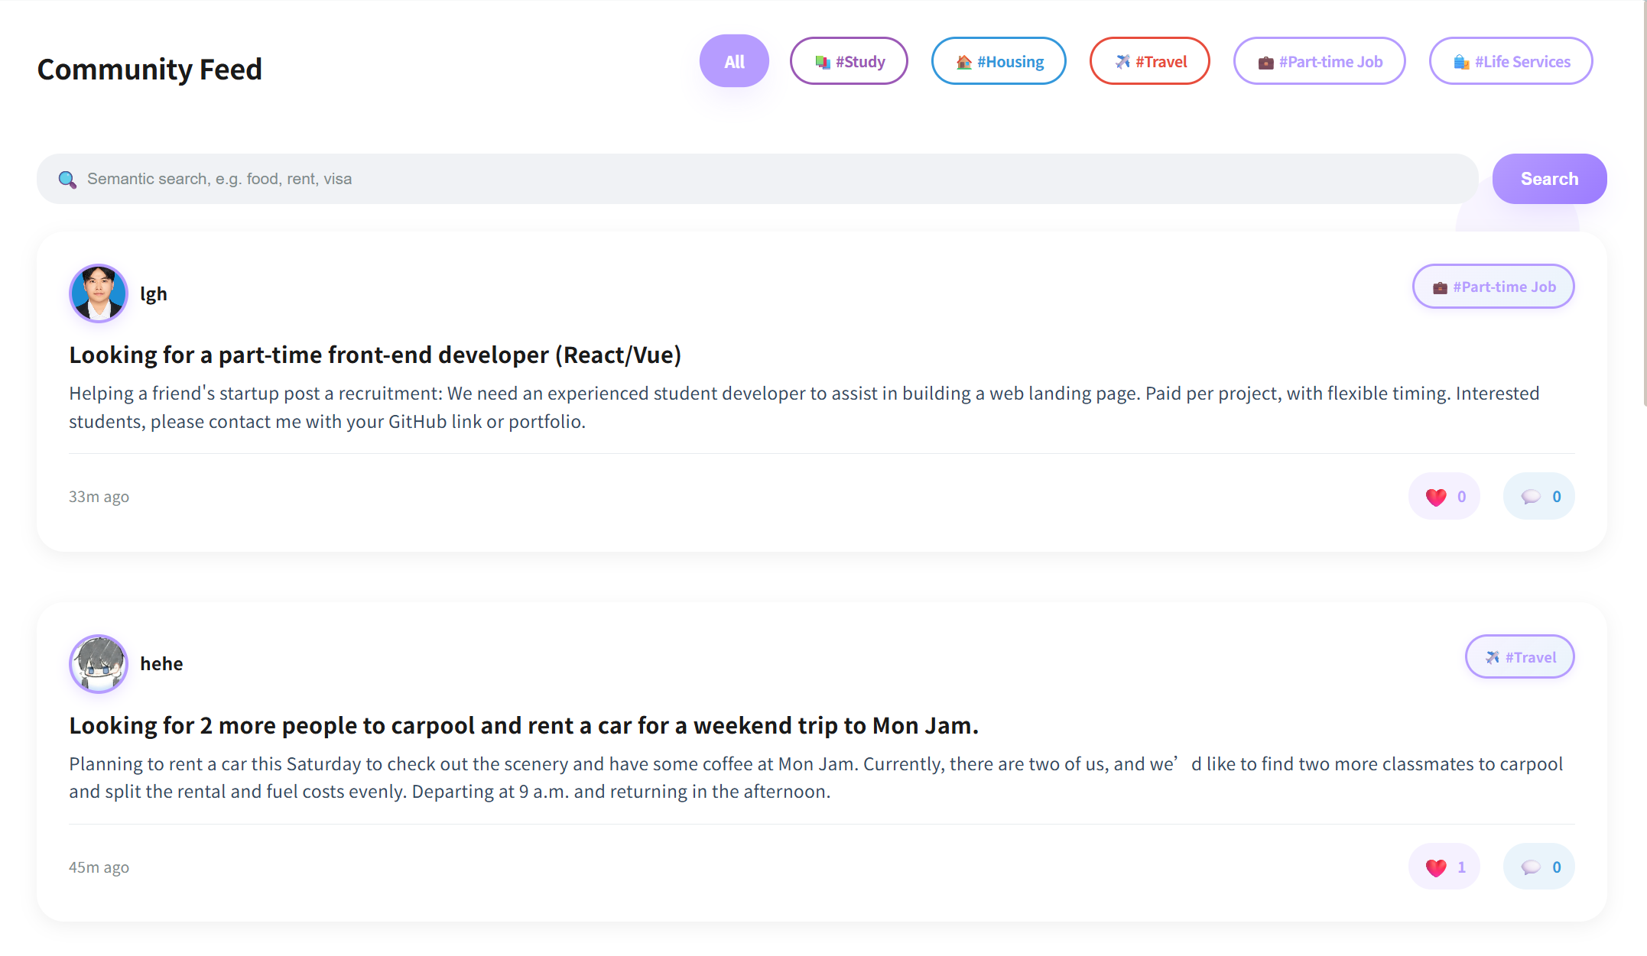
UI-03-01:Search post
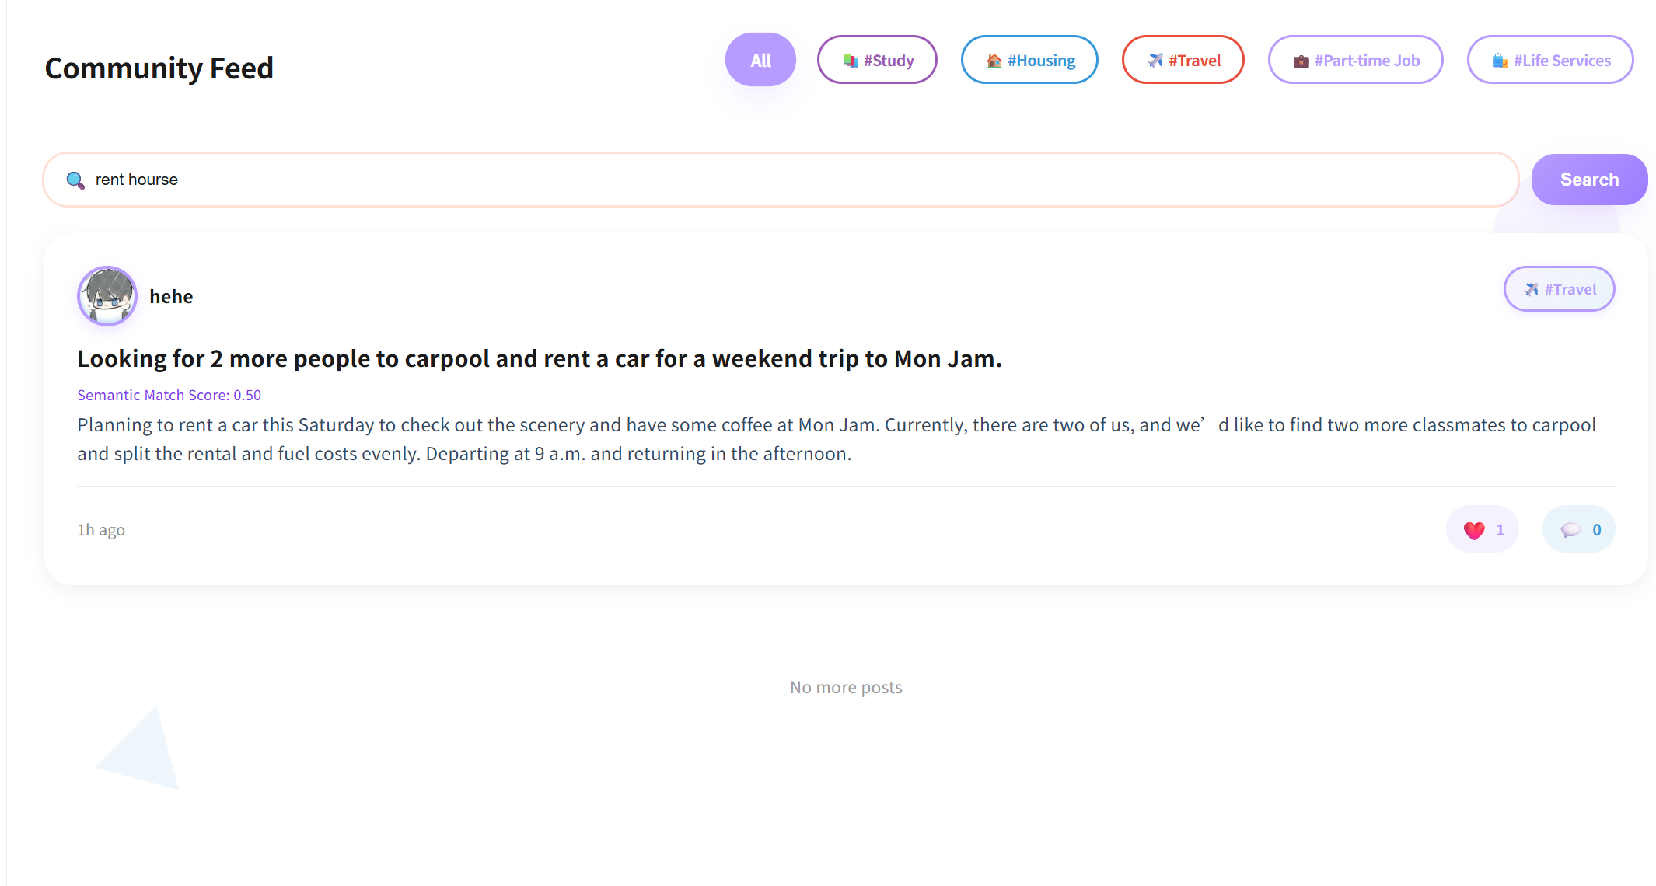

UI-03-02:Filter post by tag
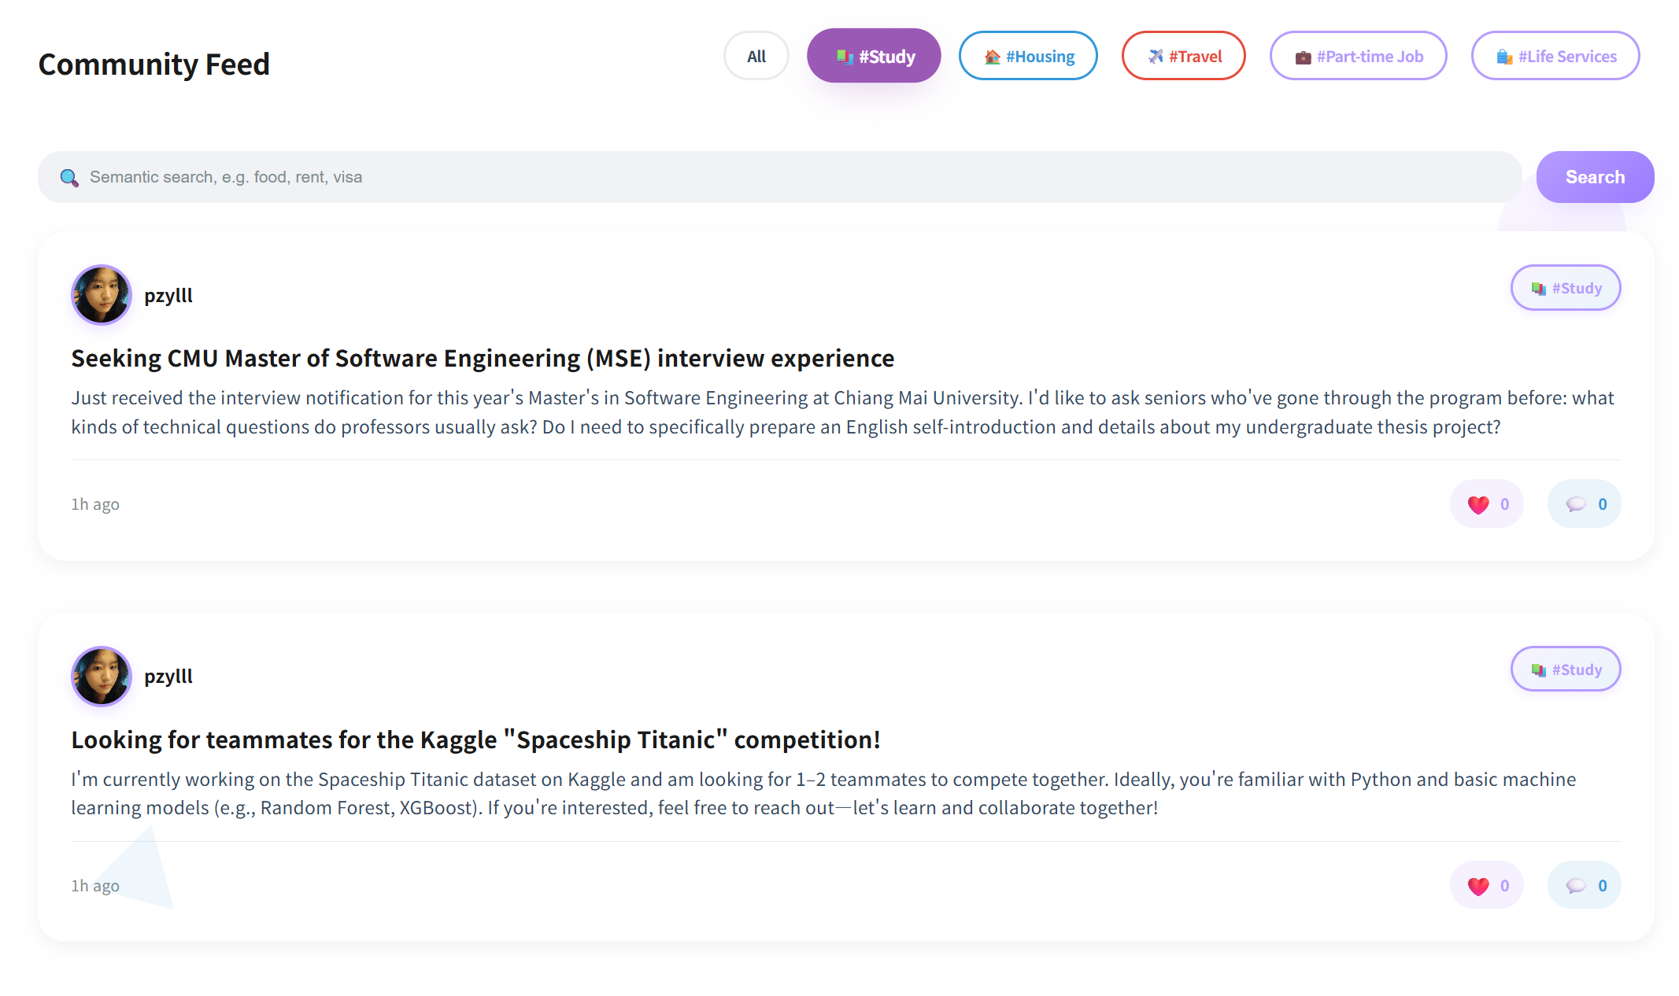
UI-04:Post detail page
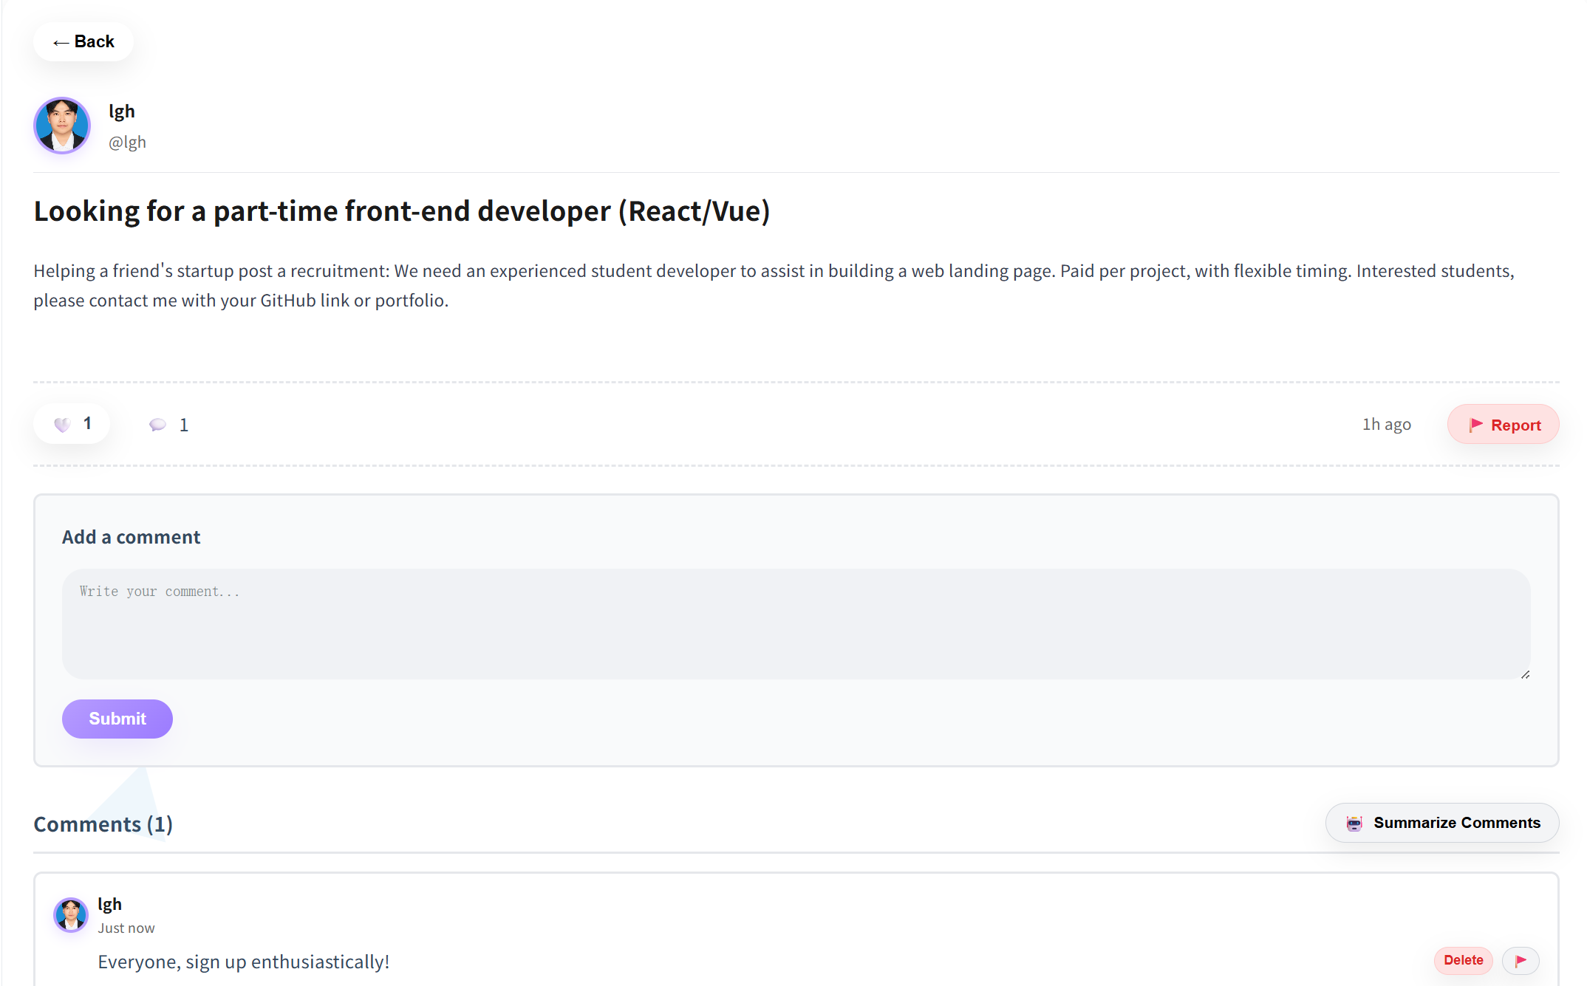

UI-04—01:Other user’s profile page
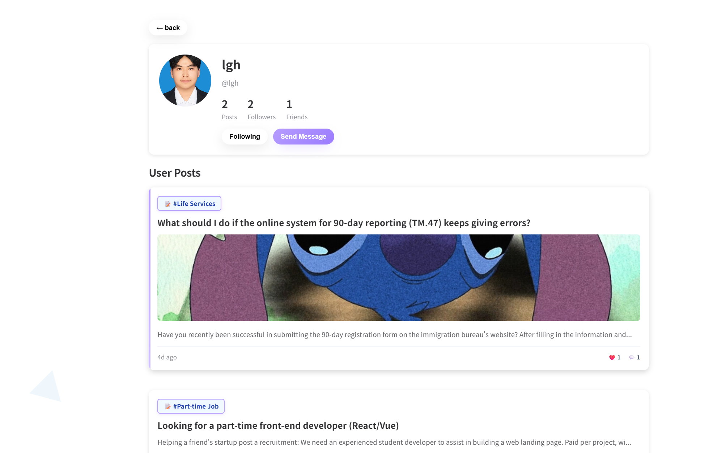
UI-05: Create Pubilc Post Page
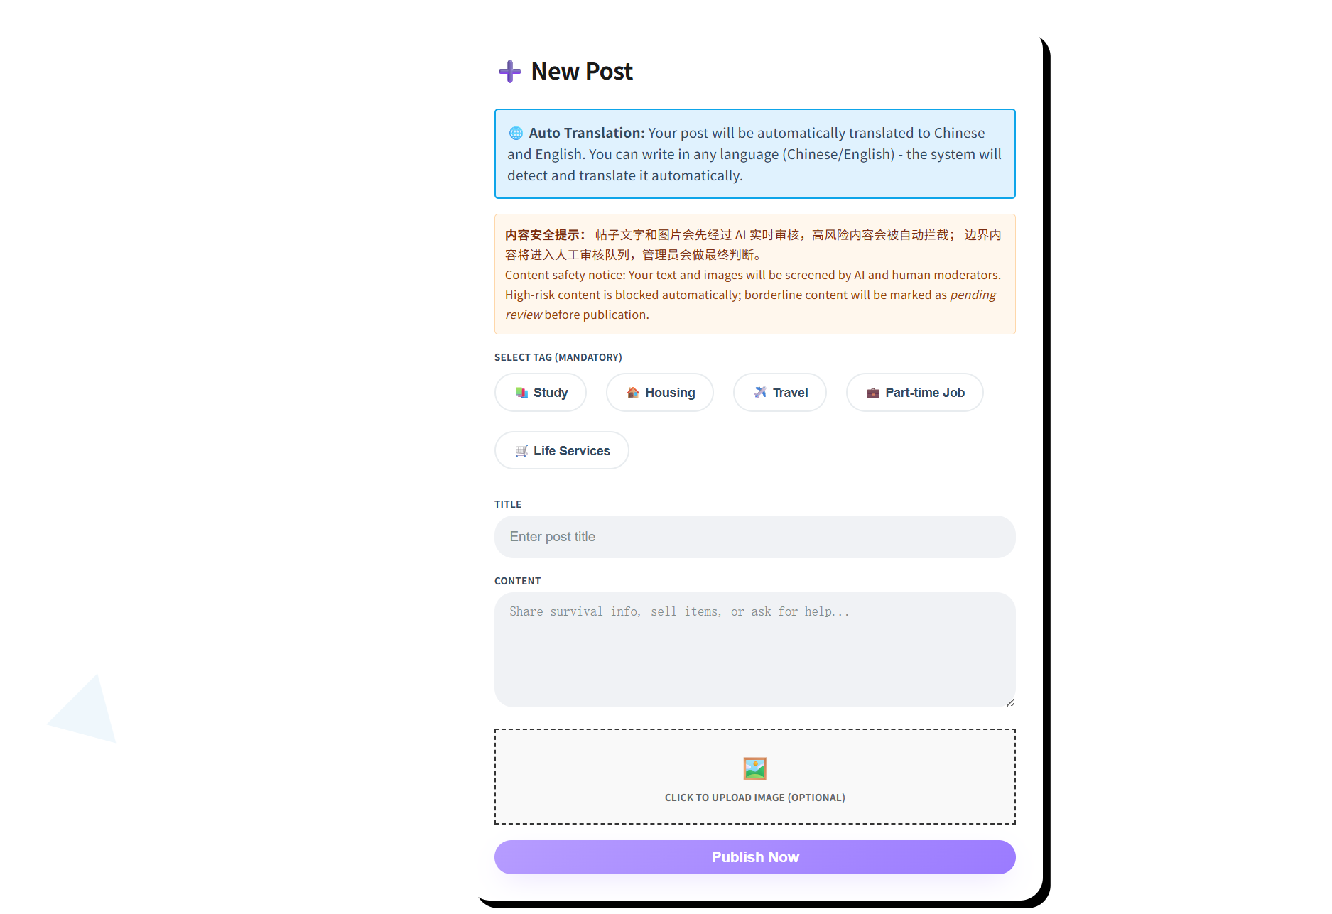
UI-05-01:Creat Pubilc Post
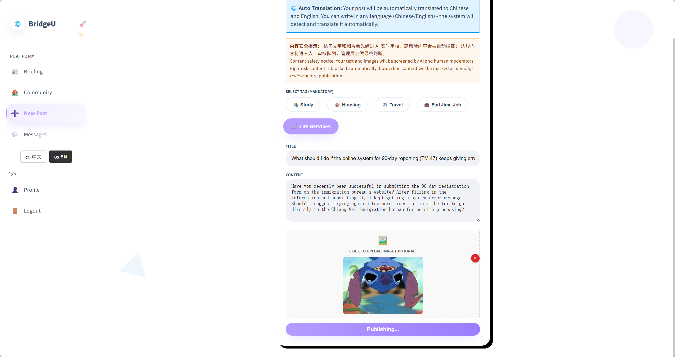
UI-06: Private Message Page
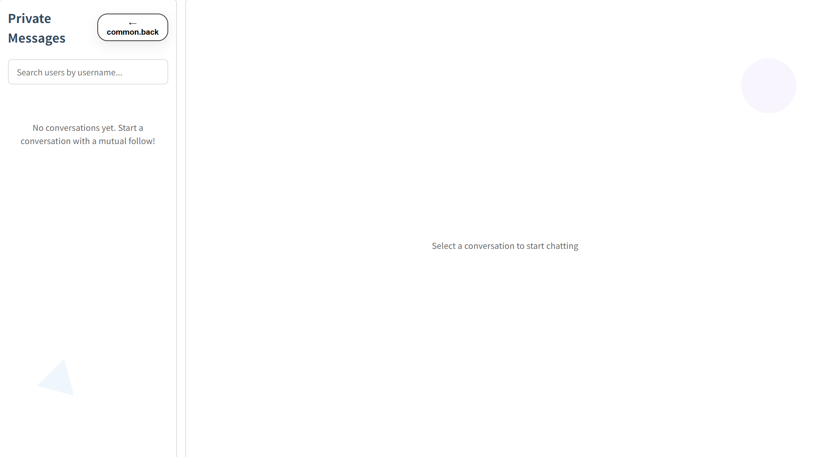
UI-06-01: One-way following
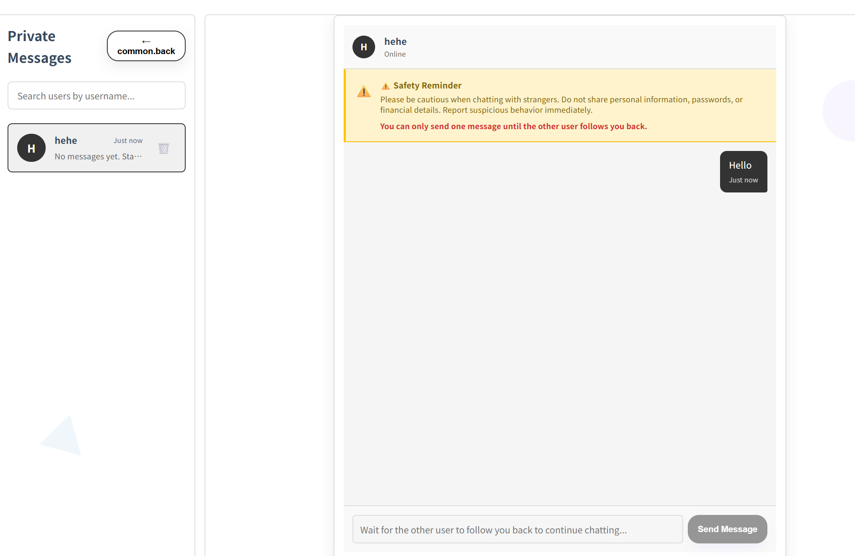

UI-06-02:Mutual Following
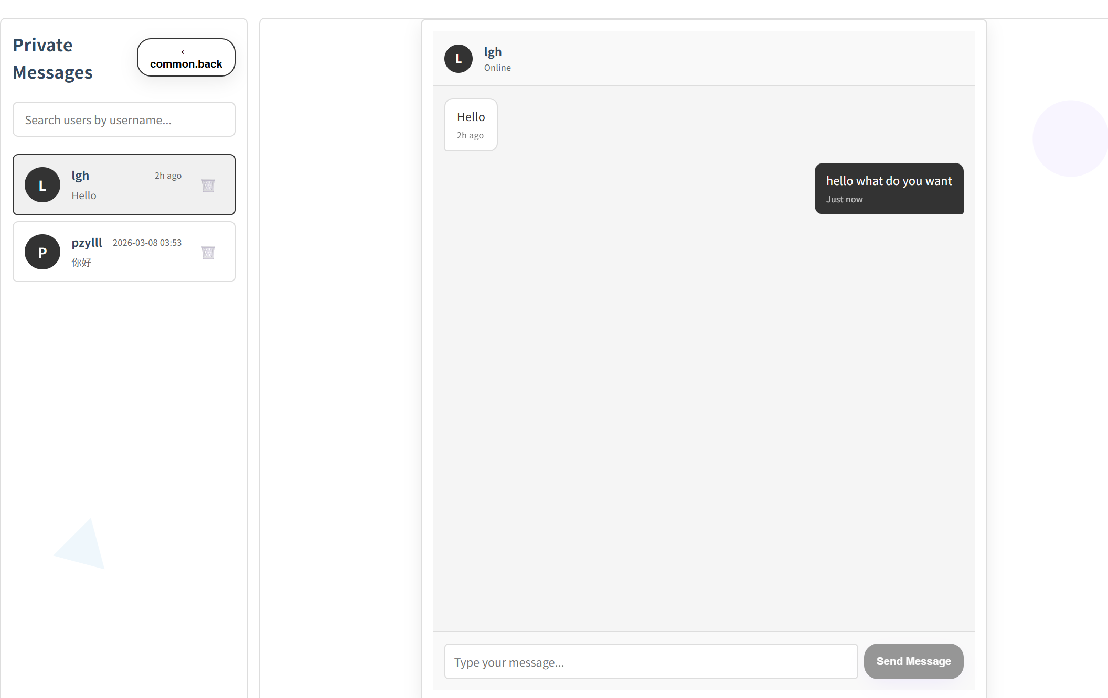
UI-06-03:Search users by username
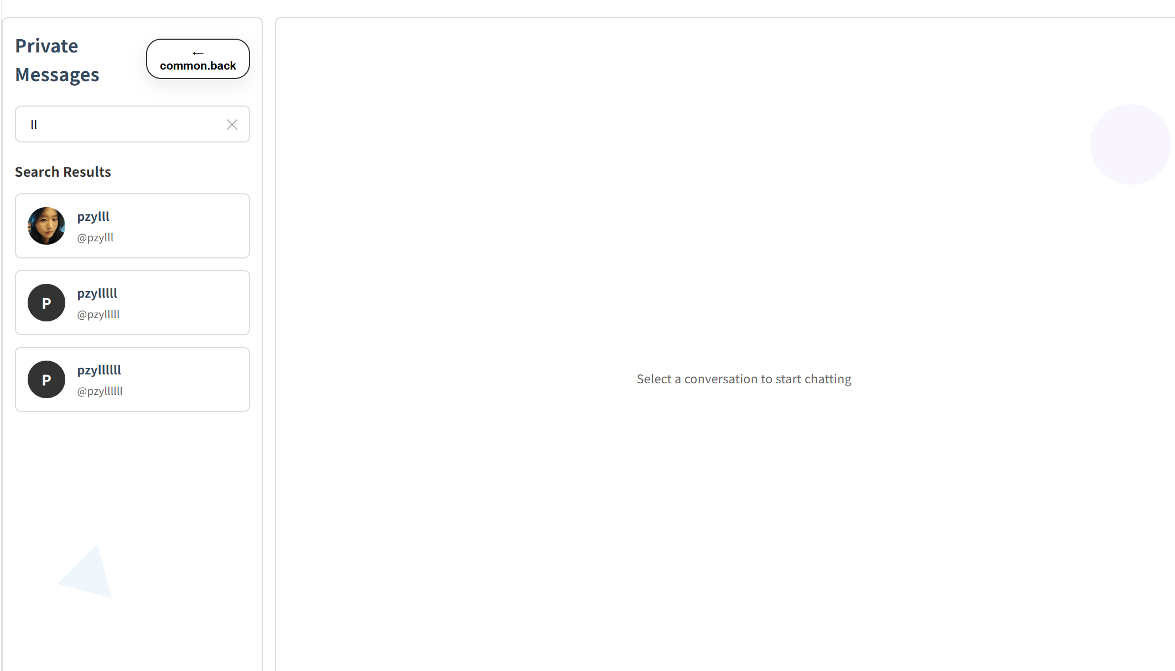

UI-07:Profile page
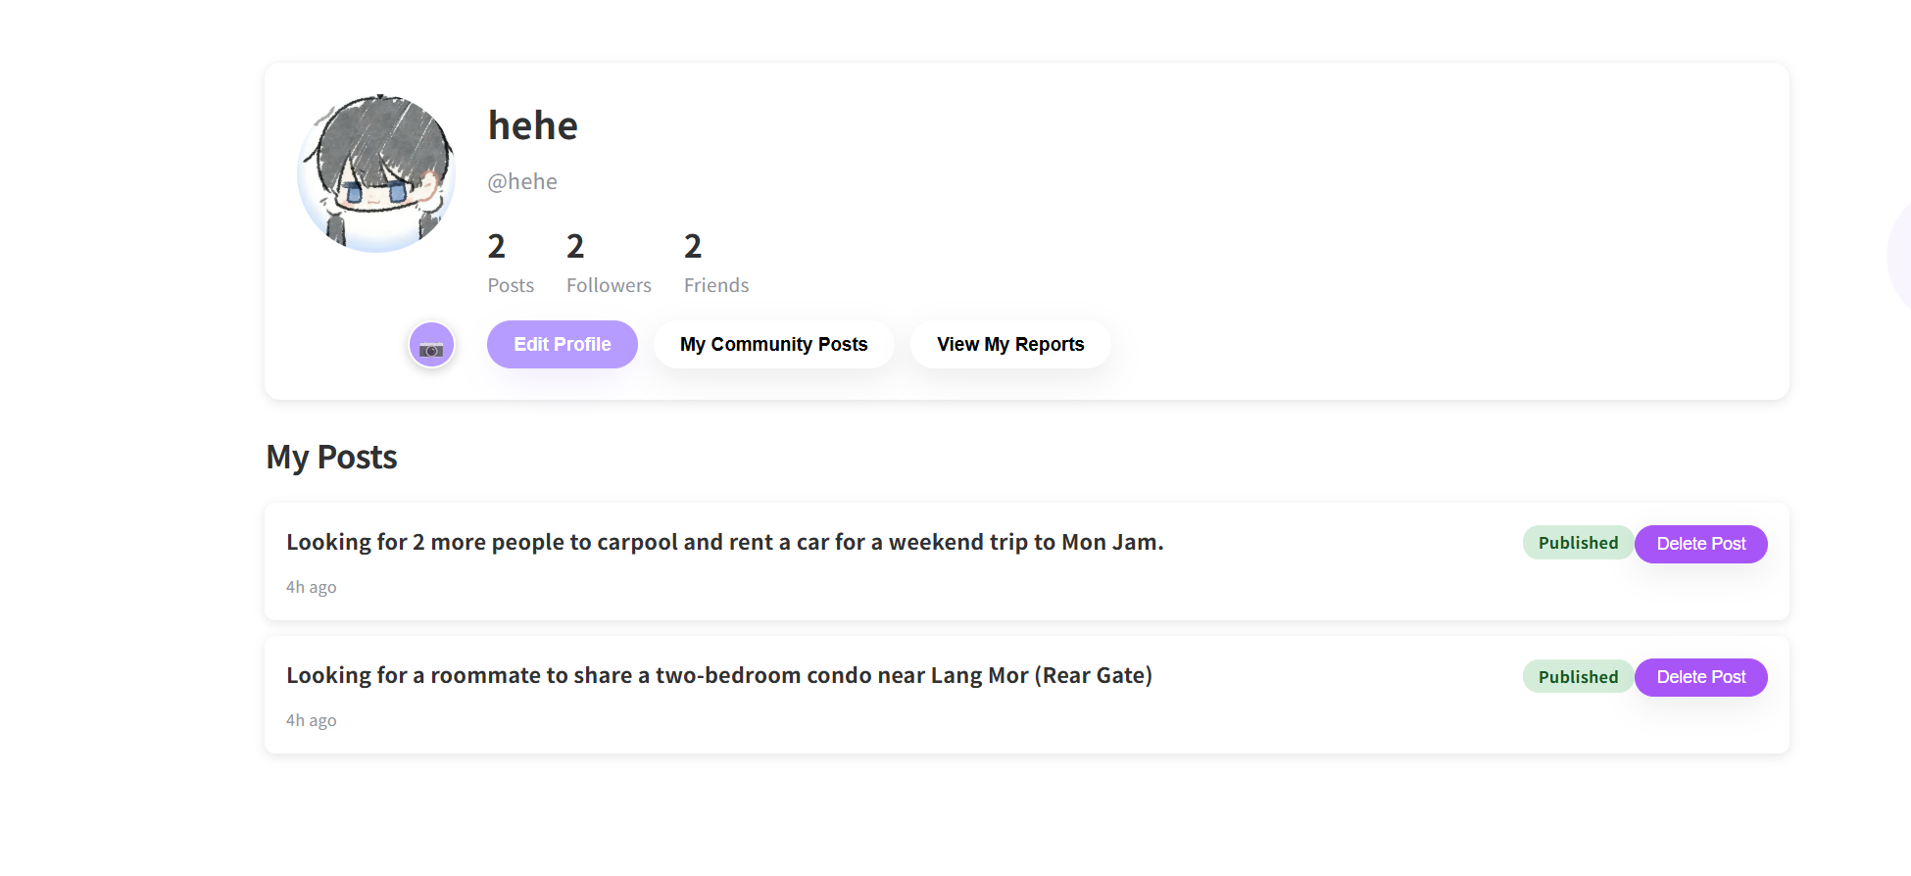

UI-07-01:Edit Profile page
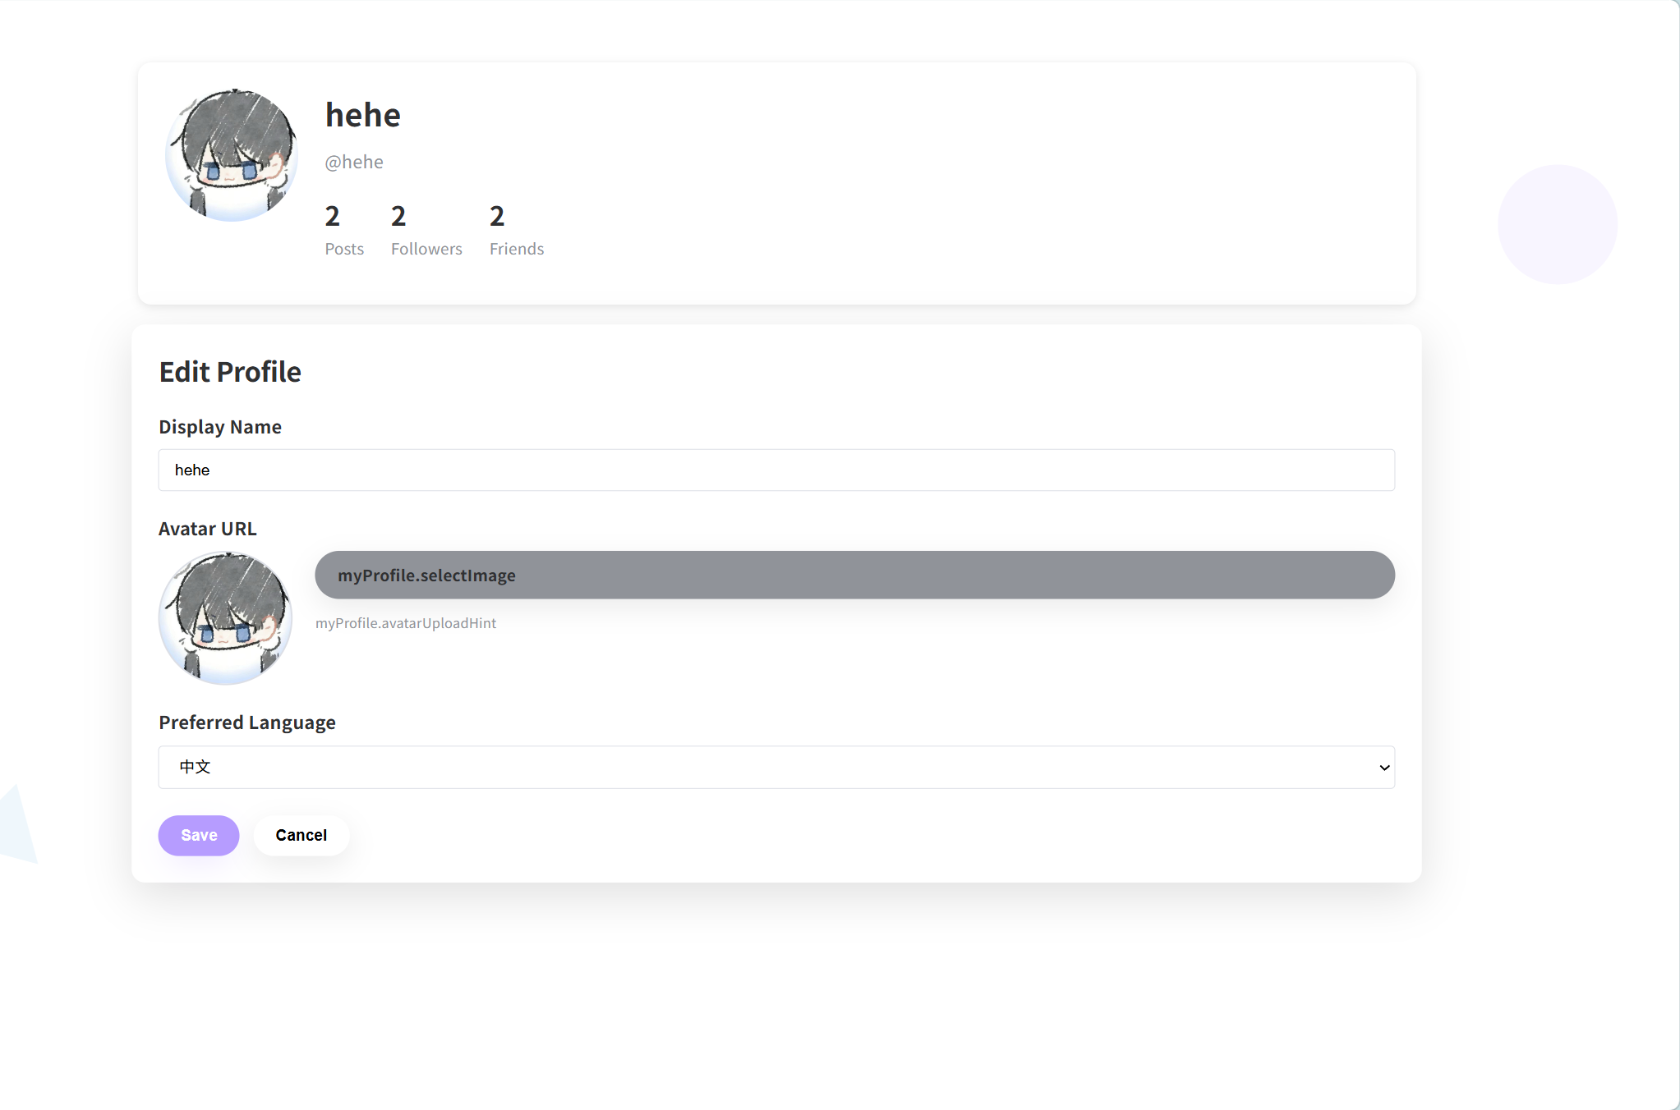

UI-07-02:Followers List Page
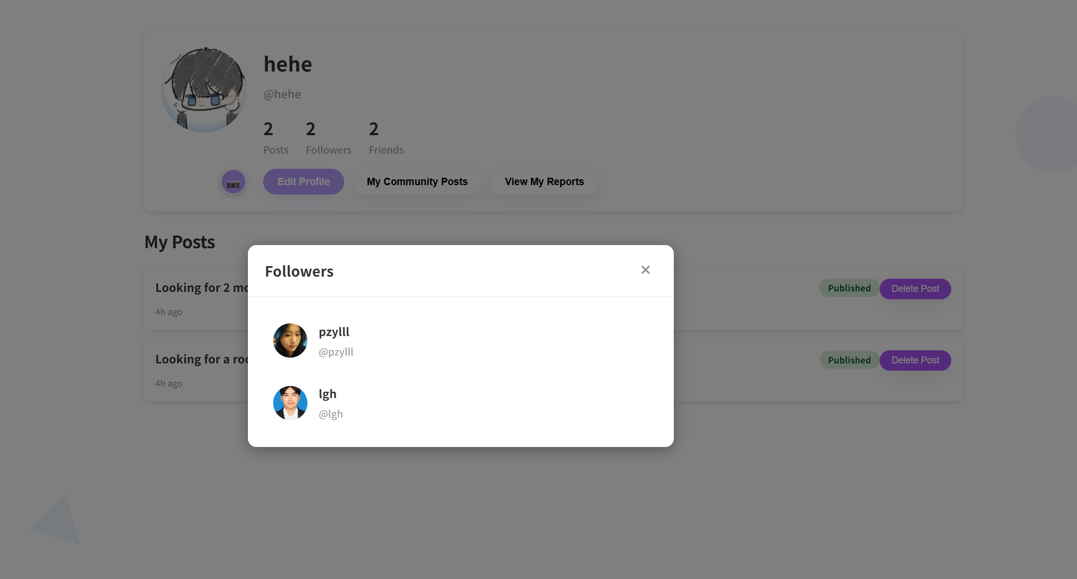

UI-07-03:Fridens List Page
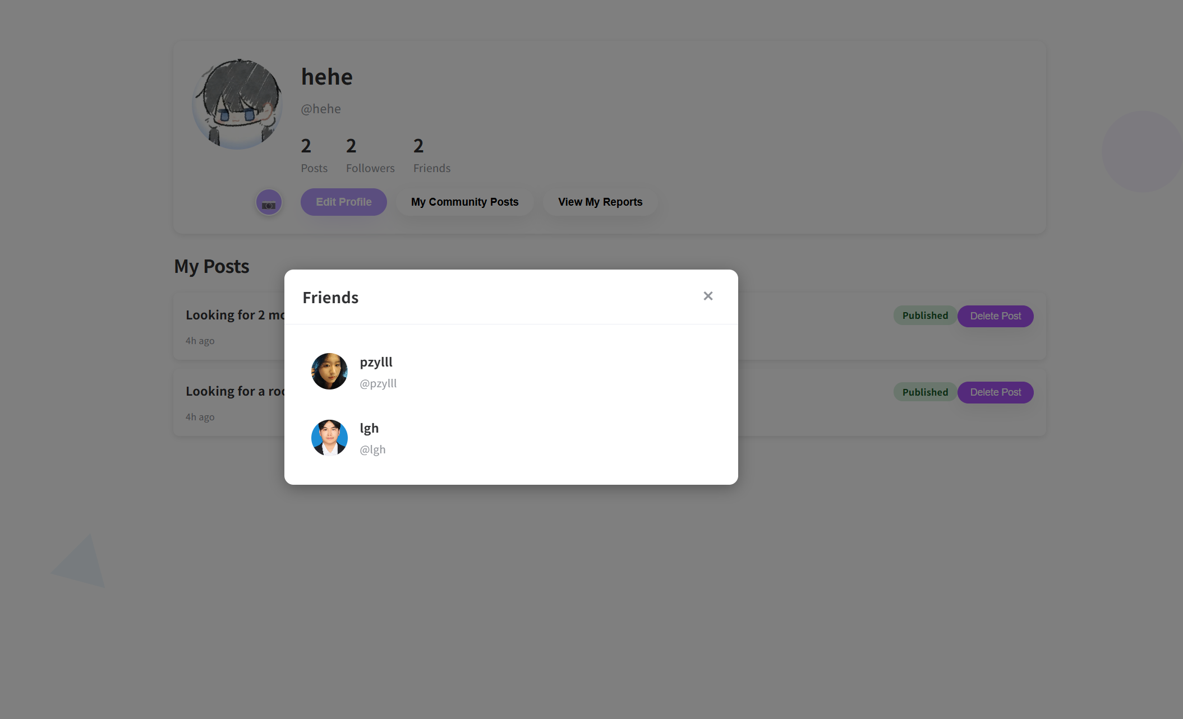

UI-08:My Community Posts Page
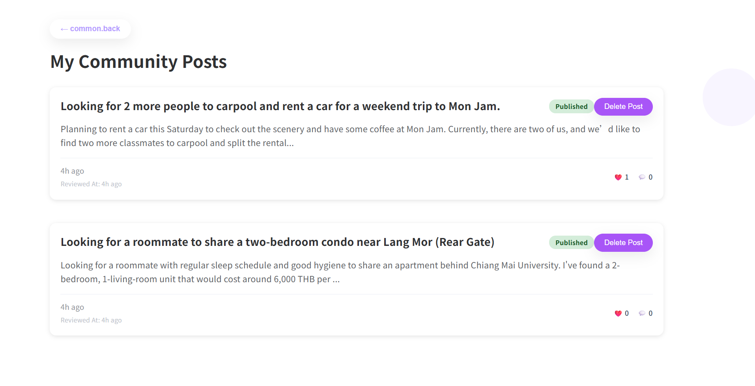

UI-09:My Reports Page
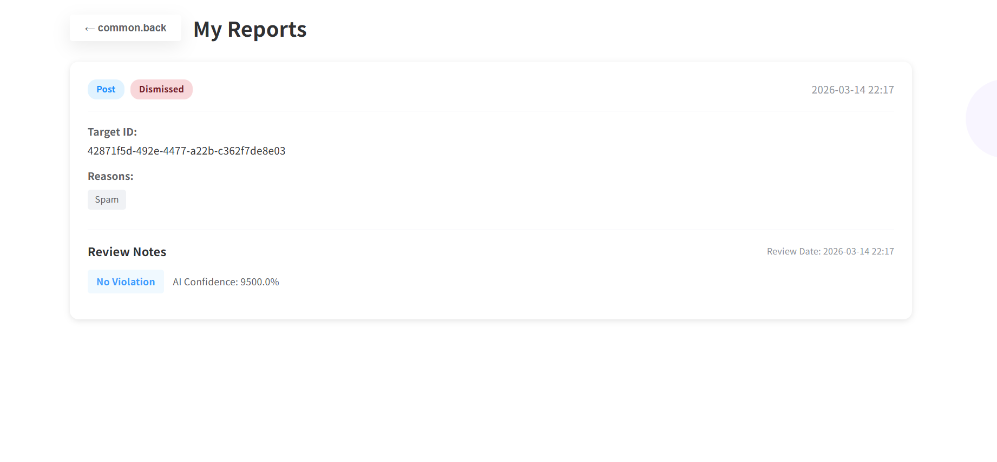
UI-10:Login Page
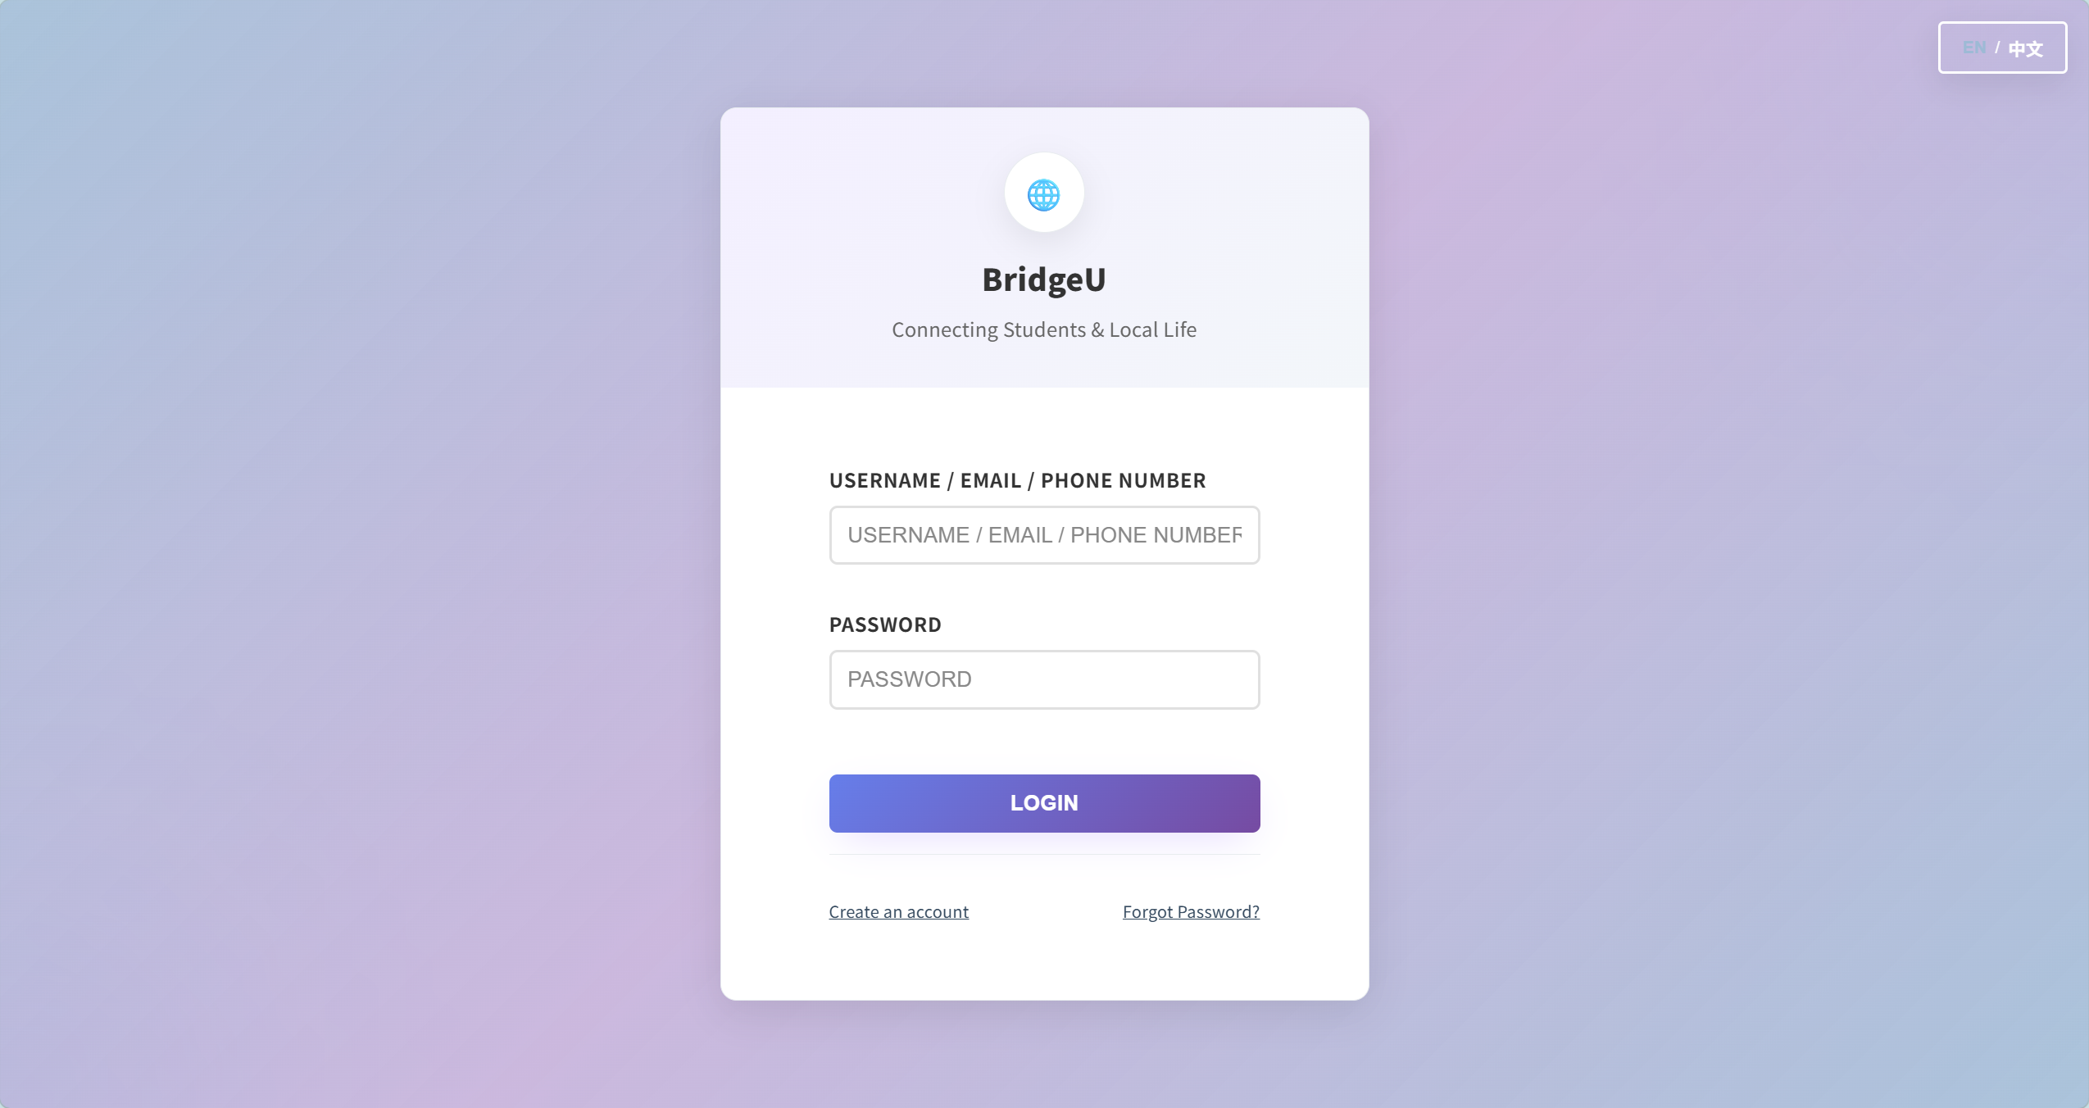

UI-11:Forgot Password Page
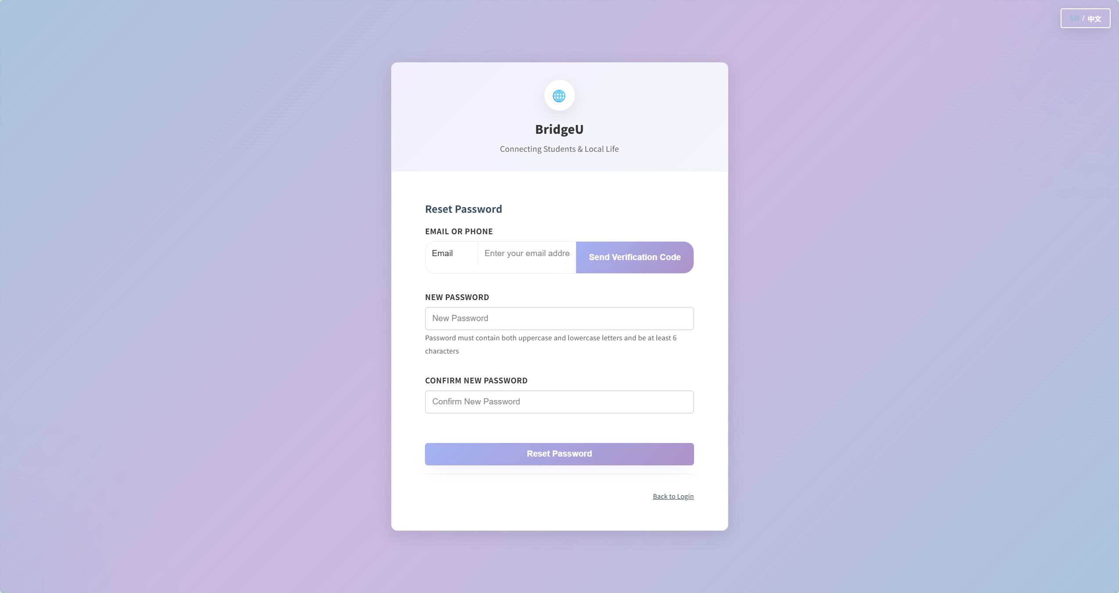

UI-12: Registration page
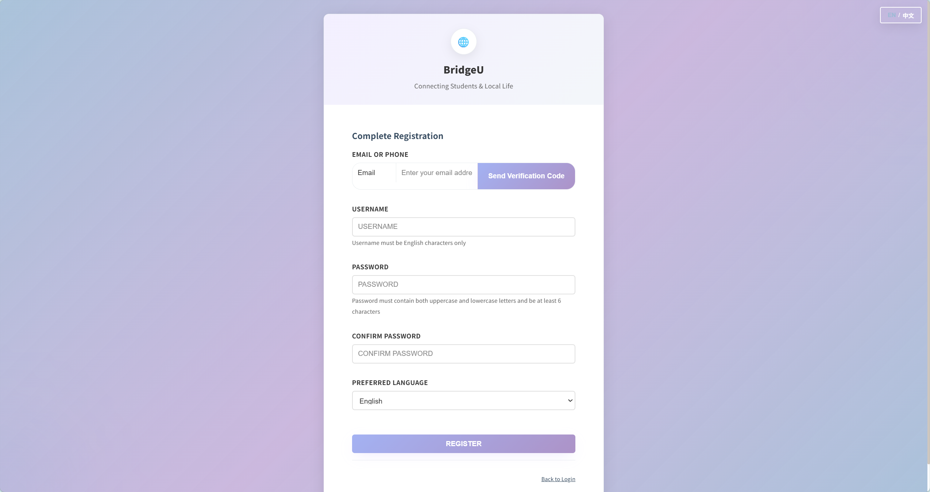

UI-13: Sidebar UI
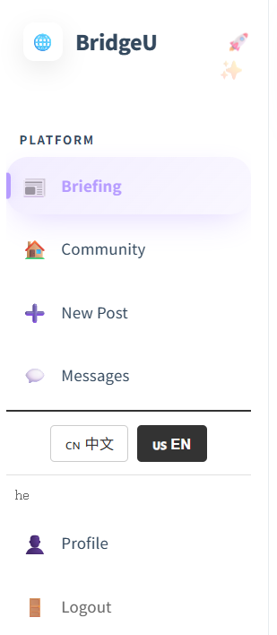

Chapter 5 Database Design

5.1 Entity Relationship Diagram (ERD)
The following diagram gives a system-wide view of all key entities in BridgeU and how they relate to each other. It mirrors the physical database schema used by the Spring Boot backend and can be read as follows:
  - USERS :Core identity table for all roles (students, merchants, admins). Stores login credentials (`username`, `password_hash`),contact info (`email`, `phone`), profile preferences (`preferred_language`) and status flags (`enabled`, `created_at`).

  - VERIFICATION_CODE : Stores email/phone-based OTP codes for registration and password reset. `identifier` links logically to a user’s email or phone, and each record includes the 6-digit `code`, type (`EMAIL`/`SMS`), purpose (`REGISTER` /`RESET_PASSWORD`), expiration time (`expiresAt`) and usage flag (`used`).

  - POSTS / COMMENTS / POST_LIKES – Represent community content and interactions. `POSTS` contains multilingual content and AI-moderation fields (`status`, `ai_confidence`, `ai_result`, `review_note`); `COMMENTS` and `POST_LIKES` reference `POSTS` and `USERS` to record who commented/liked what and when.

  - USER_FOLLOWS: Many-to-many relation capturing who follows whom; used both for community features (mutual follow list) and as a permission gate for private messaging.

  - CONVERSATION / MESSAGE: Model one-to-one private chats. `CONVERSATION` stores the pair of users and latest activity time,while `MESSAGE` stores individual messages, including sender/receiver, content, read flag and timestamps.

  - REPORT / REPORT_REASONS`REPORT` stores user reports against posts or comments (`targetType`, `targetId`), including the selected reasons, free-text description, AI moderation output (`ai_result`, `ai_confidence`, `violation_snippet`, `is_violation`), status and review timestamps; `REPORT_REASONS` stores the normalized list of selected reasons per report.

- NOTIFICATIONS – Stores user-facing notifications triggered by report processing and other events (e.g. report success/failure, Content penalties, restorations), including bilingual `title`/`content`, related `report_id`/`post_id`/`comment_id`, and read/unread timestamps.

  - REPORT: Stores user reports against posts or comments (`targetId`, `targetType`), together with status and timestamps,supporting the hybrid AI + human moderation flow.

  - NEWS: Stores crawled Thai news and their bilingual titles/summaries, as used by the Daily Briefing feature(`title_en/zh`, `summary_en/zh`, `original_url`, `source`, `publish_date`, `create_time`).
Together these entities support authentication, community interactions, messaging, content safety and the daily news briefing.
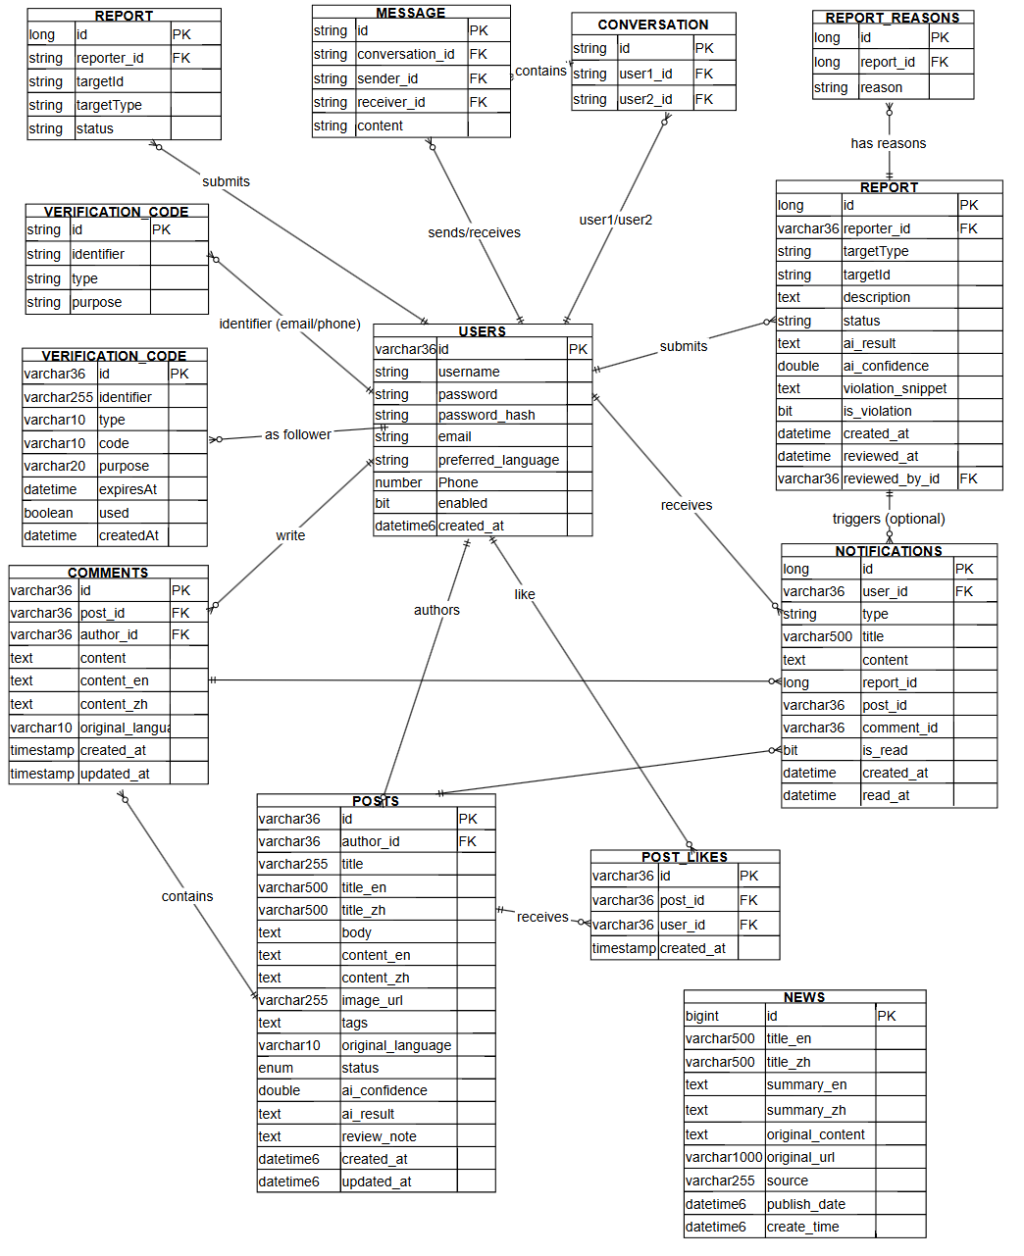

5.2 Data Dictionary
Table Name | Field Name | Data Type | Description
Users | id | varchar(36)  (PK) | Unique identifier for each user
 | username | string | Login username
 | password | string | plaintext password field if present
 | password_hash | string | Hashed password used for authentication
 | email | string | Email address
 | preferred_language | string | UI language preference (zh/en)
 | phone | number | Phone number
 | enabled | bit | Whether the account is enabled
 | created_at | datetime | Account creation timestamp
Verification_  code | id | varchar(36) (PK) | Verification code record ID
 | identifier | varchar(255) | Email address or phone number
 | type | varchar(10) | Code type (EMAIL/SMS)
 | purpose | varchar(20) | Code purpose (REGISTER/RESET_PASSWORD)
 | code | varchar(10) | Verification code (6 digits)
 | expiresAt | datetime | Expiration time of the verification code
 | used | boolean | Whether the code has already been used
 | createdAt | datetime | Creation time of the verification code record
Posts | id | varchar(36)  (PK) | Post ID
 | author_id | varchar(36)  (FK) | References `USERS.id` (post author)
 | title | varchar(255) | Original title
 | title_en | varchar(500) | English title
 | title_zh | varchar(500) | Chinese title
 | image_url | varchar(255) | Optional image URL
 | tags | text | Tag list
 | original_  language | varchar(10) | Detected original language(zh/en)
 | status | enum | Moderation status (PENDING_REVIEW/APPROVED/REJECTED)
 | ai_confidence | double | AI moderation confidence score
 | ai_result | text | AI moderation result payload
 | review_note | text | AI review note
 | created_at | datetime | Creation time
 | updated_at | datetime | Update time
Comments | id | varchar(36)  (PK) | Comment ID
 | post_id | varchar(36)  (FK) | References `POSTS.id`
 | author_id | varchar(36)  (FK) | References `USERS.id`
 | content | text | Original comment content
 | content_en | text | English comment content
 | content_zh | text | Chinese comment content
 | original_  language | varchar(10) | Detected original language
 | created_at | timestamp | Creation time
 | updated_at | timestamp | Update time
Post_Likes | id | varchar(36)  (PK) | Like record ID
 | post_id | varchar(36)  (FK) | References `POSTS.id`
 | user_id | varchar(36)  (FK) | References `USERS.id`
 | created_at | timestamp | Like time
User_  Follows | id | varchar(36)  (PK) | Follow relationship ID
 | follower_id | varchar(36)  (FK) | References `USERS.id` (follower)
 | following_id | varchar(36)  (FK) | References `USERS.id` (followed user)
 | created_at | timestamp | Follow time
Conversation | id | string(PK) | Conversation ID
 | user1_id | string(FK) | References `USERS.id` (participant 1)
 | user2_id | string(FK) | References `USERS.id` (participant 2)
 | created_at | datetime | Conversation creation time
 | last_message_at | datetime | Timestamp of the latest message
Message | id | string(PK) | Message ID
 | conversation_id | string(FK) | References `CONVERSATION.id`
 | sender_id | string(FK) | References `USERS.id`
 | receiver_id | string(FK) | References `USERS.id`
 | content | text | Message content
 | is_read | bit | Read flag
 | read_at | datetime | Read time
 | created_at | datetime | Created time
News | id | bigint  (PK) | News ID
 | title_en | varchar(500) | English title
 | title_zh | varchar(500) | Chinese title
 | summary_en | text | English summary
 | summary_zh | text | Chinese summary
 | original_  content | text | Original article content
 | original_url | Varchar  (1000) | Original URL
 | source | varchar(255) | Source website name
 | publish_date | datetime | Publication time
 | create_time | datetime | Insert time (when stored)
Reports | id | Long(PK) | Report ID
 | reporter_id | varchar(36)  (FK) | References USERS.id (user who submitted the report)
 | targetType | string | Target type: POST or COMMENT
 | targetId | string | Target entity ID (post ID or Comment ID)
 | status | string | Report status (PENDING, RESOLVED, DISMISSED)
 | description | text | Optional free-text description from the reporter
 | ai_result | text | Raw JSON string returned by the AI moderation model
 | ai_confidence | double | AI confidence score in the range [0.0, 1.0]
 | violation_snippet | text | Concrete snippet that violates the guidelines (as extracted by AI)
 | is_violation | bit | Whether the reported content is considered a violation (true/false
 | created_at | datetime | Timestamp when the report was created
 | reviewed_at | datetime | Timestamp when the report was reviewed (AI or admin)
 | reviewed_by_id | varchar(36)  (FK) | References USERS.id (admin who performed the final review, if any)
Report_  reasons | id | Long(PK) | Internal identifier of a single report reason entry
 | report_id | Long(FK) | References REPORTS.id (owning report)
 | reason | string | One of the predefined reasons (Spam, Fraud or Scam, Abusive Language etc.)
Notefications | id | Long(PK) | Notification ID
 | user_id | varchar(36)( FK) | References USERS.id (receiver of the notification)
 | type | string | Type (REPORT_SUCCESS, REPORT_FAILED, POST_VIOLATION_PENALTY, POST_RESTORED, etc.)
 | title | varchar(500) | Notification title (often stored as bilingual text)
 | content | text | Notification body content (often stored as bilingual text)
 | report_id | long | Related report ID when applicable (logical link to REPORTS.id)
 | post_id | varchar(36) | Related post ID when applicable (logical link to POSTS.id)
 | comment_id | varchar(36) | Related comment ID when applicable (logical link to COMMENTS.id)
 | is_read | bit | Whether the notification has been read by the user
 | created_at | datetime | Creation time of the notification
 | read_at | datetime | Timestamp when the notification was marked as read

